HIV-1 and HIV-2 WGS Illumina MiSeqProtocol

Oregon State Public Health Laboratory
In Collaboration with the Association of Public Health Laboratories (APHL)

Noah C. Hull¹, Eugene Yeboah¹, Laura Tskanaridis¹, Vanda Makris¹, John Fontana¹, Shane Sevey¹

Table of Contents

I. PURPOSE: 2
II. SCOPE / SPECIMEN ACCEPTANCE CRITERIA: 2
III. DEFINITIONS: 3
IV. ROLES and RESPONSIBILITIES: 3
V. EQUIPMENT / SUPPLIES / REAGENTS: 3
VI. Hazardous substances / Safety Precautions: 4
VII. Hazardous chemical waste disposal: 5
VIII. Instrument start-up / maintenance: 5
IX. CALIBRATION: 6
X. QUALITY CONTROL: 6
XI. PROCEDURE: 6
XII. QC ACCEPTANCE CRITERIA: 13
XIII. rESULT REPORTING AND INTERPRETATION: 13
XIV. TROUBLESHOOTING: 13
XV. REFERENCES: 14

PURPOSE:

The purpose of this procedure is to enable faster and easier sequencing of HIV-1 and HIV-2 whole genomes using the Oxford Nanopore Rapid kit and ONT Sequencers.

Human immunodeficiency virus (HIV) is the pathogen responsible for acquired immuno-deficiency syndrome (AIDS) and continues to be a major global public health issue. According to the World Health Organization as of 2020 there are approximately 37.7 million people living with HIV worldwide and during this year around 680,000 have died. HIV can be managed with antiretroviral (ART) drug treatments by suppressing the viral replication of HIV within the infected individual. Unfortunately, due to the nature of the virus and the availability to obtain consistent ART treatments, drug resistance can occur making the ART drug no longer effective. HIV drug resistance testing is recommended when beginning ART treatments and for evaluating treatment failure. Traditionally HIV drug resistance testing is performed by Sanger sequencing of specific regions within the HIV genome to identify drug resistance mutations. Recently, Next Generation Sequencing (NGS) technologies have been implemented to gain better sensitivity and reproducibility when compared to sanger sequencing.

The modifications include:
- Switching to the Nanopore RAPID barcoding, which requires less time (10 min) and fewer reagents.
- HIV Primer sequences designed by Primal Scheme
HIV1:
https://www.dropbox.com/sh/xnhpektoen7chdd/AAAT789gnEnwbbCjF_EMuRu8a?dl=0
HIV-2:
https://www.dropbox.com/sh/2sco4ffr30ids7a/AAD0z-VXSXElamsuys7zsmpLa?dl=0

SCOPE / SPECIMEN ACCEPTANCE CRITERIA:

For optimal results, it is recommended to use an amount of total RNA between 600-800 ng. The amount of viral RNA among samples should be approximately equivalent so that the target amplification conditions you select are optimal for all samples.

DEFINITIONS:

RNA: Ribonucleic acid; a polymeric molecule essential in various biological roles in coding, decoding, regulation and expression of genes.
RT-PCR: Reverse Transcription-PCR, a PCR technique that transcribes complimentary DNA (cDNA) from an RNA template, and then amplifies the cDNA by PCR.
PCR: Polymerase chain reaction is a process used to amplify a single or few copies of DNA.
Library: A collection of similarly sized DNA fragments with known adapter sequences added to the 5' and 3' ends.
NGS: Next-generation sequencing (NGS) is a technology for determining the sequence of DNA or RNA to study genetic variation associated with diseases or other biological phenomena.

ROLES and RESPONSIBILITIES:

It is the responsibility of the laboratorian (Microbiologist 2 and 3) to ensure that:
- All lab policies are followed, and sterile techniques are enforced.
- All laboratory equipment is calibrated and maintained consistent with manufacturer’s recommendations.
- All reagents have not gone past their expiration date and have been stored adequately.
This procedure assumes a basic familiarity with next-generation DNA sequencing (NGS). Laboratorians must be trained in molecular testing and the Illumina MiSeq instrument prior to performing this procedure. Refer to Good Laboratory Practices for Molecular Testing policy. (LINKED)

EQUIPMENT / SUPPLIES / REAGENTS:

REAGENTS
Random Primers (60uM Hexamers) 100ul |  | Fisher Cat# S1330S
10mM dNTP mix |  | Fisher Cat# R0192
SuperScript IV reverse transcriptase Kit (200ul) |  | Fisher Cat# 18-090-200
RNaseOUT |  | Fisher Cat# 10777019
HIV-1/HIV-2 Primers |  | IDT – Custom
AMPure XP beads (60mL) |  | Fisher Cat# NC9933872
Qubit™ Fluorometry 4.0 |  | Cat. # Q33238
Qubit™ 1X dsDNA HS Assay Kit |  | Cat. # Q33230 or Q33231
Absolute Ethanol, 200 proof, Molecular Biology Grade |  | Cat. # T038181000
UltraPure™ DNase/RNase-Free Distilled Water |  | Cat. # 10977015
200nM Tris-HCL, pH 7 (100 mL) |  | Fisher BP1756-100
EB Buffer(500 mL) |  | Fisher NC1801086
Q5® Hot Start High-Fidelity 2X Master Mix (500 rxn) |  | NEB M0494S
10 mM dNTP solution (800 ul x 5) |  | Fisher N0447S
1N NaOH (100mL) |  | Fisher SS277
Illumina DNA Prep (96 samples) |  | Illumina 20018705
Nextera Compatible Unique Dual Idx - Sets | Set A | Illumina 20027213
Nextera Compatible Unique Dual Idx - Sets | Set B | Illumina 20027214
Nextera Compatible Unique Dual Idx - Sets | Set C | Illumina 20027215
Nextera Compatible Unique Dual Idx - Sets | Set D | Illumina 20027216
PhiX Control V3 |  | Illumina FC-110-3001
MiSeq Reagent Kit v2- 300 cycle |  | Illumina MS-102-2022
EQUIPMENT
PCR Cabinet – NuAire, model 126-300 |  | Cat. # A35422
SimpliAmp™ Thermal Cycler |  | Cat. # A35422
Eppendorf® Centrifuge 5430/5430R |  | Cat. # EP022620645
myFuge 12 Micro-Centrifuge |  | Cat. # 50-550-338
Gentle rotator mixer or HULA mixer
Vortex Mixer
Rainin Pipettors – 2μl, 20μl, 200μl and 1000μl
Rainin Multichannel Pipettors – 20μl and 200μl
Rainin Repeater Pipettor – 20μl and 200μl
Eppendorf™ PCR Cooler |  | Cat. # 05-403-00
Magnetic Separator, suitable for 1.5ml tubes
Qubit® 4.0 Fluorometer
ONT Sequencer
SUPPLIES
MicroAmp™ Optical 96-Well Reaction Plate |  | Cat. # N8010560
MicroAmp™ Optical 8-Cap Strips |  | Cat. # 4323032
MicroAmp™ 8-Cap Strip, clear |  | Cat. # N8010535
Low Protein Binding Collection Tubes (1.5 ml) |  | Cat. # 90410
Rainin 20μl filter tips, Terra rack |  | Cat. # 17014961
Rainin 200μl filter tips, Terra rack |  | Cat. # 17014963
Rainin 1000μl filter tips, Terra rack |  | Cat. # 17014967
RNase Away™ |  | Fisher Scientific #21-236-21 or equiv.
Coverage Spray HB Plus |  | Steris #1624-77 or VWR #4212-963
Disposable powder-free gloves
Permanent marking pens
Kim Wipes
Biohazard containers for sharps, assorted sizes

Hazardous substances / Safety Precautions:
BIOHAZARD

Conduct all work in properly equipped facilities with the appropriate safety equipment (for example, physical containment devices). Safety equipment can also include items for personal protection, such as gloves and coats. Individuals should be trained according to applicable regulatory and OSPHL requirements before working with potentially biohazardous materials. Follow all applicable local, state/provincial, and/or national regulations.

- Lab coats and gloves must be worn when performing this procedure.
- The following items should be treated as biohazards after the run is complete:
  - RNA sample plates
  - RT-PCR plates
  - PCR plates
  - Reagent tubes
  - Used sample plates
  - Reagents
  - SpotON Flowcell

Hazardous chemical waste disposal:
- The MiSeq Reagent Cartridge contains formamide, an aliphatic amide that is a potential reproductive toxin (GHS classification Category 1B). Personal injury can occur through inhalation, ingestions, skin and eye contact. Take proper precautions when handling the cartridges and MiSeq waste. Ensure spent containers and unused contents are disposed of following the hazardous waste instructions in the OSPHL Chemical Hygiene Plan. See the Illumina kit SDS for additional information.

- Ensure use of primary and secondary waste containers. (A primary waste
container holds the immediate waste. A secondary container contains spills
or leaks from the primary container. Both containers must be compatible
with the waste material and meet federal, state, and local requirements for
container storage.)

- Ethanol waste can be disposed of in the lab sink under running water. Ensure that gloves, gowns are worn whenever using ethanol. Eye protection may be used as well.

Instrument start-up / maintenance:

Illumina MiSeq Sequencer

SimpliAmp™ Thermal Cycler
- After each use
  - Clean the housing or external part of the thermal cycler with a soft cleaning cloth or paper with approved disinfectant.
- Annual QC Check
  - Annual QC will be done through the “self-verification test feature” on the instrument. The check includes testing the block, heated cover, and other components.
- As needed
  - The thermal area lid should be cleaned with a cloth or soft cleaning paper moistened with isopropyl alcohol.
  - Clean the wells with water followed by Isopropanol

Qubit® 4.0 Fluorometer
The Qubit® 4.0 Fluorometer does not need regular maintenance.
- Do not perform any repairs or service on the Qubit® 4.0 Fluorometer to avoid damaging the instrument.
- Do not expose the Qubit® 4.0 Fluorometer to direct sunlight.
- Clean the surface of the Qubit® 4.0 Fluorometer with a damp cloth.
- To clean the touch screen, turn off the Qubit® 4.0 Fluorometer, disconnect the power cable, and clean the touch screen with a soft cloth lightly moistened with LCD cleansing detergent.

CALIBRATION:

Illumina MiSeq Sequencer

Thermocycler
For further information on the thermocycler system calibration and temperature maintenance procedures, refer to SimpliAmp™ Thermal Cycler User Guide (Pub. No. MAN0009889)

QUALITY CONTROL:

- Positive and negative controls are included in each assay to ensure assay performance meets acceptance criteria. The positive control should yield a positive result. The negative control should yield a negative result.
- Contamination Control
    - Take precautions to prevent cross contamination between samples during the procedure.
    - Wear lab coat and gloves always and change gloves often.
    - Use dedicated pipettes and tips.
    - Clean work surfaces, pipette, and other equipment with RNase Away® or 5% bleach to destroy any contaminating RNases or nucleic acids prior to use. Wipe down with 70% ethanol.
    - Soak plastic tube-holders in 5% bleach, rinse in water, dry and store in clean covered container following nucleic acid extraction.
    - Include at least one negative control sample (sterile water) in each extraction run and processed identically with clinical samples.
    - New personnel will be trained in this procedure by a senior technician and will demonstrate competence before testing patient samples.

PROCEDURE:
- Thaw extracted RNA specimens at 4°C or on a cold block.
- Determine the number of reactions (N) to set up assay. It is necessary to make excess reaction mix for the positive and negative and for pipetting error.
- Use the following guide to determine N:
• If number of samples (n) including controls equals 1 through 14, then N = n + 1
• If number of samples (n) including controls is 15 or greater, then N = n + 2

Reverse Transcription

NOTE: Hexamer master mix will be kept and prepared in the PCR Clean room.

- Thaw 6o µM random hexamer/anchored polyT(23) and 10 µM dNTPs on a cold block. Vortex and quick spin before using.

- Place 96-well PCR plate on an Eppendorf® PCR cooler (stored at -20ºC).

- Combine the following volumes to prepare the Hexamer master mix:

Component Volume
60uM random hexamers and anchored 1 μl
polyT(23) - Random Primers
10mM dNTPs 1 μl
Total volume per sample 2 μl

- Vortex Hexamer master mix, spin down, and place in a cold block.

- Using a repeater pipettor aliquot 2 μl of Hexamer master mix into each sample well of a 96‑well PCR plate according to plate map.

- Cover the plate and move the PCR plate containing master mix from the PCR Clean Room to the processing bench for sample addition.

- Add 15 μl of nucleic extract to the appropriate sample well. Seal the plate with MicroAmp™ 8-cap strips, gently vortex, and spin down 96 well plate containing.
- Incubate the reaction at 65°C for 5 minutes using the Hexamer Anneal program.

REPS | 1 | Hold
TIME | 5:00 | ∞
TEMP | 65ºC | 4ºC
Total volume = 17 μl per well

- Once incubation is completed, immediately remove plate and snap-cool by placing it on a cold block until step 8.

- In a new 1.5 mL lo-bind tube, combine the following volumes to prepare the Reverse Transcription (RT) master mix:
Component Volume
5X SuperScript IV RT buffer 4 μl
100mM DTT 1 μl
RNaseOUT RNase inhibitor 1 μl
Superscript IV Reverse Transcriptase (add last) 1 μl
Total volume per sample 7 μl

- Add 7µL to the RT master mix to the sample wells. Pipette to mix. Seal the plate with MicroAmp™ 8-cap strips, gently vortex, and spin down 96 well plate containing.

- Incubate plate using the HIV RT-PCR program.

REPS | 1 | 1 | Hold
TIME | 50:00 | 10:00 | ∞
TEMP | 42ºC | 70ºC | 4ºC
    - Set heated lid to 105ºC
Total volume = 24 μl per well
Safe Stop Point: If stopping, the 96 well plate can be left in the thermocycler overnight or store in -20°C for long term storage.

PCR Primer Pool Preparation

- Before proceeding, primer pools (A and B) must be diluted from 100 µM to a working stock of 15 µM.
- Thaw Q5 Hot Start HiFi 2x MM and Primers Pools A + B (15 µM). Vortex and quick spin before using.
- Combine the following components to prepare the master mix for each primer pool (A or B).

NOTE: Use the HIV-1 RT and Primer Pool Preparation Worksheet to calculate the required amount of master mix. This can be made at the same time as the RT master mix plate and stored at 4ºC until use.

Component Volume
Nuclease-free Water 6.3 μl
HIV-1 Primer Pool (A or B) 15μM 3.75 μl
Q5® Hot Start HF 2X Master Mix 12.5 μl
Total volume per sample 22.5 μl

- Place 96-well PCR plate on an Eppendorf® PCR cooler (stored at -20ºC).

- Using a repeater pipettor aliquot 22.5 μl of each master mix into the appropriate wells of the 96-well plate.
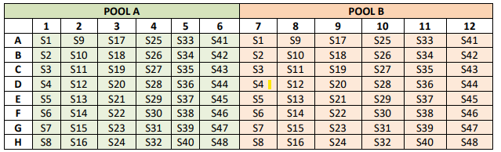

- Cover and store at 4ºC until reverse transcription protocol is complete.

- Remove the RT plate from the thermocycler and centrifuge.

- Carefully remove the 8-cap strips and using a multi-channel pipettor transfer 2.5 μl of the cDNA into the appropriate wells of the PCR plate containing the primer pools. Gently mix by pipetting the contents of each well up and down. Total volume = 25 μl per well.

- Seal the plate with 8-cap strips and briefly centrifuge.

- Load the plate into the SimpliAmp™ thermocycler, then run the HIV MiSeq Primer program with the following parameters:

REPS | 1 | 35X |  | Hold
TIME | 0:30 | 0:15 | 5:00 | ∞
TEMP | 98ºC | 98ºC | 65ºC | 4ºC
    - Set heated lid to 105ºC
    - Runtime ~4 Hours
- Safe Stop Point: If stopping, leave plate in thermocycler overnight or remove from thermocycler and store at -20C until ready to use.

Clean-up, & Size Selection
- 1.0X AMPure XP Beads Clean up
  - Prepare 80% fresh ethanol in a 15 mL or 50 mL conical; each sample needs 500 µL.
  - For each sample, combine the 25 µL reaction from WGS PCR pool A and the 25 µL reaction from pool B into a designated well in a new MIDI plate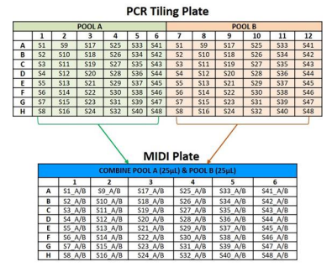
  - Proceed with 1.0x AMPure XP Bead Cleanup using the table below

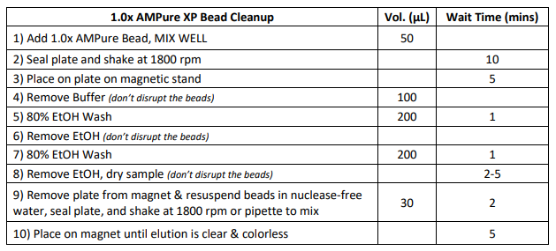
  - Remove 30 µL of supernatant from each well into a new 96 well plate or 1.5 mL lo-bind tube. Safe Stop Point: If stopping, seal plate and store at -20°C for long-term storage.
- Quantification of DNA Input for Illumina DNA Prep
  - Quantify sample using a Qubit Fluorometer with either Qubit dsDNA HS or Qubit 1x dsDNA HS kit. For more information, see the Qubit™ dsDNA HS Assay Kits User Guide.
  - Determine the DNA concentration using Qubit™ 4.0 Fluorometer:
    - Prepare the Qubit™ standards as directed in the user guide (10 μl standard + 190 μl Qubit™ dsDNA HS Buffer), mix well, and incubate for at least 2 minutes.
    - For each sample, combine 1 μl of the DNA with 199 μl of Qubit™ dsDNA HS Buffer, mix well, and incubate for at least 2 minutes.
    - On the Qubit™ 4.0 Fluorometer home screen, select dsDNA then 1x dsDNA High Sensitivity.
    - Measure the prepared standards.
    - Select the sample concentration as “ng/μl” with an input value of 1 μl.
    - Measure and record the library concentration.
    - Using the stock concentration (ng/µL), of each sample, calculate the ng of each sample. DNA input must be between 100-500 ng. See DNA Input for Illumina DNA Prep calculation sheet. “LINK” Samples with a DNA input of >500 ng must be diluted. Total volume of each samples must be minimum of 30 uL.
Calculate appropriate dilution volumes using the following:

Volume DNA (μl) = ___Target quantity (ng)___
Pool Concentration (ng/μl)
Volume EB (μl) = 30 μl – Volume Library Pool (μl)
Safe Stop Point: If stopping, seal plate and store at -20°C

Illumina DNA Prep

- Tagment Genomic DNA
  - Thaw samples, BLT, & TB1, TBS and TWB (TWB allow at least 30 minutes to reach room temperature) on a cold block. Vortex and quick spin before using.
  - In a new 1.5 mL lo-bind tube, combine the following volumes to prepare the Tag master mix. Vortex master mix gently, spin down, and place in a cold block.

Component Volume BLT 10 μl
TB1 10 μl
Total volume per sample 20 μl

  - Add 20 µL of Tag master mix to each designated well. Add 30 µL of sample DNA input to designated well; pipette to mix. Seal plate, gently vortex and spin down.
  - Incubate the plate at 55°C for 5 minute and hold at 10°C using the Flex Tagment program.
    - Set heated lid to 100ºC
    - Total volume 50 μl
- Post-Tag Cleanup
  - Remove Tagment plate from thermocycler, quick spin, and place on a cold block.
  - Immediately add 10 µL of TBS to each well to stop reaction. Pipette to mix seal plate.
  - Incubate the reaction at 37°C for 15 minute and hold at 10C s using the Flex Post-Tag program.
    - Set heated lid to 100ºC
    - Total volume 60 μl
  - Remove plate from thermocycler and place on the magnetic stand and wait until supernatant is clear (~2 minutes).
- Proceed with cleanup using the table below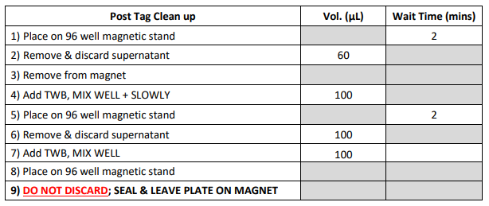
- Amplify Tag DNA
  - Thaw EPM and IDT for Illumina Nextera DNA UD Indexes*plate on cold block. Gently vortex and quick spin before using. use any set (A-D)
  - In a new 1.5 mL lo-bind tube, combine the following volumes to prepare the Flex Amplify master mix in the table below. Vortex and quick spin and place on cold block.

Component Volume EPM 20 μl
H2O 20 μl
Total volume per sample 40 μl

  - Remove and discard supernatant from the 96 well plate containing DNA input and TWB.
  - Remove plate from magnetic stand and place on cold block.
  - Immediately add 40 µL of Flex Amplify master mix to each designated well. Shake plate at 1600 rpm for 1 minute. If plate shaker is not available, pipette up and down to mix.
  - Add 10 µL of assigned Illumina Nextera DNA UD Indexes to designated well.
  - Incubate plate using the Flex Amplify program.
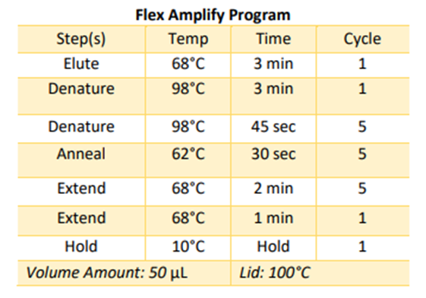
Safe Stop Point: If stopping, seal plate with adhesive & foil and store at -20°C for up to 3 days.

- Library Clean-up
  - Allow SPB to adjust to room temperature for least 30 mins.
  - Thaw RBS. Vortex and quick spin before using.
  - Remove plate from thermocycler and quick spin. Place plate on 96-well magnetic stand for 2-5 mins or until clear.
  - Transfer 45 µL of supernatant, without disrupting the beads, from each well into a new MIDI plate and discard the 96-well plate.
  - Using a reagent reservoir, combine the following volumes to prepare the SPB master mix. Vortex and quick spin the master mix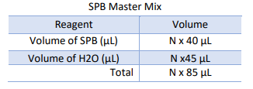
  - Add 85 µL of SPB master mix to each sample in the MIDI plate.
  - Seal MIDI plate and shake at 1800 for 5 mins.
  - During incubation, perform the following steps:
    - Vortex the undiluted stock tube of SPB.
    - In a new MIDI plate, add 15 µL of undiluted SPB tube
    - Seal plate and set aside till Step j.
  - Place MIDI plate containing samples and SPB master mix on magnetic stand.
  - Transfer 125 µL of supernatant to MIDI plate containing undiluted SPB. Pipette to mix.
  - Discard the first MIDI plate that contained the beads from the magnetic stand.
  - Seal MIDI plate and shake at 1600 rpm for 1 minute
  - Prepare 80% fresh ethanol in a 15 mL or 50 mL conical; each sample needs 500 µL.
  - Proceed with Flex Library Cleanup using the table below
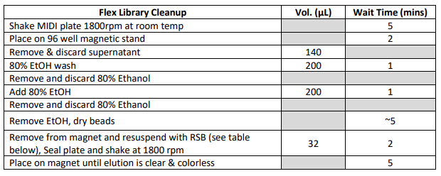
  - Remove 30 µL of supernatant and add it to new 96-well plate.
- Pooling & Quantification
  - In a new 1.5mL lo-bind tube, add 5µL of each designated sample to create a library pool for sequencing. Library pool is now ready for quantification.
  - Using Qubit Fluorometer with dsDNA HS kit to quantify library pool.
- Record the concentration at ng/µL and calculate pool to 2 nM using the table below. 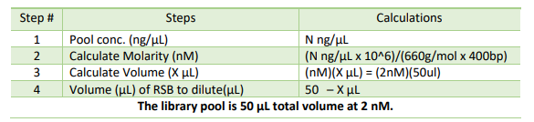
- Denaturing and Diluting library pool 10 pM
  - In a new 1.5 mL lo-bind tube, combine 400µL of Nuclease-free water with 100µL to prepare fresh 0.2N NaOH in the table below. Vortex and quick spin.
  - In a new 1.5 mL lo-bind tube, add 5 µL of 0.2N NaOH and 5 µL library pool at 2 nM.
  - Incubate tube for 5 minutes at room temperature
  - Immediately add 990 µL of HT1 buffer. Place 10pM library pool on a cold block until ready to use.
- Denaturing and Diluting PhiX Control v3 to 10 pM
  - Thaw PhiX Control v3 on a cold block
  - In a new 1.5 mL lo-bind tube, add 2µl 10nM PhiX library and 3µl 10mM Tris-Cl pH 8.5 with 0.1% Tween to make 4 nM PhiX
  - In a new 1.5 mL lo-bind tube, add 5µL 4nM PhiX library and 5µL 0.2N NaOH to make 2 nM PhiX. Vortex and quick spin tube.
  - Incubate 5 min at RT.
  - Immediately add 990µL HT1 to tube to make 20 pM PhiX. 20pM PhiX can be store at -20°C for 4 weeks.
  - In a new 1.5 mL lo-bind tube, add 50 µL of 20pM PhiX and 50 µL HT1 buffer to make 10pM PhiX.
- Final Loading Conc.
  - From the 10pM library pool, remove and discard 10µL.
  - Add 10µL of 10pM PhiX directly into the 10pM library pool tube to make Final Pool.
  - Vortex and quick spin. Keep tube on a cold block until ready
- Sequencing on MiSeq
  - Before proceeding, thaw 300 cycle kit either at 4C (up to 6 days) or in room temperature water for 1 hour. Keep kit in 4C until ready to sequence.
  - Create Sample Sheet prior to starting a sequencing run.
  - On the cartridge, puncture reservoir 17 “Load Sample” seal and transfer 600µL of Final Pool.
  - Load cartridge into instrument.
  - Rinse and then dry flow cell. Load flow cell into instrument.
    - While wearing clean, powder free gloves, carefully remove the flow cell from the container, without touching the glass of the flow cell.
    - Lightly rinse the flow cell assembly with molecular grade water, making sure that both the glass and plastic casing are thoroughly rinsed of the excess salts.
    - Using care around the black port gasket, pat dry the flow cell and cartridge using a lint free wipe. Make sure to remove all excess flu Wet a clean piece of lens paper with 70% ethanol and clean the flow cell glass, making sure that the glass is free of streaks, lint and tissue fibers. Do not add ethanol directly to flow cell and avoid getting ethanol on the flow cell port gasket.
    - Dry excess alcohol with the lens paper, and visually inspect to make sure that the flow cell ports are free of obstructions and that the gasket is well seated around the flow cell ports.
    - On the main sequencing screen of the computer, select “Sequence” to initiate the “Load Flow Cell” screen.
    - Raise the flow cell compartment door, and then press the release button to the right of the white flow cell latch.
    - Remove the old flow cell and discard. Visually inspect the flow cell stage to make sure it is free of lint. Clean the flow cell stage using a lint free tissue moistened with 70% ethanol. Carefully wipe the surface of the flow cell stage until it is clean and dry.
    - Hold the flow cell by the plastic edges near the Illumina label marked on the flow cell glass. Make sure the label is facing upward, and place it on the flow cell stage. Ensure that it sits flush to the stage, and that the two openings are directly over the two prongs set in the stage.
    - Gently press down on the flow cell latch to close it over the flow cell. There will be a click when the flow cell latch is secure.
    - Check the lower right corner of the screen to confirm that the flow cell RFID was successfully read.
    - Close the flow cell compartment door.
    - Select “Next” on the “Load Flow Cell” screen. The “Load Reagents” screen will open.
  - Load PR2 buffer into instrument
    - Gently invert the capped bottle to mix the “Incorporation Buffer” (PR2), and then remove the lid.
    - Open the reagent cartridge door and raise the sipper handle in the right-hand compartment until it locks into place.
    - Remove the MiSeq Wash Buffer bottle, re-cap, and set aside for future use.
    - Place the PR2 bottle in the indentation where the MiSeq Wash Buffer bottle was previously located.
    - Empty the contents of the waste bottle into the appropriate waste container, if necessary.
    - Slowly lower the sipper handle. Make sure that the sippers lower into PR2 and waste bottles.
    - Check the lower right corner of the screen to confirm that the RFID of the PR2 bottle was read successfully.
    - Select “Next” on the “Load Reagents” screen.
  - Loading the Cartridge into the Instrument
    - Confirm the MiSeq screen states, “Load Reagent Cartridge” and the sipper in the chiller has been raised.
    - Open the reagent chiller door, remove the wash tray, and dry the bottom of chiller compartment if necessary, using absorbent paper towels.
    - Hold the reagent cartridge on the end with the Illumina label, and slide reagent cartridge into the chiller until cartridge stops.
    - Close the chiller compartment door.
    - Select “Change Sample Sheet” to select the samples. Browse the computer for the corresponding run sample sheet and upload file in the “Runs” folder located on the desktop.
    - Select “Next” on the Load Reagents screen and the “Review” screen will open.
    - Review “Run Parameters”: Review Experiment Name, Analysis Workflow, and Read Length. These parameters are specified in the sample sheet. Make sure to save any changes made. Ensure that the correct sample sheet is loaded.
    - Select “Next”. The “Pre-Run Check” screen will open.
    - Review “Pre-Run Check”: The system performs a check of all run components, disk space, and network connections before the run is started. If any items do not pass the pre-run check, a message will appear on the screen with instructions to correct the error. For more information, see “Resolving Run Setup Error in the MiSeq System User Guide”.
    - When all the items successfully pass the pre-run check, the system is ready to start the run.
    - Select “Start Run”. Sequence run takes ~24hr to complete.

- Sequence run results
  - Metrics
  - Sequencing metrics should be recorded in HIV Sequence Run Metrics
  - Threshold for sequencing metrics:
    - Threshold for cluster density (K/mm2) is between 200 - 800 K/mm2
    - Threshold for clusters passing filter (%) is ˃80%
    - Threshold for Q30 score is ˃80%

QC ACCEPTANCE CRITERIA:

The positive sequence control should display a characteristic sequence profile and pass all quality control metrics below. If the positive control fails, the sequencing run must be repeated.

Quality Control Metrics | Acceptable Range
Target base coverage 20X
Coverage Depth
Percent N's
Total Length

The negative sequence control (NTC) should not display a sequencing profile. If the negative control fails, repeat the sequencing run due to potential of cross contamination. Make sure to thoroughly decontaminate the sequencing area using Coverage Spray HB Plus, RNAse Away® and molecular grade water.

rESULT REPORTING AND INTERPRETATION:

EXATYPE? NCBI?

TROUBLESHOOTING:

REFERENCES:

- HIV-1 and HIV-2 genome sequencing protocol (400 bp amplicon primer set, using Nanopore Rapid kit), Noah C. Hull and Eugene Yeboah, APHL 2022

