
APHL NGS Training
Eugene Yeboah¹ and Noah Hull¹
Association of Public Health Laboratories, Silver Spring, MD, USA¹

Flow cell washing protocol (06-03-2022)

The Nanopore Flow Cell Wash kit contains:
Wash Buffer A (0.5 ml) / Wash Buffer B (1 ml) / Storage Buffer (1.6 ml)
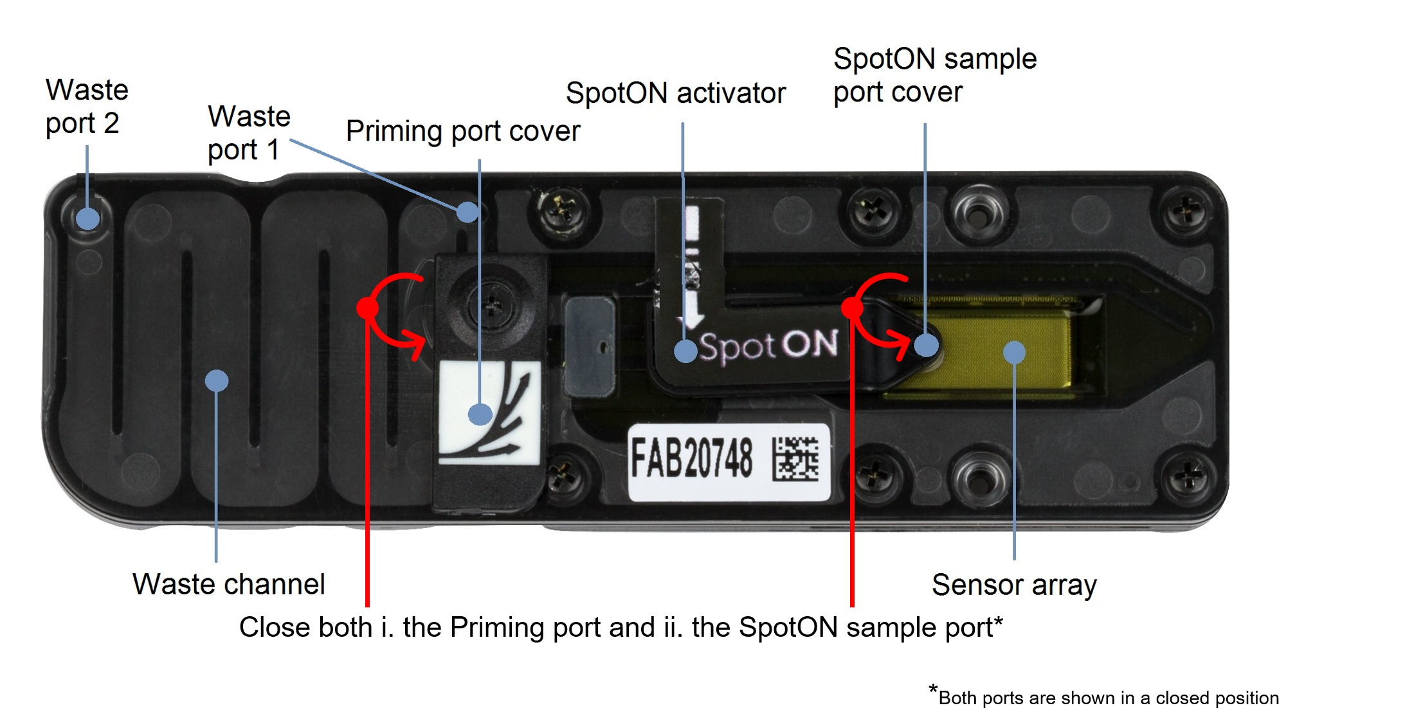
Washing Procedure
Vortex wash buffer A and storage buffer (S)
- Remove the flow cell from the sequencing device
- Open the priming port
- Slowly remove all of the waste from the waste port (2) and discard
- Make the wash buffer solution
  - 2 ul wash buffer A
  - 398 ul wash buffer B
- Slowly add 400 µl wash solution into priming port
- Incubate at room temperature for 10 minutes
- Add 500 µl storage buffer (S) into the priming port Store at 4-8°C
- QC the flow cell and record the pore numbers. QC again before use

