

APHL NGS Training
Noah Hull¹ and Eugene Yeboah¹
Association of Public Health Laboratories, Silver Spring, MD, USA¹
Instituto Nacional De SaÙde, Moçambique ¹

NGS Training (ONT Flow cell QC) (06-0-2022)

1. Start the MinKnow software from the desktop

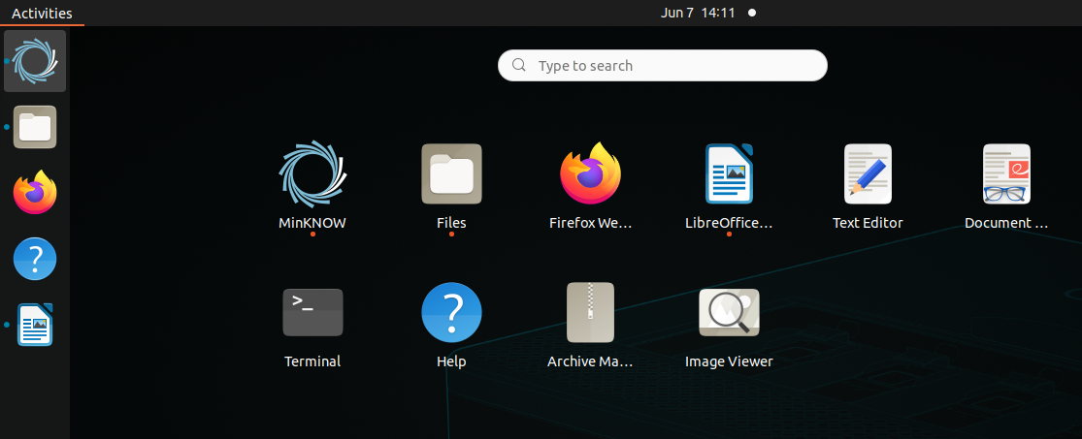
2. This will open the login page. Login if you have an Oxford Nanopore account, if not, choose “continue as guest”
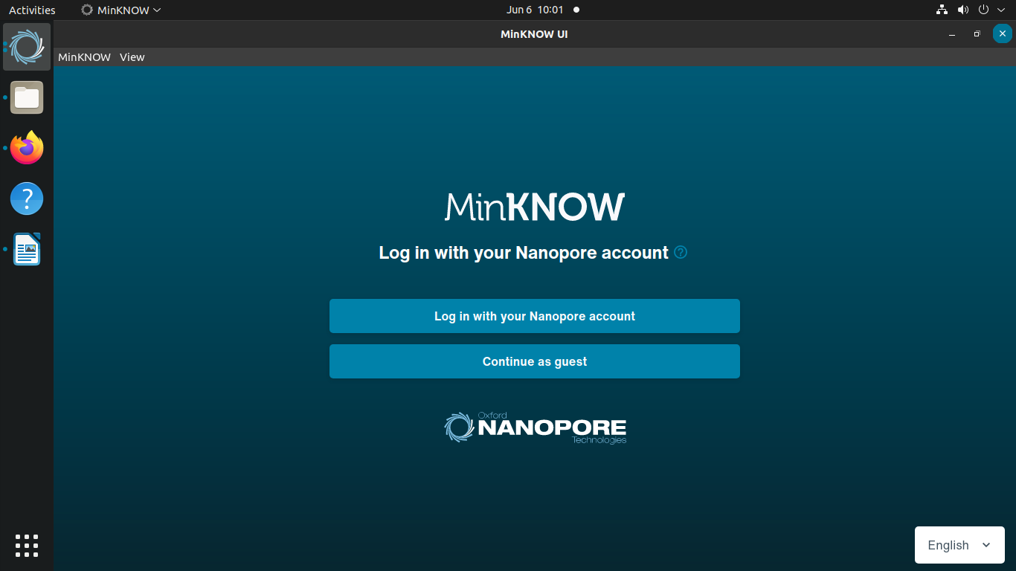

3. Click the “Start” on the left pane under My Device

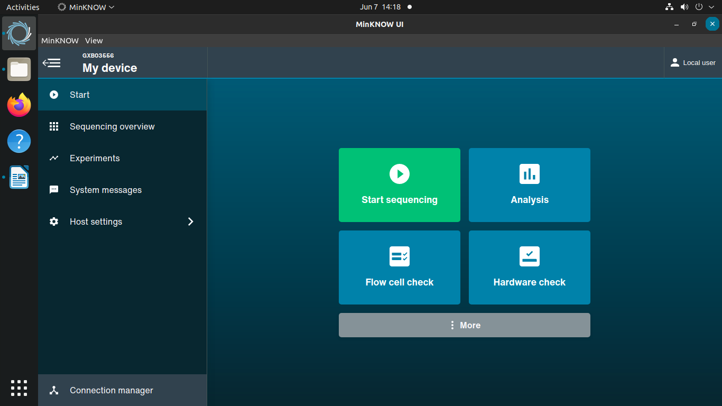

4. Select the “Flow cell check” in the center of the screen

5. “Flow cell check” screen will appear and show which lanes your flow cell is in (white shaded square).
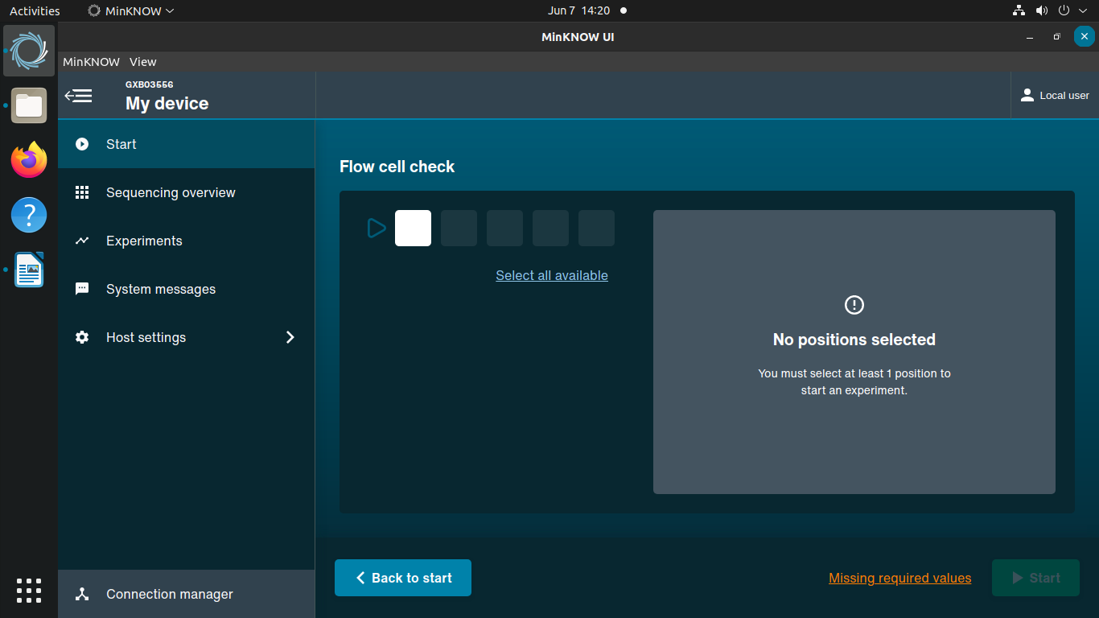

6. Select the lane or lanes that your flow cell is in (This will change the color of the square from white to blue). It will also show the position, flow cell id, and flow cell type
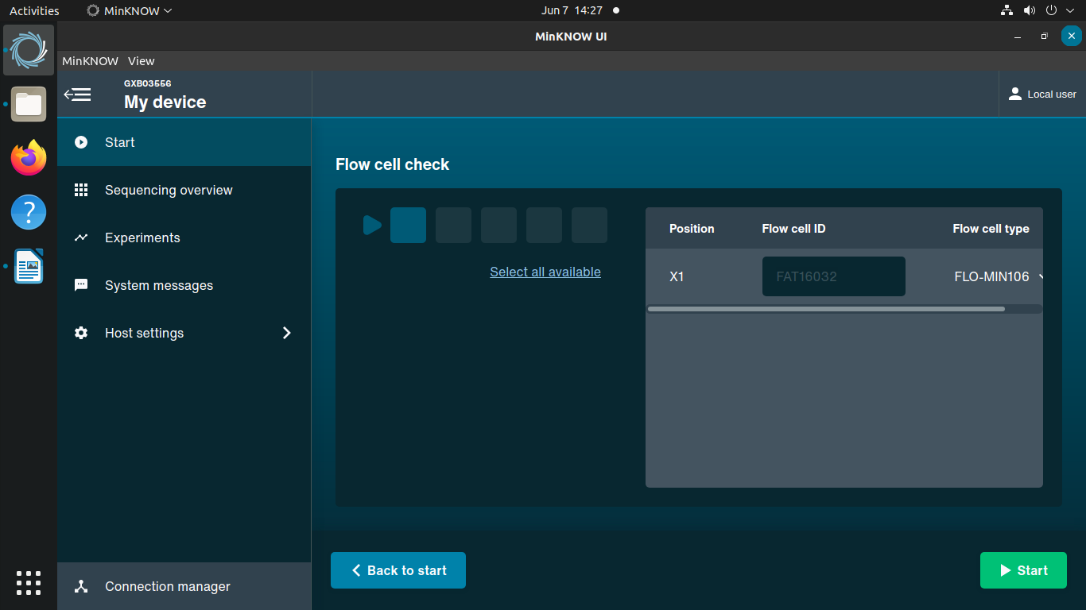

7. Press “Start” – green button on the lower right side (this will initiate a temperature check and then pore count)
