Response to the spread of Asian lineage avian influenza A(H7N9) virus into a previously unaffected country

Facilitator's Guide

Learning Objectives

After completing this case study, the participants from the country teams should be able to:

- Demonstrate effective strategies to establish human and animal surveillance to detect novel influenza A viruses.

- Demonstrate awareness of the important on-the-ground complexities and management issues during poultry outbreaks of avian influenza and investigations of human infections with novel influenza A viruses.
- Understand influenza virus-specific concepts that include: appropriate surveillance strategies in humans and animals, specimen collection and transport in humans, laboratory testing, epidemiologic risk factors, transmission mechanisms and contact tracing, control and prevention, isolation/quarantine concerns, treatment in humans, control measures in humans and animals, risk communication principles, laboratory diagnostic methods, the pros and cons of poultry vaccination, and ethical considerations.
- Gain an appreciation for important novel influenza A virus coordination efforts involving the interface between animal and human health sectors, key stakeholders such as the WHO, FAO, OIE, Ministries of Health, Ministries of Agriculture and communication processes between field staff, headquarters and relevant subject matter experts.

NOTE TO FACILITATOR:
- This case study is based on WHO, OIE and FAO guidance documents. Additional country-specific guidance documents can be found, for example, at www.cdc.gov. However, note that CDC guidance is intended for investigations in the United States.
- Remind the country team participants that, just as they would in a ‘real-life’ epidemic investigation, they should take notes on any and all details that they would likely need to conduct the investigation – such as pertinent epidemiological and clinical information, important dates and locations and relevant policies and procedures. Given the complexity of the story line, tell the participants that they will first create a case definition, and then start a line list on their own. Inform them they are already provided these line lists later in the case study but, as it is part of the simulation, they should not look or read ahead in their handouts.
- Encourage case study participants to use such details to assess epidemic curves, to suggest modes of transmission, to evaluate surveillance activities, and to make recommendations for prevention and control strategies.

- Please use the white board and markers to make notes/diagrams and to make a formal line list.

- It is recommended that facilitators decide how many and when BREAKS should be provided to the participants. It is suggested that at least two short – 10-15 minute breaks are given in the 6 hour session.

This is an "Open Book" case study. The following documents are referred to in this case study and some key documents may be printed and on the table during the case study for use by the country teams during discussions:

- WHO Global Epidemiological Surveillance Standards for Influenza. http://www.who.int/influenza/resources/documents/WHO_Epidemiological_Influenza_Surveillance_Standards_2014.pdf?ua=

- Interim WHO surveillance recommendations for human infection with avian influenza A(H7N9) virus http://www.who.int/influenza/human_animal_interface/influenza_h7n9/InterimSurveillanceRecH7N9_10May13.pdf?ua=1.

- Avian influenza A(H7N9) virus: Post-exposure antiviral chemoprophylaxis of close contacts of a patient with confirmed A(H7N9) virus infection and/or high risk poultry/environmental exposures. http://www.who.int/influenza/human_animal_interface/influenza_h7n9/13_January_2013_PEP_recs.pdf?ua=1

- WHO guidelines for investigation of human cases of avian influenza A(H5N1). http://www.who.int/csr/resources/publications/influenza/WHO_CDS_EPR_GIP_2006_4r1.pdf

- WHO Laboratory biorisk management for laboratories handling human specimens suspected or confirmed to contain avian influenza A(H7N9) virus causing human disease. Interim recommendations http://www.who.int/influenza/human_animal_interface/influenza_h7n9/InterimRecLaboratoryBioriskManagementH7N9_10May13.pdf

- CDC Influenza Specimen Collection Guide: https://www.cdc.gov/flu/pdf/freeresources/healthcare/flu-specimen-collection-guide.pdf

- Collecting, preserving and shipping specimens for the diagnosis of avian influenza A(H5N1) virus infection http://www.who.int/ihr/publications/CDS_EPR_ARO_2006_1.pdf?ua=1

- Guidance on regulations for the Transport of Infectious Substances 2017-2018 http://apps.who.int/iris/bitstream/10665/254788/1/WHO-WHE-CPI-2017.8-eng.pdf?ua=1

- FAO. Risk-based disease surveillance – A manual for veterinarians on the design and analysis of surveillance for demonstration of freedom from disease. http://www.fao.org/3/a-i4205e.pdf

- Addressing avian influenza A(H7N9) Surveillance guidelines for uninfected countries in Southeast Asia and South Asia http://www.fao.org/docrep/019/i3601e/i3601e.pdf
- OIE Animal Health Code AIV: http://www.oie.int/en/international-standard-setting/terrestrial-code/access-online/?htmfile=chapitre_avian_influenza_viruses.htm

- OIE Terrestrial Manual AIV: http://www.oie.int/fileadmin/Home/eng/Health_standards/tahm/2.03.04_AI.pdf

- OIE information document on avian influenza vaccination http://www.oie.int/downld/AVIAN%20INFLUENZA/Guidelines%20on%20AI%20vaccination.pdf

- Avian Influenza, Including Influenza A (H5N1), in Humans: WHO Interim Infection Control Guideline for Health Care Facilities http://www.wpro.who.int/emerging_diseases/documents/docs/AI_Inf_Control_Guide_10May2007.pdf

- USDA APHIS Avian Influenza, https://www.aphis.usda.gov/aphis/ourfocus/animalhealth/animal-disease-information/avian-influenza-disease

- International Health Regulations, 2nd edition. (2005)
http://www.who.int/ihr/publications/9789241580496/en/
- Rapid Risk Assessment of Acute Public Health Events. (2012)
http://www.who.int/csr/resources/publications/HSE_GAR_ARO_2012_1/en/
- Tool for influenza pandemic risk assessment (TIPRA) (2016)
http://apps.who.int/iris/bitstream/10665/250130/1/WHO-OHE-PED-GIP-2016.2-eng.pdf?ua=1

- WHO Western Pacific Regional Office Guide for Event-Based Surveillance: http://www.wpro.who.int/emerging_diseases/documents/docs/eventbasedsurv.pdf

- USDA APHIS HPAI Response Plan, HPAI Response Goals (Nov 2015); https://www.aphis.usda.gov/animal_health/emergency_management/downloads/hpai/responsegoals.pdf

- OFFLU Strategy document for surveillance and monitoring of influenzas in animals. May 2013. http://www.offlu.net/fileadmin/home/en/publications/pdf/OFFLUsurveillance.pdf

- http://www.oie.int/en/animal-health-in-the-world/web-portal-on-avian-influenza/early-detection-warning-diagnostic-confirmation/

- http://www.oie.int/en/animal-health-in-the-world/web-portal-on-avian-influenza/

The Field Investigation

Background

Tropica



Tropica is a lower-middle income country that contains 21 provinces and has a population of approximately 30 million people concentrated primarily in the central and southern coastal regions.

Geography: There is a tropical monsoon climate. Tropica is bordered by five other countries on the Western, Eastern and Northern borders, but faces the ocean on its southwestern border. Rural, transient migratory human populations regularly cross these borders and have prompted attempts at coordinated infectious disease surveillance activities between these countries. The 75% of the population that lives in rural areas does not have access to highways. Road conditions become very poor or impassible during the monsoon season, and in a recent health survey 30% of rural population respondents indicated that they would not bother taking sick family members to local hospitals but instead would go to their village healer.
Health problems: Malaria, cholera, plague, dengue, dysentery, watery diarrhea, and viral hepatitis are endemic with somewhat cyclic epidemic patterns. Tropica has had positive environmental samples for polio (though no human cases despite good surveillance) in the recent past so there are enhanced vaccination and surveillance efforts that will continue for at least three years. There is therefore a well-established grassroots polio eradication infrastructure. Village health volunteers are trained to report priority conditions (e.g. dengue and dengue hemorrhagic fever) to sub-district health officers and participate in mosquito larva control activities. Zika virus, and chikungunya have been also become increasing problems in the country.

Health care: The Tropica Ministry of Health is the focal point for planning, organization, financing, regulation and provision of health care for the population. Hospitals within the country include teaching hospitals, specialist hospitals, provincial hospitals, district hospitals, and local health stations/traditional clinics. Every district has a 16-50 bed hospital, with a district medical officer who has both public health (i.e., preventative) and curative responsibilities. Influenza antiviral medications not commonly used to treat influenza though the Ministry of Health maintains about 500 courses of oseltamivir for treatment in an emergency situation. There is some concern that they will expire soon.

There is an uneven geographical distribution of health care with poor quality of care and low service utilization in rural areas. However the leadership represented in the village health committees has connected those who traditionally lack adequate healthcare to health care providers, and has greatly facilitated public health campaigns associated with vaccine-preventable diseases, allowing them to be relatively successful both in terms of mass immunizations and disease surveillance.

Public Health laboratory testing capabilities for influenza viruses: Most district hospitals and traditional hospitals have very limited laboratory capacity. Some provincial and private hospitals have PCR capacity and receive external quality assurance checks from the central human (National) laboratory. Some of these hospitals can undertake rt-PCR analyses for seasonal influenza but do not have the materials to test for novel viruses. The national laboratory can perform real-time RT-PCR assays for seasonal influenza A/H1, A/H3 and B viruses as well as for avian influenza A/H5 and A/H7 viruses. They have passed recent external quality assessment tests using the WHO influenza reagent kits. The closest WHO regional reference laboratory for novel human influenza viruses is in the country to the Southeast of Tropica.

Animal Health laboratory testing capabilities for animal influenza viruses: The national/central veterinary laboratory has capabilities to detect low (LPAI) and high pathogenic avian influenza (HPAI) A viruses including A/H5 and A/H7. All samples must go to the national veterinary laboratory for real-time RT-PCR testing. Any additional testing is required to be submitted to the regional OIE Veterinary Reference Laboratory also in the country to the Southeast of Tropica.

Human surveillance and response infrastructure: There is a national notifiable disease surveillance system that requires a standard “minimum data set” from hospitals. The vital records system captures about 90% of urban and 50% of rural births. Acute flaccid paralysis (AFP) surveillance is conducted throughout the country although significant cold chain challenges remain in rural areas. There are six Influenza-Like-Illness (ILI) and Severe Acute Respiratory Illness (SARI) sentinel sites that collect specimens to be tested at the central human laboratory for influenza viruses. This influenza surveillance system is working well but is funded externally and a sustainability plan for this surveillance system is currently in preparation. Rapid response teams exist at the provincial and district levels are subject to staff turnover and there is variability in team quality and viability by district (some are outstanding and some quite unorganized).

Poultry surveillance and outbreaks: There is a network of local veterinary epidemiologists who have reported poultry die-offs to district, provincial, and national agricultural authorities in the past. This reporting remains in place but in the absence of poultry die-offs there is no active surveillance of healthy birds or environmental sampling currently in place. In the past there have been effective responses to highly pathogenic avian influenza A virus outbreaks in poultry, and there are sporadic outbreaks of HPAI A(H5N1) virus in domestic poultry. However no outbreaks have been reported during the current year. For smaller poultry die-offs there has been limited testing of birds, but during large outbreaks the central veterinary laboratory has received specimens and provided timely results. However, there have been sporadic local complaints in the media about low quality poultry with “poor egg production” in the southeastern region of Tropica. The farmers have been upset that they have been purchasing “lower quality imported chickens.” However on inspection many/most chickens appear healthy. Notwithstanding the Ministry of Agriculture has the desire to increase some surveillance for poultry die-offs, and even among healthy chickens when no die-offs are occurring, in this and other priority regions thought to be at risk along the value chain for avian influenza virus importation.

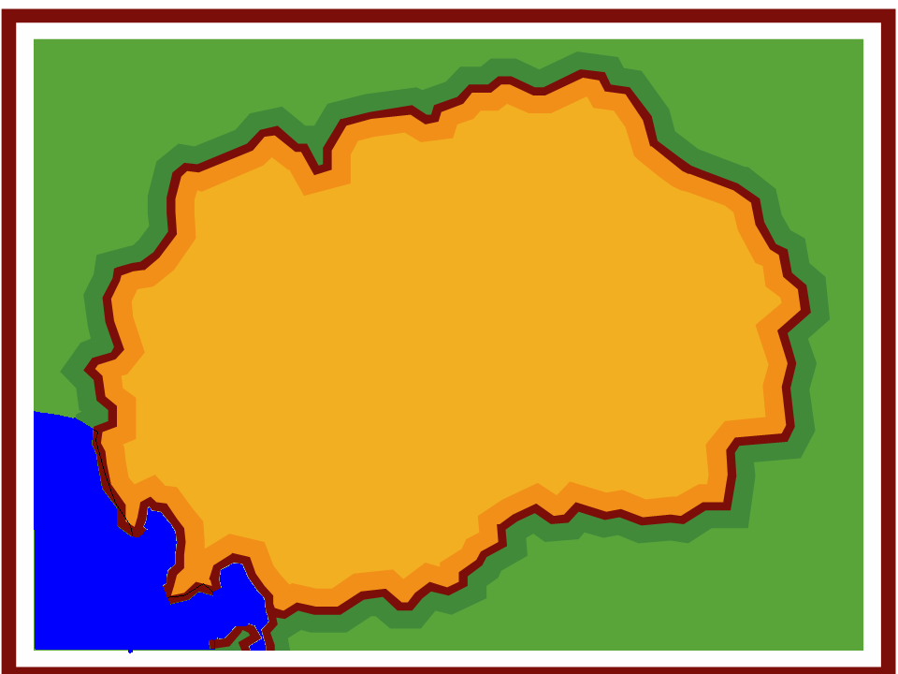
Tropica Provincial Hospitals
Palmtown
Pelu Jaghai
Dava Ghar

The month is June of the current year. You are an internationally renowned epidemiologist and you have been sent to Tropica with a similarly well-regarded veterinary colleague. The MOH and MOA have requested you to help them enhance human and poultry surveillance for novel influenza A viruses. Tropica already has six sentinel sites for influenza that systematically detect and collect specimens from outpatients and inpatients meeting the WHO ILI and SARI case definitions. However you have been asked to enhance broader surveillance in an attempt to improve the sensitivity and timeliness of detecting emerging respiratory pathogens, with a specific concern about influenza, in humans and animals. This is part of an effort to help Tropica meet its obligations under the International Health Regulations (2005) to meet needed core capacities for pandemic early warning surveillance.

An event-based reporting protocol exists linking the local village volunteers and health workers to District Health offices but this system is inconsistently used. There is an on-line application for smart phones and a hotline number used for reporting to local rapid response teams. With regard to poultry, a recent market (value) chain analysis (that identifies the main routes of poultry trade in Tropica) undertaken under the guidance of the UN Food and Agriculture Organization in Tropica suggested that there were five important regional distribution points for imported poultry. Some of these included the direct (and somewhat informal) transport of birds from a neighboring country known to have active circulation of several novel influenza A viruses [including avian influenza A(H7N9) virus] in local poultry populations. Some of these viruses are known to produce few or no signs and symptoms in infected poultry or wild birds (i.e., LPAI), yet they can cause severe disease in humans. This analysis also produced a set of live bird market network maps along poultry market chains with descriptions of how biosafety and security could be improved.

Question 1:
The Ministry of Agriculture approaches your veterinary colleague and asks: “From the perspective of poultry surveillance, what types of activities might be recommended? What level of risk is Tropica at for a virus such as avian influenza A(H7N9) in poultry?”

Question 1 Answer and Facilitator Notes:

Tropica could be considered a “high risk” country for potential (formal or informal) importation of domestic poultry infected with avian influenza A viruses. It shares a land border and has both formal and informal poultry trade networks with a country with active circulation of A(H7N9), as suggested by the value chain analysis. Formal trade occurs mostly with large commercial poultry farms, and informal trade occurs mostly with small backyard poultry farms along the border. A likelihood versus risk impact assessment undertaken per WHO recommendations suggests that there is a high likelihood of importation and that the impact of this virus on human and animal populations could be substantial.
  - It is impossible to monitor all possible entry points and market chain for virus spread so surveillance could focus on live poultry networks at major points of entry and/or at central distribution points and main live bird markets within the country.
  - If there are no ongoing poultry die-offs then active surveillance of avian influenza A viruses in well-appearing birds at regional distribution points is also an appropriate strategy, following FAO emergency risk-based surveillance guidance for high risk uninfected countries.
  - Rapid response training for potential outbreaks or detections of avian influenza A viruses such as A(H7N9) virus in domestic poultry should continue.
  - Retrospective surveillance of previously collected biological samples might also be possible.
  - Review current veterinary laboratory capabilities and resources, including equipment and reagents, and trained personnel.

- All of this should be accompanied by a refresher training and possible scenario exercise for multi-sectoral rapid response teams at the national and local levels. Training should include veterinary epidemiology and laboratory staff, as well as MOH liaison personnel.
- Multi-sectoral activities may include working together to enhance existing event-based surveillance for further poultry outbreaks or human illness cases and clusters through a training refresher of local veterinary contacts, village level volunteers, and health care workers.
- Sentinel surveillance for Influenza-like-illness and SARI in locations serving those who handle poultry on the value chain might also be considered.

Key Points:

- Countries that have not undertaken analyses to identify high risk poultry trade networks and market chains should begin to do so. This work should occur between Department of Agriculture/Livestock and FAO partners. Do the participants have the data to make targeted poultry surveillance decisions in their own countries? If not what is needed and how might they achieve that?

- Surveillance for poultry (and other animal) die-offs is important, as is active surveillance of avian influenza A viruses in well-appearing poultry when no poultry die-offs are occurring.

- Enhance surveillance for Acute Respiratory Illness (ARI), ILI, and SARI in areas serving those who work with poultry along the value chain may be considered.

- Preparedness and effective response begins with immediate multi-sectoral coordination and mutual collaboration for the essential contributions of human and animal health partners to these zoonotic disease situations.

- Early in an investigation, epidemiologists looking to enhance surveillance for novel influenza A virus infections in humans should be reminded to consult Ministry of Agriculture/Livestock and local FAO and OIE authorities to understand the avian influenza A virus situation in the country and in surrounding countries, including if similar market chain analyses and risk-based surveillance recommendations have been undertaken.

- Event-based surveillance can involve informal notification systems from the community as well as more structured event notifications from health care workers.

- The details of how to implement risk-based surveillance can be found in http://www.fao.org/docrep/019/i3608e/i3608e.pdf and http://www.fao.org/docrep/019/i3601e/i3601e.pdf and should also be available in one of the veterinary technical group training modules.

- Information about avian influenza prevention and control is available from the OIE Avian Influenza Portal: http://www.oie.int/en/animal-health-in-the-world/web-portal-on-avian-influenza/early-detection-warning-diagnostic-confirmation/.

9) Guide for Establishing Event-Based Surveillance from the WHO Western Pacific Regional
Office:
http://www.wpro.who.int/emerging_diseases/documents/docs/eventbasedsurv.pdf

New information available

The results of the market chain analysis suggest a specific importance of undertaking enhanced surveillance in Dava Ghar, Pelu Jaghai and several other local communities in the Southwestern part of Tropica. The Tropica Ministry of Agriculture has already been undertaking some focused testing of poultry for avian influenza A viruses in Dava Ghar and Pelu Jaghai. However you work with them during the next few days to thoughtfully expand surveillance into additional live poultry distribution areas thought to be at risk, such as main market chain distribution points or major live bird markets. Due to your combined efforts, active surveillance now, for the first time, includes healthy birds at locations when no poultry die-offs are occurring.

Question 2:
From the perspective of human surveillance, what types of triggers for investigation (within the existing EBS protocol of Tropica) might you provide refresher training on?
How might this differ for health care workers or community volunteers?

Question 2 Suggested Answer and Facilitator Notes:

With a particular (but not exclusive) focus on the areas suggested to be at high risk for importation of poultry infected with avian influenza A viruses, refresher training of local health workers might focus on important respiratory triggers for event reporting of possible signals of human infections with avian influenza A viruses that can cause severe illness in infected humans. There may also be non-respiratory triggers in an EBS. However for the purposes of this discussion respiratory triggers might include:
  - Clusters of two or more cases of severe respiratory illness or pneumonia in families, work places, or social networks.
  - Even a single severe respiratory illness in those who have traveled to locations where avian influenza A viruses or other pathogens of pandemic potential are known to be circulating in animals (e.g. http://www.who.int/influenza/human_animal_interface/influenza_h7n9/Data_Reports/en/ ).
  - An unexpected pattern of respiratory disease or pneumonia reported by an astute clinician such as a local increase in apparent mortality, a shift in the age group associated with severe illnesses, a particularly unusual death, or a noted change in the pattern of clinical presentation of severe respiratory illnesses.
  - Persistent changes noted in lack of treatment response or an increase in fatal outcomes of severe respiratory illness.
  - Even a single severe, unexplained respiratory illness occurring in a healthcare worker who cares for patients with respiratory disease.
  - Respiratory disease in humans that is associated with exposure to ill poultry.
  - Severe respiratory illness in persons occupationally exposed to chickens or pigs (e.g., sellers and distributors). NOTE: this can be healthy animals.
  - Reported agriculture/veterinary outbreaks of death or illness in fowl (e.g., poultry or ducks) or other animals (e.g., swine) that should trigger active surveillance in exposed humans.
  - Detection of pathogens of concern, (e.g. avian influenza A/H5 or A/H7) during routine poultry or animal surveillance.
  - Human cases of infection with an influenza A virus that cannot be subtyped or any identification of an influenza A virus not currently circulating in human populations.
  - Illness causing concern or panic among the local population.

This is just an example and event lists should be adapted to any local context. A list of events such as those above is fairly structured and may be appropriate for healthcare providers. However, community reporting would have to be much simpler with fewer possible events (e.g. person with severe respiratory disease who works with chickens, poultry die-offs, clusters of respiratory illness, or unusually severe illness etc.). Ask those in the group what they have done in their countries.

For village health volunteers, it may be helpful to use pictographics or other locally determined lay-person communication strategies to encourage reporting of unusually severe respiratory illness clusters; local animal die-offs or severe respiratory illness in humans who have been in contact with ill/dead poultry; those with occupational exposure to poultry; or who recently traveled to a neighboring country with avian influenza A viruses circulating among poultry

Key Points:
1) Work with the group to discuss event criteria appropriate for health care workers and community members. Ask participants what they do in their countries.

2) Any signal event must have a process of verification, and then risk assessment to assure that a response is proportional to an assessed risk. Countries can give examples of how this works in their locations. RRTs should receive this training.
3)The MOH and MOA should partner to train health care workers, community leaders, RRTs and local volunteers on appropriate events that should be reported to authorities and make sure that you reinforce existing mechanisms for reporting signal events.

- http://www.who.int/influenza/resources/documents/WHO
_Epidemiological_Influenza_Surveillance_Standards_2014.pdf?ua=1
- WHO Western Pacific Regional Office Guide for Event-Based Surveillance: http://www.wpro.who.int/emerging_diseases/documents/docs/eventbasedsurv.pdf

New information available

JULY 15:

It is now the morning of July 15, and you receive a call from a recently trained staff doctor at Dava Ghar hospital who notified the District Health Office that they have admitted two persons with “very severe” respiratory illness. The doctor is concerned that his patients may have “severe pneumonia, MERSCoV, or possibly a bird flu.”
Apparently, the two patients are related – a 65 year-old grandmother (JAM) and her ten-year old grandson (AAJ). The grandmother (JAM) resides in the same house as her husband (AWM), and both live in a house near the grandson’s house in a small mountain village in the province. This village is almost 60 km away from the hospital.
The child’s father was away in a nearby city during the week of illness onset and the grandmother (JAM), who is chronically in ill-health, became a caretaker of the child on July 11th along with the mother (DBJ) who lives with the child. The grandfather (AWM) also helped despite his elderly status and chronic heart illness. The child (AAJ) was brought to the hospital by his family two days ago and presented with fever, cough, diarrhea and shortness of breath.
The only pertinent history you are able to obtain regarding potential exposures is that the child visited a live bird market (called the “Murg Market”) with his mother (DBJ) and uncle (SJO) in Pelu Jaghai province (where his friends and relatives live) on July 8th.

The Director of Epidemiology of the MOH, following communication with the Ministry of Agriculture has determined that the Murg market was a central distribution node for poultry and determined to be at some risk for the spread of avian influenza. Poultry specimens were collected as part of the newly enhanced risk-based surveillance system about 20 days earlier and sent to the central agricultural laboratory for testing. You obtain the history that the boy played with chickens and a small dog, helped pour water into a chicken defeathering machine, and played with chickens at the live-animal market event with a friend. Shortly after hospital admission yesterday, the child’s condition rapidly declined because of worsening respiratory distress. He was started on ceftriaxone for treatment of suspected bacterial pneumonia. The mother (DBJ) is asymptomatic. The grandfather also denies any symptoms. The grandmother reports that her ongoing respiratory condition suddenly worsened on about July 9th. There are rumors that there are additional sick persons in a village in the adjacent nearby province, Pelu Jaghai.

Later on July 15th, after a call made by the MOH to the central animal laboratory, you learn that several specimens from the Murg market, including those from the group of chickens AAJ was playing with, had already tested positive for avian influenza A(H7N9) virus. Later a senior official abruptly added that “final confirmation has not occurred” and testing has been under way for the past 4 days.

Question 3:
Is it possible that opportunities have already been missed to prevent possible human exposures to avian influenza A(H7N9) virus? Why?

Question 3 Suggested Answer and Facilitator Notes:

Yes. Testing of chickens has been underway at the Murg Market which was known to be a place receiving commercially imported poultry, and at risk for avian influenza. A presumptive positive result has occurred, yet no internal communication occurred between the MOA and MOH for this notification. This could have initiated human contact tracing and possibly reduced further human exposure. There of course may be economic disincentives for reporting, but internally government agencies must stay coordinated to stop this problem from getting larger. If any suspicion of avian influenza A(H7N9) virus infection, let alone a positive test, is not shared between sectors quickly it is possible there will be many more exposed people to track in an urgent manner if A(H7N9) virus infection is finally confirmed in the child (AAJ). In addition to increasing the risk of a larger outbreak, this can have enormous implications for the amount of field investigation, treatment and laboratory resources required in a response, and the economic costs of the outbreak.
Routine surveillance data from healthy or sick chickens should be shared between the MOA and the MOH under the auspices of ongoing national preparedness coordination.
Conversely, the MOH should be sharing updates on humans under investigation as it is possible that they could serve as sentinels for viruses circulating “silently” or openly in animal populations.

Ask Participants:

1) How would this work in your countries?
2) What specific mechanisms exist to ensure this type of cross communication may occur?
3) Is this coordination covered in your avian or pandemic influenza preparedness plans?
4) What barriers exist to this?

To be conservative and to protect the community the Director of Epidemiology decides to treat this as an investigation of a case of laboratory-confirmed avian influenza A(H7N9) virus infection in poultry.
Further clinical history, obtained over the phone, reveals that the child (AAJ) became ill on July 10th and was admitted to the hospital almost 4 days later. By the 2nd day of illness (July 11th) the child’s grandparents started assisting the mother with care of the child. The family was very distressed and kept close vigil taking care of the child for almost 48 hours in the village starting on July 11th. By the 3rd day, the child was deteriorating and also had a documented temperature of 38.7 °C (101.7° F). The family decided to bring him to the Dava Ghar hospital, despite the long distance. The child arrived in unstable condition late at night on the 13th (admitted in the early morning of the 14th). A nasal swab collected upon admission and tested for only seasonal influenza at the provincial laboratory tested positive for influenza A virus but negative for Influenza A(H1), A(H3) and influenza B. The chest X-ray on admission is shown.

Child (AAJ) CXR on Admission (10 year old boy)
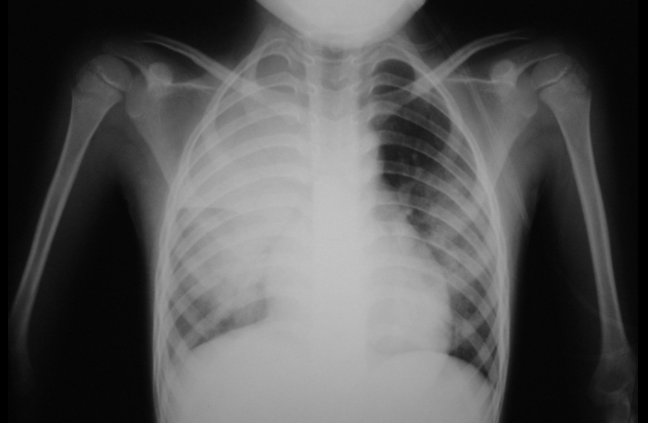

AAJ’s illness had rapidly progressed requiring respiratory support and he was placed on a mechanical ventilator. His status was deemed critical with this life-threatening pneumonia. You learn that the grandmother (JAM) has had long term chronic cough and dyspnea for the past 18 months. She also has had a temperature of 38 degrees Celsius since July 9th. Her condition was not improving but also had not worsened. She wanted to be near the child, and given her frail condition and ongoing respiratory symptoms a decision was taken to also admit her to the hospital for monitoring. The grandmother repeatedly denied any visits to the Murg market or contact with poultry.

On the phone the doctor said that no more clinical specimens were available for further testing as the provincial laboratory only had minimal nucleic acid available from the specimen for testing. The doctor said he would talk to the family about collecting more specimens from both patients for laboratory testing though he seemed very focused only on clinical management questions. It is the monsoon season and you then lost phone contact and could not continue that conversation despite your best efforts.

Question 4:

You and your team realize the need to develop case definitions for this outbreak investigation. What are the critical components of a case definition?

Question 4 Suggested Answer and Facilitator Notes:

- A case definition should be specific to the outbreak under investigation.

- A case definition includes criteria for person, place, time, and clinical features.
  - Person: includes key characteristics of affected persons, such as age, sex, race, occupation and exclusion criteria
  - Place: typically describes a specific geographic location or facility associated with the outbreak
  - Time: is used to delineate a period of time associated with illness onset for the cases under investigation
  - Clinical information: is based on simple and objective measures

  - Laboratory testing: This will often define if a case is a confirmed case

- The elements of defining person include key characteristics of affected persons. For example, a case definition might specify poultry workers or persons exposed to sick pigs at a livestock show. The elements of defining place typically describes a specific geographic location or facility or institution associated with the outbreak. Limiting the time period enables exclusion of similar illnesses which are unrelated to the outbreak of interest. Clinical criteria should be based on simple and objective measurements.
- There may be more than one case definition in an outbreak investigation. For example, there may be different case definitions for suspect, probable, and confirmed cases. In this circumstance, laboratory results are essential. Case definitions may change as investigation progresses
  - Early in investigation: the case definition may be broad
  - Later in investigation: the case definition may be refined to be more specific to person, place, time, or clinical information that has been gained
- There will be separate case definitions for human events and animal events

Question 5:

Have your team develop a suspect, probable and confirmed case definition for this outbreak. However after the discussion, for the sake of standardizations, please use the case definition below for further case characterizations. Note that case definitions may always be adapted to the local context to confirm any case of novel influenza A(H7N9) in humans.

Question 5 Suggested Answer and Facilitator Notes:

Confirmed case: A person with influenza A(H7N9) virus infection in a person that is laboratory confirmed using methods in accordance with WHO-approved protocols for detection of avian influenza A(H7N9) virus (e.g. rt-PCR and/or viral culture).
Probable case: A person with acute onset or worsening of fever or respiratory illness during past two weeks meeting exposure criteria (below) and for whom laboratory results were A/unsubtypeable (influenza A positive, but influenza A(H1) negative and influenza A(H3) negative by RT-PCR) and influenza B negative.
Suspect case: A person with acute onset or worsening of fever or respiratory illness meeting exposure criteria* and for whom confirmatory laboratory test results are not known or pending.

Exposure Criteria:
- Recent exposure (within 14 days prior to illness onset) to a market where animal/poultry illness has been reported or avian influenza A(H7N9) virus has been detected
- Recent travel (within 14 days of illness onset) to areas where humans have become infected with avian influenza A(H7N9) virus or to areas where avian influenza A(H7N9) viruses are known to be circulating in animals (poultry)
- Persons who have had recent close contact* (within 14 days prior to illness onset) with confirmed, probable, or suspected cases of human infection with avian influenza A(H7N9) virus
- Unprotected exposure prior to onset of symptoms to live avian influenza A(H7N9) virus in a laboratory
* Close contact may be regarded as coming within about 3 feet (1 metre) of a confirmed, probable, or suspected case while the case was ill (beginning 1 day prior to illness onset and continuing until resolution of illness).
- This includes healthcare personnel providing care for a confirmed case without appropriate PPE use, family members of a confirmed case, persons who lived with or stayed overnight with a confirmed or suspected case, and others who have had similar close physical contact.

Question 6: Using the case definition above how would you classify AAJ (the 10 year old boy) and JAM (the 65 year old grandmother)?

Question 6 Suggested Answer and Facilitator Notes:

10 year old boy (AAJ):
Clinical: Fever, cough, diarrhea and shortness of breath (acute onset of respiratory illness)
Epidemiological: Exposure to live-market on July 8th and to specific groups of chickens where avian influenza A(H7N9) virus infections were confirmed in the previous 10 days.
Laboratory: Influenza A, not subtypable, no further specimens available.

The acute respiratory illness combined with exposure to what may be poultry with laboratory-confirmed influenza A(H7N9) at the Murg market, and an “A not subtypable” test result give AAJ a “probable A(H7N9) case” designation.

65 year old grandmother (JAM):
Clinical: Chronic cough and shortness of breath for last 18 months that has not worsened. She has a fever that started prior to exposure to AAJ. However there was a recent decision to hospitalize her.
Epidemiological: Close contact with a person who is a probable A(H7N9) case. Close contact with probable case occurred 2 days after “onset of symptoms.”
Laboratory: No laboratory specimens collected yet.

The grandmother’s classification is intentionally challenging. She does not technically meet any of the case definitions for influenza A(H7N9) as she does not have an acute illness, did not visit the live bird-animal market and was in fact symptomatic with respiratory complaints prior to when her grandchild had onset of illness for the first time. However, she has been exposed to a probable case of influenza A(H7N9) and there was a decision to hospitalize her. She should be monitored for worsening of symptoms which would then make her a suspected case. She should also be tested for seasonal and novel influenza (to be discussed below).

Key Points:

- Make sure participants understand the case classification criteria.

- Remind participants that these criteria are used for surveillance purposes but not clinical decision-making.

There may be a debate about the case status of the grandmother (suspected Ccse or not?). This is fine as things often don’t work “cleanly” in real world settings.

Question 7:

What are appropriate laboratory tests for the confirmation of influenza A(H7N9) virus in humans and poultry in this setting? What minimum capacities are needed to establish RT-PCR testing in Dava Ghar?

Question 7 Suggested Answer and Facilitator Notes:
Laboratory tests for confirmation:
Real-Time Reverse-Transcription Polymerase Chain Reaction can be performed using WHO RT-PCR assays for humans and OIE Reference Laboratory network RT-PCR assays for poultry.

Viral culture under appropriate safety (BSL-3) conditions would be required to grow the virus in order to develop vaccine candidates.

Antigenic testing methods (virus isolation, RT-PCR, and sequencing) are essential to characterize novel or avian influenza A virus infections in human and poultry populations. When undertaking serological surveillance in animals full consideration must be given to the potential for exposure to other avian influenza A viruses through vaccination or natural infection.

International public health laboratories for humans can order the A(H7N9) virus testing reagents and the positive controls from the CDC and other WHO Collaborating Centers. To order the A(H7N9) virus testing reagents, NICs and national public health laboratories are encouraged to register with the IRR if they have not done so already, as web ordering will expedite the distribution process. CDCFluorder@cdc.gov will remain open to assist those laboratories with extenuating circumstances; however, the IRR web page is the preferred method for ordering. Similarly reagents should be obtained from laboratories in the OIE reference laboratory network.

Minimum Capacities for PCR testing:

For a laboratory to be established for human or animal testing in Dava Ghar it would be essential that it meets the standards set for laboratory biorisk management for laboratories handling specimens suspected or confirmed to contain avian influenza A(H7N9) virus causing human disease. It would also need to pass proficiency panels received from international reference laboratories.

A safe laboratory for RT-PCR would need to have SOPs in place for the following systems:

- Risk assessments and biorisk management systems
- Biological agents and toxins inventories
- General safety and appropriate PPE
- Trained and competent personnel using good microbiological techniques
- Emergency response and accident investigation plans
- Adequate physical facilities and maintenance plans
- Appropriate decontamination and sterilization procedures
- Adequate transport supplies and infrastructure
- Adequate security

Virus isolation on clinical specimens should be performed only in BSL-3 laboratories capable of meeting the following additional essential containment requirements:
- A controlled ventilation system maintains directional airflow into the laboratory room.
- Exhaust air from the laboratory room is not recirculated to other areas within the building. Air should be HEPA filtered, if reconditioned and recirculated within the laboratory. When exhaust air from the laboratory is discharged to the outdoors, it must be dispersed away from occupied buildings and air intakes. This air may be discharged through HEPA filters.
- Laboratory workers should wear protective equipment, including disposable gloves, solid front or wrap-around gowns, scrub suits or coveralls with sleeves that fully cover the forearms, head coverings, shoe covers or dedicated shoes, eye protection (goggles or face shields), and respiratory protection (fit-tested particulate respirator, e.g., EU FFP2, US NIOSH-certified N95 or equivalent, or higher protection), because of the risk of aerosol or droplet exposure.
- A dedicated hand-wash sink should be available in the laboratory.
- All materials transported within and between laboratories should be placed in secondary containers to minimize the potential for breakage or a spill. An example includes transfer of materials from the biological safety cabinet to an incubator and vice versa. Specimens leaving the biosafety cabinet should be surface decontaminated.

Key Points:
- Have participants articulate where they obtain their reagents and supplies for human and animal testing. Have them describe their EQA processes.
- In the hypothetical situation, resources should be prioritized to ensure timely transport of specimens from Dava Ghar to the central public health and animal health laboratories for testing.
- In this case, if a human specimen turns out to be RT-PCR positive for novel influenza A(H7N9) virus, the specimens should be shared with a WHO collaborating center for safe virus isolation and additional genetic testing to determine the characteristics of the virus.

Helpful Link http://www.who.int/influenza/human_animal_interface/influenza_h7n9/InterimRecLaboratoryBioriskManagementH7N9_10May13.pdf

Question 8:

You realize that you will likely need to start creating a line list for your investigation. What categories of variables might be included?

Question 8 Suggested Answer and Facilitator Notes:

- Patient ID and demographic information
- Date of report
- Date of exposure
- Date of symptom onset
- Dates of health care seeking
- Pre-existing medical illnesses and co-morbid conditions
- Clinical signs and symptoms
- Place of current residence and travel
- Occupation and exposure history
- Treatment with neuraminidase inhibitors
- Date/time of treatment with neuraminidase inhibitors
- Current clinical status
- Laboratory specimens collected
- Laboratory test results
Key Points:

1) Participants should be encouraged to brainstorm about as many useful data variables that they think should be captured in this respiratory outbreak investigation as possible.
2) Keep in mind that additional variables may be collected as part of a case investigation and only a critical subset of these may be included on a line list.

3)Make the skeleton of a line list on the white board (see shell blank line list and then the July 15th mid-day line-list). Remind the participants that for purposes of this case study and time constraints there will be a finite small number of specific fields for which information on the line lists will be provided to them as the case investigation storyline unfolds. When they update the line list as the story continues (below), subsequent line list updates will be provided to them.

Note to facilitator:
You will be given WHO suggested templates for a case report form that you should hand out after the discussion. One example is below. Other templates are found at http://www.who.int/influenza/human_animal_interface/influenza_h7n9/InterimSurveillanceRecH7N9_10May13.pdf?ua=1.

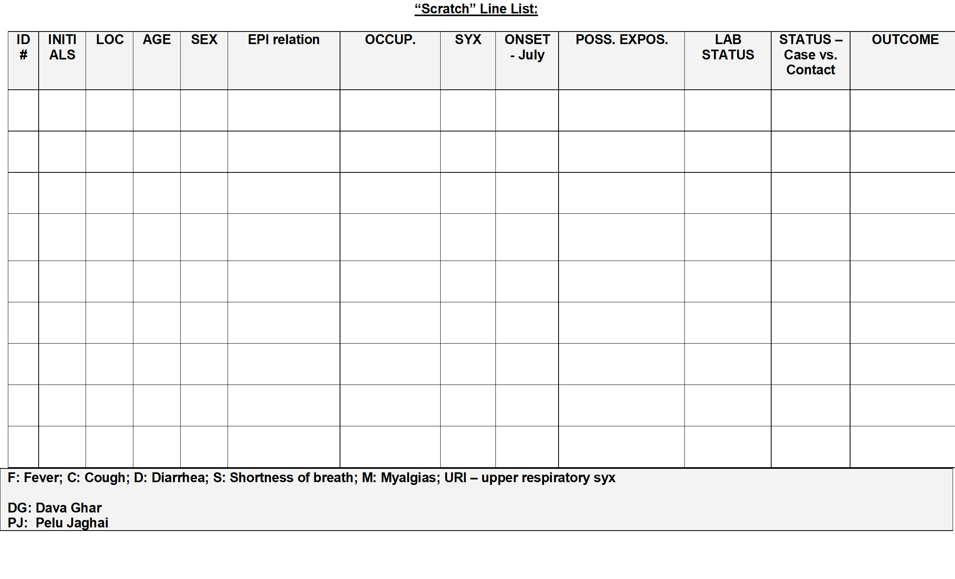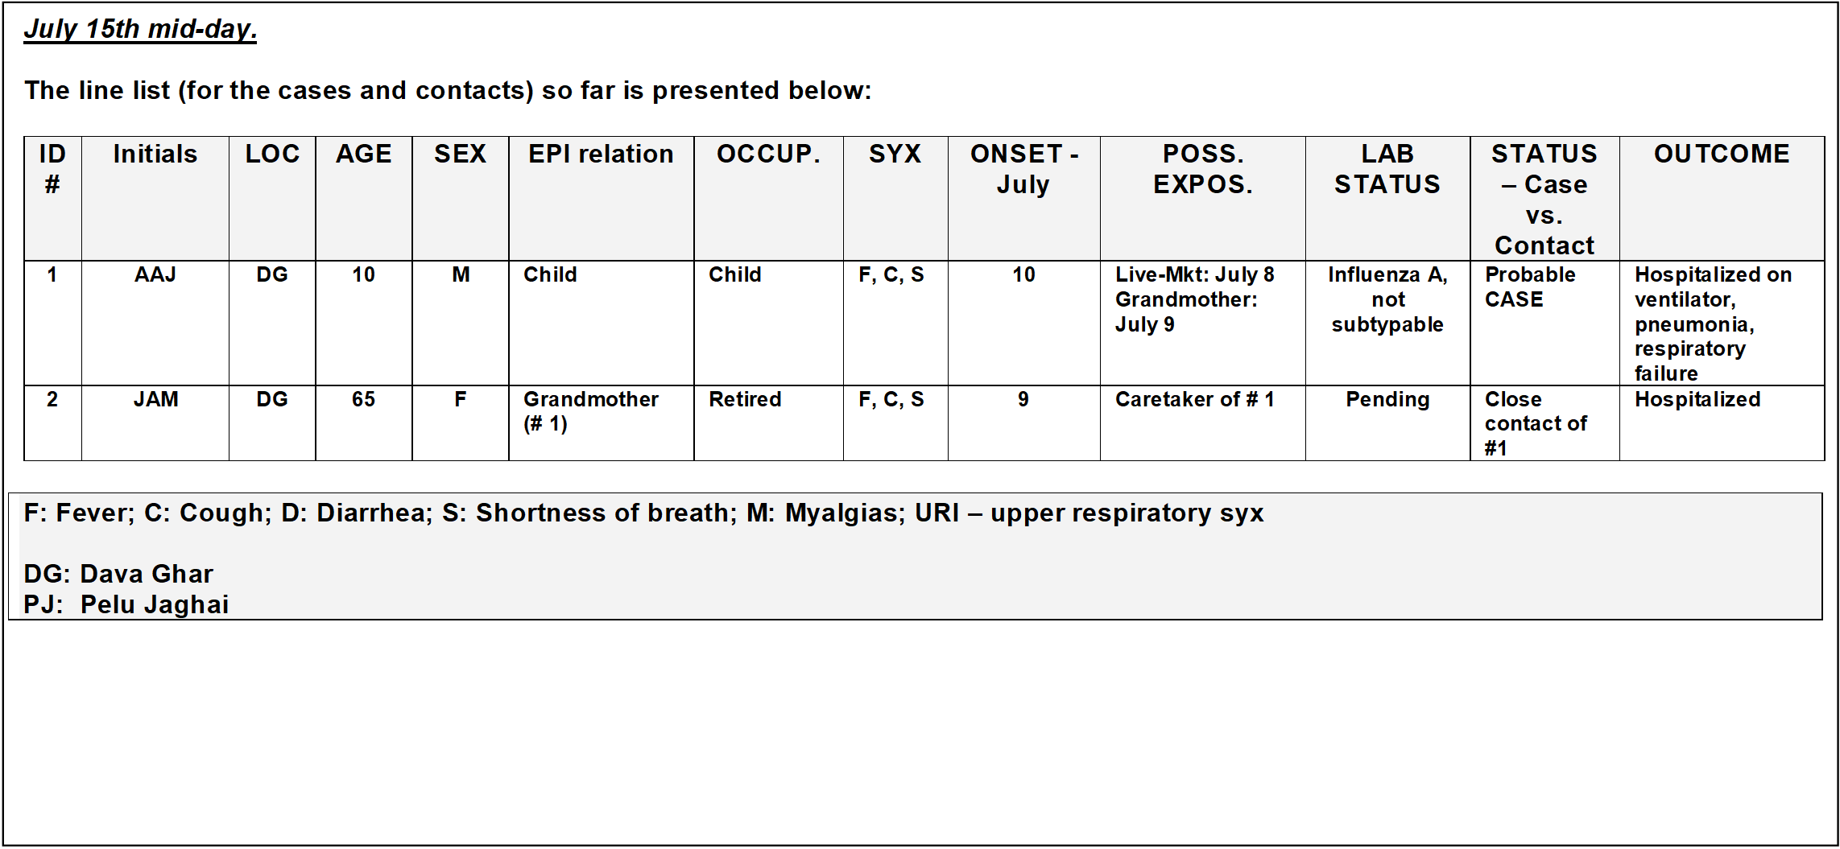

Question 9:

What criteria should be used to define who is a close contact of this probable
case? Is JAM a close contact? What testing is needed for JAM?

Question 9 Suggested Answer and Facilitator Notes:

- Contact tracing efforts should focus on persons who had unprotected close contact (i.e., were not wearing recommended PPE) with the patient. This includes anyone who provided care for the patient, including a health care worker or family member, or who had other similarly close physical contact and anyone who stayed at the same place (e.g. lived with, visited) as a probable or confirmed case while the case was symptomatic.

- While JAM doesn’t clearly meet the case definition due to a pre-existing non-acute condition she is of obvious concern and some signs and symptoms could be masked within her underlying illness. In this case AAJ was a probable case that would have required testing further. JAM is a close contact of AAJ. The lack of additional specimens from AAJ, JAM’s current respiratory illness that make mask influenza signs/symptoms, and the recent decision to hospitalize her, suggests that it would be prudent to collect a combined OP and NP swab for RT-PCR testing from her.

- Early in the outbreak it is important to make sure any exposed persons with respiratory symptoms receive laboratory testing. These types of uncertainties often exist in “real world” outbreak settings and it is prudent to make sure you are doing all that you can to collect and test specimens that will help you determine if a novel influenza A virus is infecting humans.

Links:
http://www.who.int/influenza/human_animal_interface/influenza_h7n9/13_January_2013_PEP_recs.pdf?ua=1

http://www.who.int/influenza/human_animal_interface/influenza_h7n9/InterimSurveillanceRecH7N9_10May13.pdf?ua=1

Question 10:
If limited quantities of neuraminidase inhibitor antiviral drugs are available, should AAJ and JAM be given antiviral prophylaxis or treatment? Should family members of AAJ be given antiviral chemoprophylaxis? How about health care workers who treated AAJ?

Question 10 Suggested Answer and Facilitator Notes:

WHO recommendations for antiviral treatment:
The WHO continues to recommend antiviral treatment with a neuraminidase inhibitor drug as soon as possible for patients with suspected, probable or confirmed A(H7N9) virus infection; antiviral treatment should not be delayed while A(H7N9) laboratory test results are pending.
Asymptomatic persons who have had unprotected close contact with a patient with confirmed A(H7N9) virus infection or exposure to poultry, live poultry market or environments contaminated by A(H7N9) virus should be monitored for at least 7 days after the last known exposure. If fever or any respiratory symptom develops, empiric antiviral treatment doses should be started immediately, and respiratory specimens should be collected for A(H7N9) virus testing.
WHO recommendations for antiviral prophylaxis:
The WHO does not recommend post-exposure antiviral chemoprophylaxis for influenza A(H7N9) virus infection. However, for some asymptomatic persons in which a substantial unprotected or prolonged exposure to an ill patient with A(H7N9) virus infection has occurred, initiation of empiric post-exposure antiviral treatment doses (e.g., oseltamivir 75 mg orally twice daily for 5 days) may be considered. This is likely to be limited to healthcare or other settings involving substantial exposure of those at higher risk for complications from influenza virus infection, including, but not limited to, patients with severe immunosuppression, neonates and infants, pregnant and early post-partum women, elderly adults, persons with chronic co-morbidities and, other highly vulnerable patients; or, unprotected healthcare workers, especially those involved in aerosol-generating procedures.
- Sampling should not delay the initiation of the treatment dosages using neuraminidase inhibitors.
Key Points:

Facilitators should refer to hard copies of the salient WHO guidance documents and discuss them in detail.
1) AAJ and JAM should be given antiviral treatment doses of oseltamivir.
2) Nobody should be given antiviral chemoprophylaxis - especially persons who had close contact with AAJ or JAM more than 2 days ago since they might be already infected and the once daily antiviral chemoprophylaxis dose would be less than the treatment dosing (twice daily). In addition under-treatment dosing might facilitate emergence of antiviral resistance to oseltamivir. However, asymptomatic family members with high-risk chronic medical conditions could be considered for oseltamivir treatment doses.
4) Health care workers should be considered individually for their need for antiviral treatment based on their own risk factors, whether they were close contacts, and if they implemented transmission-based precautions as recommended.
5) Exposed persons should be monitored for at least 7 days though in this case a more conservative approach of longer monitoring (e.g., up to 14 days) could be considered.
6) Prompt initiation of antiviral treatment doses using neuraminidase inhibitors should occur in any exposed persons who becomes symptomatic, without waiting for confirmatory testing.

Question 11:

If there are not enough antiviral resources to provide antiviral treatment to all close contacts, how should you prioritize resources?

Question 11 Suggested Answer and Facilitator Notes:

- Symptomatic individuals with exposure to influenza A(H7N9) virus should receive prompt antiviral treatment with a neuraminidase inhibitor.
- Empiric antiviral treatment with a neuraminidase inhibitors can be considered for the following groups:
  - Asymptomatic persons with underlying medical conditions (e.g., immune system compromise) with recent exposure to poultry, live poultry market or environments contaminated by A(H7N9) virus;
  - Asymptomatic persons with underlying medical conditions (e.g., immune system compromise) or unprotected healthcare workers (especially those involved in aerosol generating procedures) who have recently had close unprotected exposure to a patient with confirmed A(H7N9) virus infection.
Key Points:
1) To the extent possible, plans regarding the distribution of scarce resources, such as access to antiviral treatment, should be specified in advance and government officials should engage stakeholders in determining what criteria should be used to make resource allocation decisions.

2) There should be a commitment to transparency throughout the process and the reasoning behind choices should be fully articulated (in language appropriate for the intended audience). Ask participants if they have plans in place for antiviral prioritization?

- This also highlights the importance of timely sharing of information between public health and animal health authorities to prevent further exposures.

New information available

JULY 16th:

The hospital is a 5 hour car ride away and your rapid response team doesn’t arrive at the Dava Ghar hospital until the next day (July 16th). You go directly to the hospital to begin the investigation. You are told the following:

The boy’s (AAJ) admission vital signs had been as follows: a temperature of 39○C, heart rate of 120, tachypnea at 30 breaths/minute with a blood pressure (BP) of 90/60. His oxygen saturation on room air was 88%; he was subsequently intubated on July 14th and placed on mechanical ventilation. He became hypotensive and went into renal failure. Despite aggressive measures, he died on the morning of the 16th, prior to your arrival.

You and your team are quite frustrated when you are told that the staff did not want to collect additional nasal or throat swab or endotracheal aspirate specimens because they felt the child’s condition was “too severe” and this would hurt him. The parents were frustrated and didn’t want more testing “just treatment”. Cultural practices and the family’s wishes precluded any further post-mortem evaluation. The child has been cremated quickly and the reasons for this are not clear though some mentioned fear in the community.

Facilitator reminder: make sure the participants are taking notes.

Question 12:

Had your team arrived earlier, what might you have said to increase the chances that proper additional specimens had been collected from the boy (AAJ) for influenza A(H7N9) virus testing? What could you have done after the boy had already died in order to learn more about his infection?

Question 12 Suggested Answer and Facilitator Notes:

Explain to the doctor and family the concern about avian influenza A(H7N9) virus in Tropica and the importance of correctly diagnosing novel influenza A virus infection in people in order to contain further virus spread. This could prevent others from getting sick. The doctor might have explained to the mother that the laboratory tests might help determine the best way to treat persons infected with this illness. The doctor should find a way to work through cultural or religious concerns and emphasize that collecting these specimens provides no added risk to the child. This highlights the importance of local refresher preparedness training for clinicians and other health care providers at regular intervals.

Considering that AAJ had died, it is possible there could have been blood or other respiratory specimens that could have been collected during routine car and now tested for influenza. Post-mortem specimen collection for A(H7N9) virus testing (while wearing recommended PPE) might also have been an option to be considered by the doctor. Complete diagnostic autopsy, the gold standard method to determine the cause of death, may or may not have been a possibility due to limited human resources and cultural and/or religious backgrounds that negatively influence acceptance and consent. However increasingly, minimally invasive postmortem sampling procedures, such as needle biopsies of the lung or other organs, have been validated in different settings and may provide reliable etiological information for cause of death.

Key Points:

- Explain to the doctor and family the concern about avian influenza A(H7N9) virus in Tropica and the importance of correctly diagnosing novel influenza A virus infection in people in order to contain virus spread.
- Post-mortem specimen collection for A(H7N9) virus testing might also have been an option to be considered by the doctor.

New information available

The grandmother was verified to be a caretaker of the child (AAJ) and presented to the hospital in moderate respiratory distress. Her vital signs were as follows: temperature of 38.5○C, a respiratory rate of 28 breaths/minute, BP of 160/95 and an oxygen saturation on room air of 90%. The grandmother’s initial laboratory findings included high lymphocyte / leukocyte counts. She is not intubated. You and your team recognize that you will need to quickly determine whether you’re dealing with A(H7N9) virus infection or some other pathogen. You are justifiably concerned that this may in fact represent an outbreak related to a novel influenza A virus with pandemic potential. You decide to send biological samples from the grandmother to the national laboratory for testing.

Question 13:

What specimens need to be collected from the grandmother?

Question 13 Suggested Answer and Facilitator Notes:

In an ambulatory patient such as the grandmother in this case, combined oropharyngeal and nasopharyngeal swabs should be obtained to optimize detection of a novel influenza A virus.

In a patient with signs of lower respiratory tract disease such as pneumonia, a lower respiratory tract specimen should also be sent for testing (in addition to a nasopharyngeal swab), if one is available (see below for methods of obtaining a lower respiratory tract specimen). This is because most avian influenza A viruses are thought to possess characteristics that make them more likely than seasonal influenza viruses to bind and replicate in the lower respiratory tract so virus may be present in higher quantities in a lower respiratory tract specimen than in upper respiratory tract specimens.

Options for collection of lower respiratory tract specimens include obtaining an endotracheal aspirate from intubated patients (which could have been done for AAJ) or obtaining bronchioalveolar lavage (BAL) or pleural fluid specimens if these specimens are being collected for normal care.

Key Points: Do not delay initiating antiviral therapy in order to obtain diagnostic specimens.

1) Combined oropharyngeal and nasopharyngeal swabs should be obtained from ambulatory patients to optimize detection of novel influenza A viruses.

2) To improve the ability to detect novel virus infections, specimens should be collected from different respiratory sites (e.g., nasopharyngeal, throat, nasal, sputum) over multiple days.
3) If the patient is intubated and receiving invasive mechanical ventilation, then endotracheal aspirate specimens should be collected.

Ideally specimens should be collected:
• As soon as possible after symptoms begin – although it may not always
be logistically possible to collect respiratory specimens early in the
clinical course of disease
• Even if symptoms began more than one week ago – it may still be
possible to detect virus in these specimens
• On multiple days when you have access to the patient – it is best to
collect multiple types of respiratory tract specimens on multiple days to
increase the chances of virus detection/isolation.

Question 14:

How and with what materials/procedures should the combined NP and OP specimens be collected from the grandmother?

Question 14 Suggested Answer and Facilitator Notes:
Collection begins with assembling your specimen collection kit. The specimen collection kit contains the supplies you will need to safely gather specimens from suspected cases of novel influenza virus infection. Vials containing viral transport medium (VTM) are one component of the specimen collection kit. In the table below, you will see all items that should be in the specimen collection kit:

Table: Items in Specimen Collection Kit
- Collection vials with VTM
- Polyester fiber-tipped applicators
- Personal Protective Equipment (PPE)
- Field collection forms
- A pen or marker for labeling samples
- Tongue depressors
- Ice pack

Fiber-tipped applicators are used in collecting specimens from the oropharynx (throat) or the nasopharynx (nose). Although it may not always be possible, try not to use swabs made of cotton or calcium alginate since they inhibit the RT-PCR assay, and false negative results can occur. Individually wrapped applicators are preferable to ensure they are sterile. However if cotton-tipped swabs are the only type available, they should be used.
Combined Nasal & Throat Swab
- Tilt patient’s head back 70 degrees.
- While gently rotating the swab, insert swab.
- The swab should reach depth equal to distance from nostrils to outer opening of the ear.
- Leave the swab in place for several seconds to absorb secretions (NOTE: It takes skill and practice to get a patient to allow you to leave the swab in place for several seconds while rotating it against the nasal wall).
- Rotate the swab several times against nasal wall and repeat in other nostril using the same swab.
- Place tip of the swab into sterile viral or universal transport media tube and cut off the applicator stick.
- For throat swab, take a second dry polyester swab, insert into mouth, and swab the posterior pharynx and tonsillar areas. (Avoid the tongue.)
- Place tip of swab into the same tube and cut off the applicator tip.
https://www.cdc.gov/flu/pdf/freeresources/healthcare/flu-specimen-collection-guide.pdf




Question 15:

How should the swab specimens be stored, packaged, handled and transported?

Question 15 Suggested Answer and Facilitator Notes:

Specimen storage:
Respiratory samples should be kept at 4°C ideally for no longer than 3 days. Specimens should then be stored in a -70 °C freezer. If a -70 °C freezer cannot be located, keep samples in the refrigerator at 4 °C. Do not put them in a normal freezer. Serum samples can be kept either in a -70 °C freezer or a normal freezer (-20 °C). The most important point is to avoid freezing and thawing the samples multiple times.

Packaging:
Most of the samples and cultures suspected of influenza can be shipped in category B. However, culture of highly pathogenic avian influenza A virus must be sent in category A.
Here is an image of a properly packed specimen:

...

- Three layers of packaging
- Absorbent packing material
- Specimen ID
- Biohazard label
- Itemized list of contents
- Labeling of the outer package as UN 3373 diagnostic specimens

If this material is not available to you, transport specimens with all appropriate labels and packaging in a cool box with ice. NOTE: A vaccine carrier or a cold box with frozen ice packs routinely used by immunization services typically fits these requirements. In many places, it is routine immunization services that has the equipment and experience to transport something successfully while maintaining the cold chain.

For specimens in viral or universal transport medium:
- Store specimens collected within 48 hours at 4°C both before and during
transportation. A cooler filled with ice packs can be used for this purpose.
- Store specimens at -70°C beyond 48 hours (if you will not be able to
immediately transport specimen to laboratory). Do not use dry ice unless
the specimens are double-bagged and airtight; carbon dioxide from the dry ice can inactivate the virus.
- Do not store in a standard freezer – keep specimens on ice or in a refrigerator (standard freezers will damage the specimen)
- Avoid freeze – thaw cycles. It is better to keep a sample on ice even for a
week, than to allow the sample to freeze and thaw multiple times

Transport (Shipping):

- When you send any specimens from potential cases of novel influenza from the field to a laboratory, we recommend that you follow WHO guidelines which have been outlined here for the safe transport of infectious substances and diagnostic specimens.
http://apps.who.int/iris/bitstream/10665/254788/1/WHO-WHE-CPI-2017.8-eng.pdf?ua=1
- In addition, you may need to follow additional local regulations on the transportation of infectious material.
- In all specimen shipments, include an itemized list of specimens, with specimen identification numbers that are linked to epidemiologic information and instructions for the laboratory.
- You will need to use a specimen tracking system to keep track of the specimens at all times. It is advisable to maintain a database that contains information about each specimen, including:
  - Identification or tracking number on the specimen field data collection form that links to the tracking number on epidemiologic data collection forms
  - Case demographics
  - When and where a specimen was collected
  - Type of specimen
- Be sure to coordinate the shipment with the laboratory. Arrangements should be made so that the laboratory is prepared to receive the specimens when they arrive.

Key Points:

- Cover issues of storage, packaging, labeling, and transport

- Whenever possible the field team should oversee the actual steps involved in packaging, transport and shipping, including labeling specimens, packing, courier handoff, etc.

Question 16:
What clinical data need to accompany the laboratory specimens?

Question 16 Suggested Answer and Facilitator Notes:

Patient’s name | Contact details for specimen collector  (i.e. phone, email address)
Date of birth of patient (dd/mm/yy) | Sex of patient (M, F)
Patient’s Hospital/clinic number | Patient’s contact information (i.e. address)
Type of specimen collected | Date of specimen collection
Use of neuraminidase inhibitors | Date/time of neuraminidase inhibitor use
Health status of patient when specimen was collected | Date of symptom onset

As part of contact tracing, you want to identify all of the potentially exposed individuals who have had contact with the probable case (AAJ). In a team meeting, you review available information and determine that the mother (DBJ), uncle (SJO), and grandparents (JAM and AWM) qualify as contacts using the previously established criteria.

Question 17:
Update the line list with the known contacts. : as of July 16th a.m

Question 17 Suggested Answer and Facilitator Notes:

The updated line list as of July 16th a.m. is provided below

Key Points:

1) As of July 16th, a.m., this line list emphasizes that now there are at least 4 known close contacts [AWM – the grandfather, JAM – the grandmother (symptomatic and swabbed), DBJ – the mother and SJO – the uncle of the 10-year-old index case (AAJ) at Dava Ghar].

2) While other contacts are not mentioned to keep the case study simple, as a teaching point it is important to think beyond the nuclear family. This could include village health workers, traditional healers, heath care workers, friends, taxi drivers and other people a case may have had close contact with while infectious.
3) Future line list updates may be provided to the participants without manual completion of each cell. This will facilitate the timely completion of the exercise.

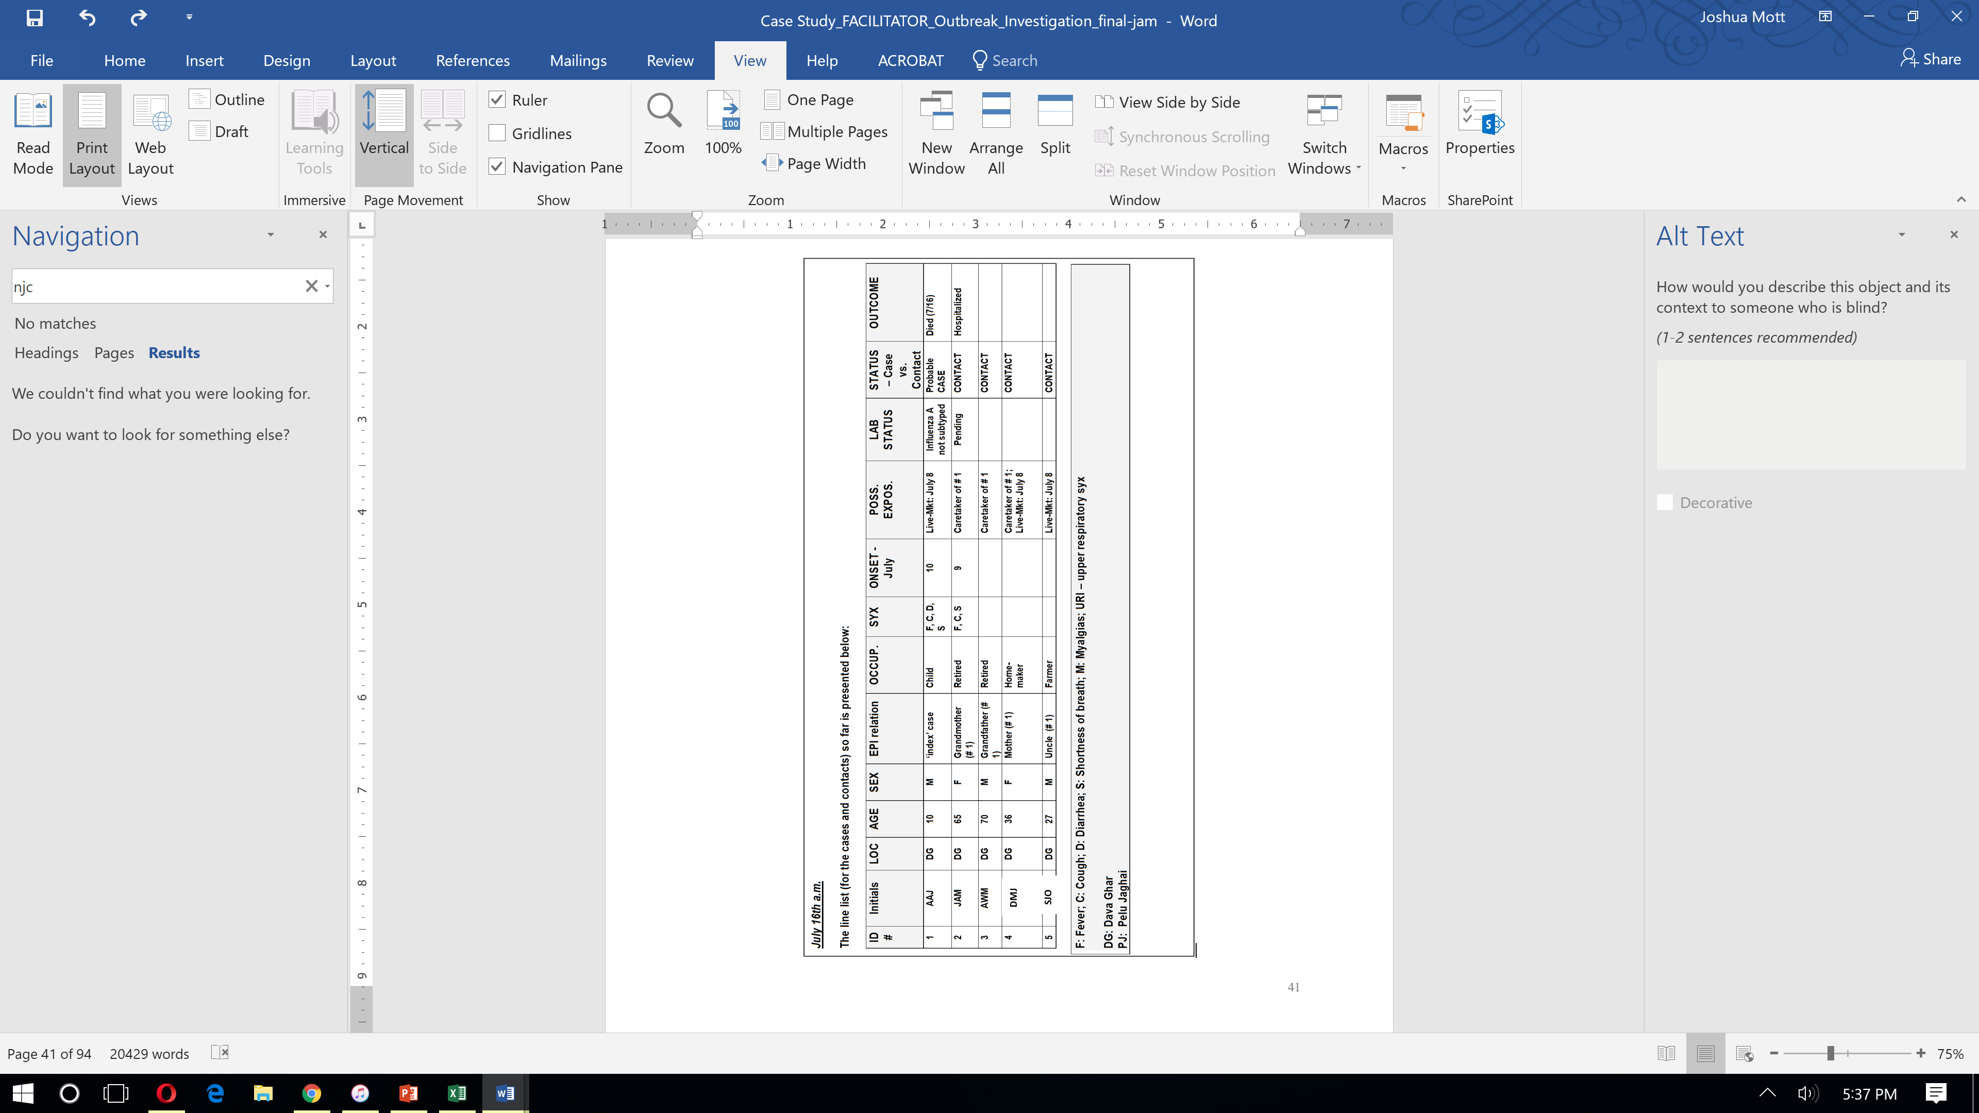
DBJ
Question 18:

What specific places would you visit and who would you speak with to determine
if there are additional cases and contacts to be concerned about?
What would your specific activities be at each of these places and with each person?

Question 18 Suggested Answer and Facilitator Notes:

Participants should identify all contacts the boy may have had going back to one day before symptom onset. The list therefore in this situation might include school mates, play mates, health care personnel (including traditional healers), and persons involved in transportation of or care of the child. There are (at least) four key sources of information that may prove useful:

- Hospital/Other Health Care Facilities

  - Talk to doctors, nurses, and other hospital workers about their exposures, the possibility of illness among health care workers, and potential contacts of the probable case patient.
  - Retrace the movements of the cases within the hospital and determine possible exposures to staff, visitors and other patients. For example, did any of the case patients spend time in a waiting room? Did the nurses and respiratory therapists wear recommended PPE?
  - Contact other healthcare facilities in the province (e.g., clinics, other hospitals, lay health workers) and request that they increase their vigilance in looking for possible cases of novel influenza A virus infection. Remind them of the WHO case definitions. Perhaps offer to provide them with refresher training on case detection, reporting and infection control. Review health care registries to see if there are cases that may have been missed.

- Patient

  - If possible, meet with the patient (you may use a relative as a proxy if the patient is too ill or is a young child).
  - The RRT interviewer should wear PPE (mask, gloves, gown, eye shield) if interviewing probable or confirmed cases, and should avoid touching possibly infected surfaces. A safe distance of 2 meters should be maintained during the interview. The WHO recommends N95 respirators in the context of aerosol generating procedures.
  - Administer a case finding questionnaire:
- Ask the patient if s/he knows of anyone else who is sick with similar symptoms.
- Ask about risk factors and possible exposures.
- Ask about all of their personal contacts (family members, workplace contacts; friends, neighbors, school contacts or playmates).

- Home of case patients (village) to continue investigation

  - Interview family members, other villagers and traditional healers who may be aware of additional cases.
- Ask about the exposure history of the patient; how they were potentially exposed to poultry or other animals.
- Ask if others have developed symptoms.
- Ask the traditional healers/others who may see sick
- Ask if they have received any unusual visits from ill villagers.

- Maintain communications with the MOA and international animal health authorities. This is essential and can help you determine areas where human cases may be more likely to arise.

Key Point:

Important information to inform additional case findings may come from the health care facilities, the patient him/herself, family and friends of the patient, and the Ministry of Agriculture. It is also important to confirm that the Ministry of Health is aware of all cases that may exist. For example, in some countries, the military has their own separate health system, surveillance system and disease reporting system. In these circumstances, a novel influenza infection of someone covered by the military system might not routinely be reported to the MoH or even to the Minister of Health. The military authorities might inform their superiors, but it would probably take some higher than the civilian Minister of Health, say a Vice-Premier, to release that information to the civilian health authorities.

Question 19:

Once you have identified contacts how long should you follow them?
What should be done if these contacts develop ARI, ILI or SARI symptoms?

Question 19 Suggested Answer and Facilitator Notes:

- Close contacts of cases (in this case a probable case with no available specimen) should be followed for at least 7 days after the last known exposure to the case patient. Especially early in an outbreak when human resources are available it may be better to extend this to 14 days.
- If a close contact develops ARI, ILI or SARI, combined OP and NP specimens should be collected from the patient and tested for novel and seasonal influenza A viruses, and perhaps additional respiratory pathogens.
- If a close contact develops ARI, ILI or SARI, efforts should be made to ensure that no other persons are exposed to them. Depending on the severity of illness, acceptability, and the availability of hospital beds, contacts who are ill may be isolated at a health-care facility or at home while awaiting test results.
  - If the test result is negative but the contact has not been followed for at least 7 days, the contact must continue to be followed as they may still be in the incubation period for illness.
  - If the test result is pending after 14 days and the patient is still symptomatic then contact tracing and appropriate isolation/infection control measures should continue while all efforts are made to expedite a laboratory result. More specimens should be collected in case there is a problem with the original specimen.
  - If the test result is pending after 14 days and the patient has recovered fully the patient is no longer a contact. However you should assure your ability to follow—up with the patient when results are received and all efforts are made to expedite a laboratory result.
- To the extent that the patient tests positive for a different respiratory pathogen (not A(H7N9)) they still should be followed for at least 7 days to determine if there is a change in their condition as they still could develop illness from A(H7N9) virus infection.
- Prioritization of contact tracing activities may be necessary if a large number of contacts are eligible for tracing or personnel resources are limited. In such situations it may be necessary to focus on those contacts with the highest risk of infection or exposure.
  - In this case we are following contacts of a probable case who is an index case, and no additional specimens are available for testing. While this is a conservative approach it is probably feasible at this point when other cases have not been identified.
Key Points:
1) A line-listing of all contacts and exposed persons should be maintained that records: demographic information, date of last common exposure or date of contact with the probable A(H7N9) case patient, daily temperature check, date of onset if fever or respiratory symptoms develop, what respiratory specimens were collected and when, what testing results were and when results were available, and dates of receipt of neuraminidase inhibitors.

2) This contact line-list can be combined with a case line list or maintained separately.
3) In this case a conservative approach to defining a contact should be taken as it appears to be early in an outbreak and containment may be possible.

4) A version of the contact tracing form below may be adapted for use in this context. Facilitators should talk through its contents:

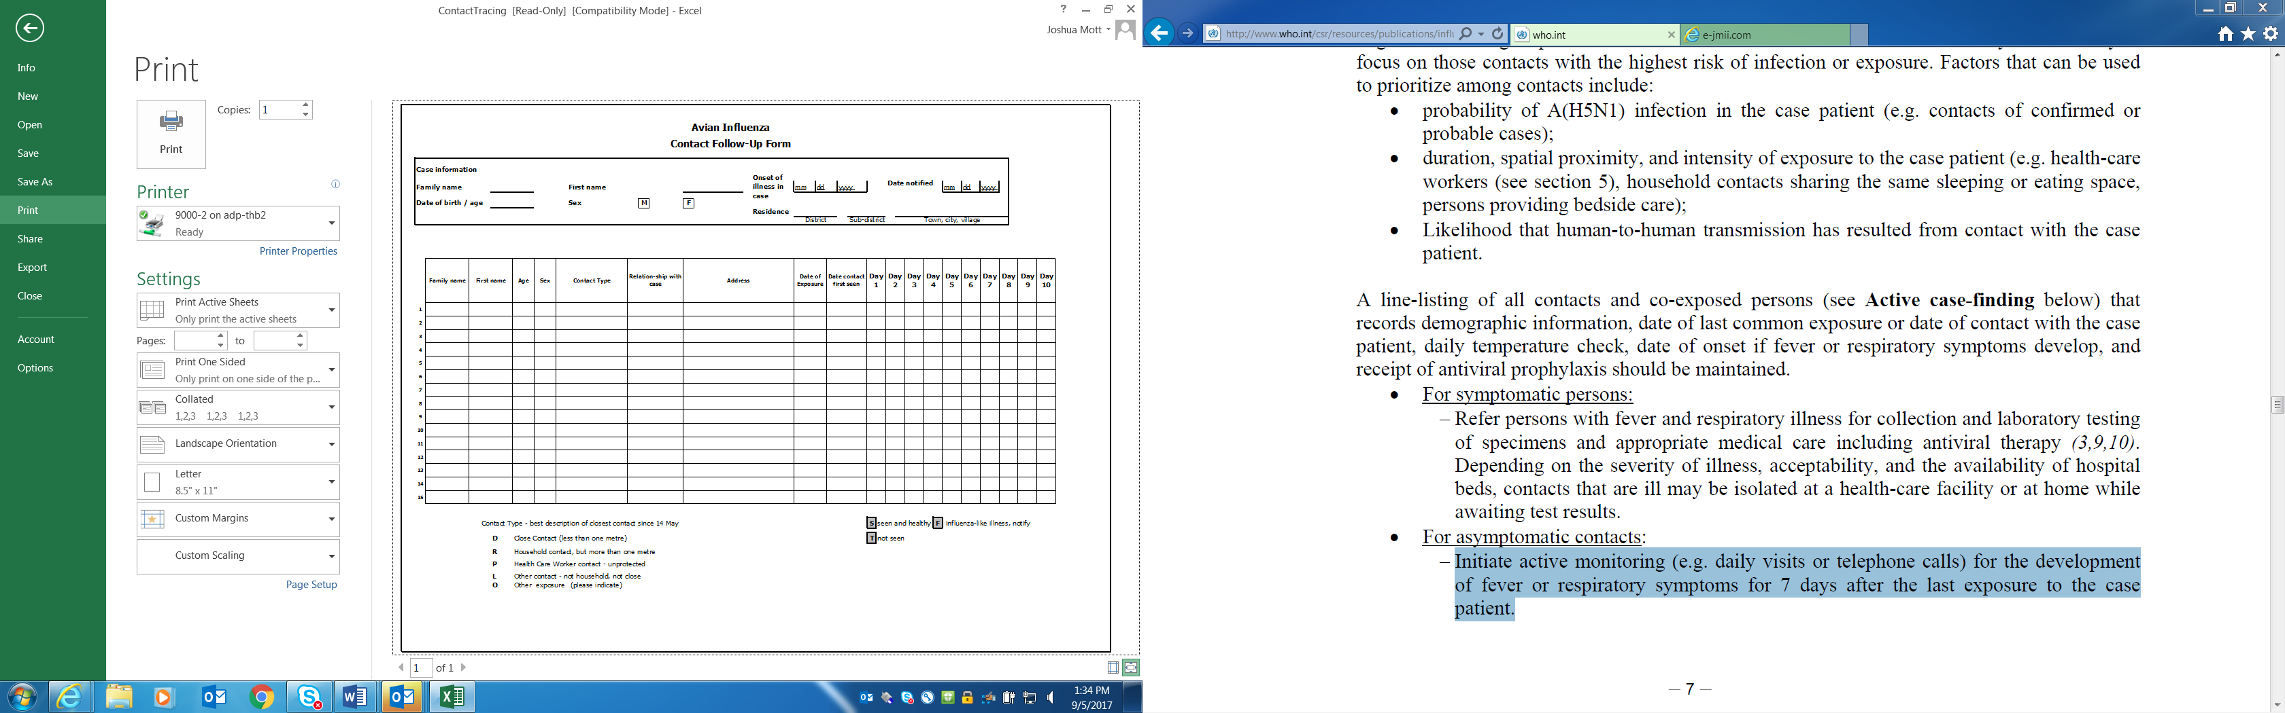

New information available

As a result of additional case finding and sensitization activities undertaken by your team, a village health committee leader in nearby Pelu Jaghai has reported that there is also a child with unexplained respiratory illness there. The Director of Epidemiology recommends that you and part of your team go out to meet the MOH field workers in Pelu Jaghai and make site visits to the local hospital and villages. The Director of Epidemiology states that he will stay and manage the situation in Dava Ghar. You visit the Pelu Jaghai hospital that day (July 16th). You are told by the staff doctor that yesterday they admitted a child of 11 years of age (TMU) for a severe respiratory illness characterized by fever, cough and shortness of breath that began on July 12th. He is critically ill but not intubated and is available for clinical evaluation. He has been kept in an improvised isolation room on one of the hospital wards. You and your team
members put on your PPE, evaluate the patient, review the medical charts and interview some available family members. The mother (AMC) of this boy (TMU) isn’t a very good informant and cannot provide details about her son’s recent history except that the boy was healthy up until July 12th when he developed illness. She recalls that the boy also visited the Murg market on July 8th as this was within walking distance of their house. No one else from her family visited the Murg market or touched chickens from the market. The boy is started on antiviral treatment and diagnostic specimens are collected.

Question 20:

Update the line list: as of July 16th p.m.

Question 20: Suggested Answer and Facilitator Notes:

The updated line list as of July 16th pm is provided below

Key Point:

As of July 16th, p.m. this line list shows there are two important individuals to follow in Pelu Jaghai – the 11-year old boy (TMU) who visited the Pelu Jaghai live bird market on July 8th (SUSPECT CASE) and his mother (AMC – a healthy CONTACT) who was a caregiver while he had his initial symptoms of respiratory illness.

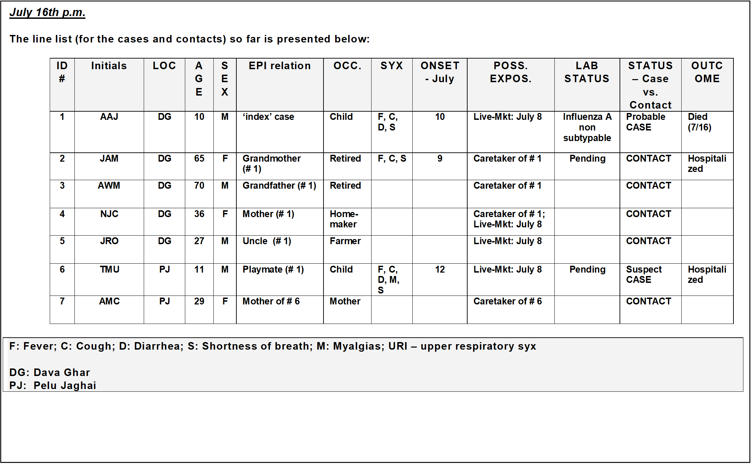
SJO
DBJ

Question 21:

You and your medical colleagues realize the need to clinically evaluate TMU.
What clinical features might distinguish novel influenza A(H7N9) virus infection
in humans from seasonal influenza A or B virus infections?

Question 21 Suggested Answer and Facilitator Notes:

It can be difficult to tell if a patient has influenza because the signs and symptoms for influenza are similar to those for other diseases that may cause respiratory illnesses. While illnesses from seasonal and novel influenza can be different one cannot distinguish between the viruses without laboratory testing.

Seasonal influenza A or B virus infection: usually leads to an upper respiratory tract illness but can produce lower respiratory tract disease, and can worsen underlying chronic medical conditions. It can be severe or fatal. Signs and symptoms include fever, headache, cough, sore throat, nasal congestion, muscle aches, and exhaustion. Most people generally recover anywhere from 3 to 7 days after symptoms appear. However, cough and muscle ache may last more than 14 days. Although seasonal influenza virus infection generally causes an upper respiratory tract illness, it can progress to a wide range of complications such as pneumonia (primary influenza viral pneumonia or secondary bacterial pneumonia) and respiratory failure or death in some cases. Pregnant women, and persons with underlying chronic medical conditions, among others, are at risk for severe complications of seasonal influenza and were also shown to be at higher risk of complications during the H1N1pdm09 pandemic.

Novel influenza A(H7N9) virus infection in humans: is different than seasonal influenza virus infection. Although the focus of surveillance on more severe respiratory illness cases limits our understanding of the possible less severe manifestations of novel influenza A(H7N9) virus infection, it appears to be more likely to produce severe lower respiratory disease with variable upper respiratory involvement. Initial signs and symptoms are similar to seasonal influenza. These include fever, headache, cough, sore throat, muscle ache, and exhaustion. However, symptoms of lower respiratory disease may appear early in course of the illness. Patients often begin to have difficulty breathing leading to progressive respiratory distress. A crackling sound may be heard on chest auscultation during inhalation, and an increased respiratory rate may also be observed as pneumonia worsens. At hospital admission, patients with A(H7N9) virus infection are usually severely ill with bilateral pneumonia and may have laboratory abnormalities such as lymphopenia, thrombocytopenia, and elevated liver function tests.

Key Points:

1) It is not possible to clinically differentiate seasonal influenza from novel influenza A (H7N9) virus infection. They really cannot be distinguished on clinical examination alone.

2) There is always a critical need for discovering the important epidemiologic linkages and exposures to define who should have respiratory specimens collected for confirmatory testing.

3) The underlying epidemiologic clues and laboratory testing must be sought and the two illnesses, seasonal influenza and A(H7N9) cannot be differentiated purely on clinical grounds alone. This is evident from the incomplete list of pathogens that can cause acute respiratory illness, influenza-like-illness and/or severe pneumonia included below:
Viruses  - Seasonal influenza A and B viruses  - Zoonotic influenza A and B viruses  - Parainfluenza viruses  - Respiratory syncytial virus  - Adenoviruses  - Rhinoviruses  - Flaviviruses (e.g., dengue)  - Coronaviruses (including MERS-CoV)  - Human metapneumovirus  - Hantavirus | Bacterial  - Mycobacteria tuberculosis  - Yersinia pestis (pneumonic plague)  - Streptococcus pneumoniae  - Staphylococcus aureus  - Hemophilus influenzae  - Burkholderia pseudomallei  - Legionella spp.  - Chlamydia pneumoniae  - Mycoplasma pneumoniae  - Coxiella burnetii  (Q fever)

Patients with either seasonal or novel influenza A virus infections may also have a bacterial co-infection. In addition to antiviral treatment, if a bacterial co-infection is suspected, these patients should also be treated with antibiotics for bacterial pneumonia per WHO or local guidelines.

Question 22:

The Minister of Agriculture calls your veterinary colleague. She says that she now has definitive confirmation of avian influenza A(H7N9) virus in chickens from the Murg Market, as well as from environmental samples collected from the defeathering machine. She would like to close, clean and disinfect the market, and depopulate all of the poultry. She also asks for your team’s recommendations for other live bird markets. What is your response?

Question 22 Suggested Answer and Facilitator Notes:
Yes, it is advisable to depopulate the poultry in the Murg market to prevent further spread of A(H7N9) virus, and in any other markets where chickens or associated human cases test positive for avian or novel influenza A(H7N9) virus. Following OIE guidelines, if the infection is detected in animals, a policy of culling infected and contact animals is normally used in an effort to rapidly contain, control and eradicate the disease.

Requirements include (and are described in the OIE Terrestrial Animal Health Code):
- humane destruction of all infected and exposed animals (according to OIE animal welfare standards);
- appropriate disposal of carcasses, litter and all animal products;
- surveillance and tracing of potentially infected or exposed poultry;
- strict quarantine and controls on movement of poultry and any potentially contaminated vehicles and personnel;
- thorough cleaning and decontamination of infected premises;
- a period of at least 21 days before restocking according to FAO guidelines.

When outbreaks are detected, stamping out is generally applied at the level of the infected farm or within a short radius around the infected premises in conjunction with active surveillance.

Traceback investigation should occur to identify from which poultry farms or market chain locations the infected poultry may have come. Following FAO emergency surveillance guidelines, expanded oropharyngeal and cloacal swabbing of chickens, ducks, quail and environmental specimens should now be collected from ports of entry, live bird markets, secondary sites such as highly connected live bird markets (LBMs) as indicated in value chain analyses, and connected farms as determined by on-site epidemiologic investigations (using logbooks and questionnaires) at the Murg Market. If there are no poultry die-offs occurring, specimens should be collected from healthy poultry at these types of high priority locations at least every two weeks. Serum specimens could also be collected monthly from poultry for H7 serology testing as part of animal health monitoring (assuming no H7 vaccination of poultry has been implemented).

To avoid the selling of infected chickens in informal settings, live bird markets should not stay closed for too long, and consideration should be given to providing fair market compensation to farmers for their chickens.

To the extent that a highly pathogenic form of A(H7N9) virus (or another avian influenza A virus) appears, added incentives could include paying farmers a higher compensation for more rapid reporting of sick or dead birds and requests for diagnostic laboratory testing.

In all live bird markets other key infection prevention and control measures should be immediately put in place including:

- Proper decontamination of equipment that enters and exists the markets
- No overnight stocking of poultry as this allows the virus to spread. All poultry at markets should be culled at the end of each day.
- The market should be closed for decontamination at regular intervals.
- Measures should be put in place to reduce casual human-poultry exposure to a minimum level. For example, efforts should be made to limit casual contact with animals in live poultry markets, general public entering areas where poultry may be slaughtered, or public contact with any surfaces that appear to be contaminated with feces from poultry or other animals. Procedures should be put in place to wash hands often with soap and water following any contact.
- Measures should be put in place to prevent the mixing of different species of birds in the market (to prevent possible reassortment between viruses in humans, ducks, poultry, pigs and other animals). Barriers (e.g. distancing by fencing or nets) can be used to separate species and help prevent transmission.
Key Points:
1) Early and humane culling and ongoing active surveillance activities remain critical.
2) In places where avian influenza A viruses have become endemic among poultry - these last prevention and control measures alone have not stopped the spread of these viruses.
3) International guidance for expanding surveillance and outbreak control should be followed.

Question 23:

The office of a senior government official is also very concerned about the economic impacts of this outbreak and wants to purchase a new A(H7N9) poultry vaccine from a neighboring country and begin vaccinating all poultry in the country with emergency funding. What is your response? What things would you consider if you pursue vaccination? What problems could arise due to pursuing vaccination and how would you prevent or address these possible problems?

Question 23 Suggested Answer and Facilitator Notes:

The vaccination of poultry can have an important role in the control of avian influenza A(H7N9) virus, in addition to other appropriate control measures. However it has to be thought about very carefully including having an appropriate vaccination exit strategy. There are several issues that must be considered if a vaccination policy is pursued:

- Ensure the vaccine is matched to the currently circulating strains of avian influenza A(H7N9) virus
- No vaccine is 100% effective at preventing infection and we know that all avian influenza A viruses change rapidly. This will mean that a country of limited resources such as Tropica is committing to the ongoing surveillance and monitoring of its poultry populations and to the purchase of new poultry vaccines as circulating strains change.
- If an exit strategy to stop poultry vaccination is not in place then this is likely a long term commitment, as the virus may have other reservoirs beyond poultry or not be quickly eliminated.
- Because even a well-matched vaccine is not 100% effective, non-vaccinated sentinel chickens (identified by paint, clipping or tag) would need to be maintained in every flock and tested to determine if the virus is circulating.
- Serological tests of chickens will not be able to distinguish vaccinated chickens from those infected by circulating strains of A(H7N9) virus. To the extent that other countries implement policies requiring serological testing of birds prior to importation, this will prevent export to those countries.
- Vaccination can be implemented when culling policies cannot be applied countrywide because either the disease has become endemic and therefore widespread, or the infection in affected animals is too difficult to detect.
- To be effective, vaccination should ideally be combined with several other measures, including surveillance, biosecurity, and depopulation measures and as mentioned above, as part of a multi-focused response strategy.

Key Points:
1) Vaccination can reduce influenza A viral shedding by infected animals and the capacity of the virus to spread.

2) Careful consideration must be given prior to implementing a poultry vaccination policy and the recommendations from the World Organization for Animal Health (OIE) on vaccinations and vaccines must be closely followed.

http://www.oie.int/downld/AVIAN%20INFLUENZA/Guidelines%20on%20AI%20vaccination.pdf

3) A vaccination campaign which is not managed appropriately may result in the virus becoming endemic. Therefore, a monitoring program should be implemented in vaccinated poultry populations to determine whether virus is still circulating in these populations; this can be based on the differentiation of infected from vaccinated animals (DIVA) principle or the use of sentinel birds. In addition, serological analysis can be used to monitor efficacy and coverage of the vaccination.

New information available

JULY 17th:

The hospitals in Dava Ghar and Pelu Jaghai both have probable cases of human infection with novel influenza A(H7N9) virus in their wards. Understandably, the hospital physicians and nurses are concerned about health care worker safety. You must review infection prevention and control practices, respiratory hygiene and worker safety issues with the staff doctor.
Question 24:
What are some specific questions about infection control that you will seek answers to at the hospitals?

Question 24 Suggested Answer and Facilitator Notes:

- Are standard precautions being practiced at all times?
  - Are the WHO “Five Moments” of hand hygiene being followed?
  - Is there constant use of gloves for these contacts?
  - Are face-shields, masks, eye protection, or gowns being used for any contact with blood, moist body substances (except sweat), mucous membranes or non-intact skin?
  - Has compliance to hand hygiene been assessed? If yes, what’s the compliance rate?
  - Has compliance been similarly assessed for PPE use, environmental cleaning, etc.?
  - Are appropriate administrative policies and practices in place; for example, posted signs, available hand sanitizers, tissues, and waste receptacles in clinic waiting rooms and emergency departments?
  - Is staff educated in respiratory hygiene and cough etiquette?
  - Is cohorting or spatial separation (ideally >3 feet [one metre]) of persons with respiratory infections being implemented?
- Are contact and droplet precautions additionally implemented during routine care of suspected/probable/confirmed influenza A(H7N9) cases?
  - Is there a private room or room shared for all probable/confirmed influenza A(H7N9) cases?
  - Do staff wear disposable gown and gloves and a mask, and a face shield or goggles when entering the patients’ rooms?
  - Are disposable gown and gloves removed and discarded inside the patients’ rooms?
  - Are hands washed immediately after leaving the patients’ rooms?
  - Is each patient’s room cleaned daily using a hospital disinfectant, with attention to frequently touched surfaces (bed rails, bedside tables, lavatory surfaces, blood pressure cuff, equipment surfaces)?
  - Is there use of disposable equipment or patient-dedicated use of such equipment if possible (e.g. blood-pressure cuffs, stethoscopes)?
  - Are a face shield or goggles, and a surgical mask (not N-95 respirator) worn when entering the isolation room?
  - Does the patient wear a surgical mask when outside of the patient room?
- Are standard + contact + airborne precautions being implemented whenever performing aerosol-generating procedures on influenza A (H7N9) patients?
  - Are aerosol-generating procedures being undertaken in an airborne infection isolation room?
    - This is a single-patient room equipped with special air handling and ventilation capacity that meets specific standards. This may be improvised to create negative pressure in low resource environments. If the facility has no negative air pressure rooms, keep the door closed and all windows open.
  - Do personnel inside the negative pressure room wear a fit-tested N-95 particulate respirator (or higher)?
  - Is isolation room air prevented from re-circulating in the building?
  - Is exhaust air from the isolation room venting away from people (e.g. off the roof)?
- Are sufficient and appropriate PPE available for staff at the entrance to
the isolation room?
- Are there available treatment doses of oseltamivir available for health
care workers who have a breach of PPE?

Key Point:
The WHO guidelines recommend contact and droplet precautions for routine care of documented or suspected cases of novel influenza A virus infection but airborne precautions for aerosol-generating procedures.

Question 25: What are the five important times (moments) for Hand Hygiene:

Question 25 Suggested Answer and Facilitator Notes:

- Before touching a patient,
- Before clean/aseptic procedures,
- After body fluid exposure/risk,
- After touching a patient, and
- After touching patient surroundings

Facilitator note: Many countries adapt the WHO guidelines to meet their resource needs, for example with improvised PPE.

Question 26:

A triage nurse wearing an N-95 respirator raises a concern that N-95 respirators are in short supply. She asks you who these should be prioritized for?

Question 26 Suggested Answer and Facilitator Notes:

- N-95 or higher level of respiratory protection (with appropriate fit testing) are recommended for activities with a high likelihood of generating infectious respiratory aerosols in patients with probable or confirmed A(H7N9) virus infection or other novel influenza A viruses of animal origin that have caused severe human illness:
- Intubation, nebulizer treatment, bronchoscopy
- Resuscitation
- Direct care for patients with A(H7N9) or novel influenza A virus-associated
pneumonia
- Surgical masks, not N-95 respirators, should be put on patients when they are outside of the patient room.

New information available (Participants should be taking notes)
You are intrigued by the possibility that there may be a possible epidemiologic connection between this 11-year old boy (TMU) in Pelu Jaghai and the 10-year old boy (AAJ) in Dava Ghar through a common potential Murg market exposure. Through additional interviewing you also learn that the two boys played a local children’s game ~ ‘hu-tu-tu’ called ‘chasing after the chicken’ at the live-market. During this game they enjoyed chasing what appeared to be one of the slower and unsteady chickens before it was placed in the defeathering machine. You oversee the appropriate collection and transport of respiratory specimens from this 11 year old (TMU). You get the history that it was the uncle (SJO) of the 10 year old (AAJ) who took him to the live-bird market. You return to Dava Ghar on the late afternoon of the 17th, tired and anxious that there are possibly other human cases of novel influenza A(H7N9) virus infection that you are missing.

JULY 18th:
On the morning of the 18th, you go with the staff doctor to make rounds on the ward to see the grandmother (JAM) and to conduct active case surveillance for any interim cases of respiratory illness. You find that the grandmother is coughing copious amounts of yellow sputum with occasional hemoptysis, and though she is laboring to breathe, she is not progressing to respiratory failure. She is still in isolation; you are given the real-time RT-PCR results of the laboratory testing of specimens. The results are negative for influenza A(H7N9) virus. One of her sputum specimens was positive for acid fast bacilli. Her chest x-ray, which you had not been able to see initially, now shows evidence of an upper lobe cavitary lesion, and a presumptive diagnosis of active pulmonary tuberculosis is made.

As part of the team’s daily updates, you are also told that the grandfather (AWM) now has been documented to have a new fever and complaints of myalgias and a worsening lower respiratory infection. Being frail and very anxious about JAM’s condition, he hadn’t really ventured out of her hospital room. He wore an N-95 respirator almost continuously and sat by her bedside in deep concern. He has congestive heart failure due to chronic hypertension. Though he had already been started on antiviral treatment doses of oseltamavir, his clinical status rapidly worsens.

Later on the 18th, you intend to get your team members together and create a more detailed summary of the ‘cases’ to date and to tally any data that they have acquired from their active case surveillance efforts. Your team also informs you that the combined OP/NP swab specimen from the 11-year old child (TMU) is positive for influenza A(H7N9) virus by real-time RT-PCR. Both the probable case (AAJ) and the confirmed case (TMU) have been reported to the WHO, which is mobilizing resources to assist in the investigation. This reporting is essential to obtain additional resources to support a more robust response in Tropica now.
Question 27:

What are the international reporting requirements in the above circumstance?

Question 27 Suggested Answer and Facilitator Notes:

Humans: The WHO encourages countries to continue strengthening influenza surveillance, including surveillance for severe acute respiratory infection (SARI) and influenza-like illness (ILI), to carefully review any unusual patterns. They also recommend enhancing event based surveillance with additional triggers for respiratory event reporting. This is to ensure reporting of all human infections under the IHR 2005, and continue national health preparedness actions. This means that the cases of TMU and AAJ should be reported under IHR. The laboratory specimens from TMU should rapidly be shared with a WHO Collaborating Center for Reference and Research on influenza to ensure timely sequencing for assessment of the virus transmission and pathogenicity characteristics, as well as its possible use for vaccine development. This, accompanied with epidemiologic information from this investigation, will allow specimens to be characterized for their pandemic potential using the TIPRA and IRAT risk assessment tools.
Animals: Avian influenza in birds/poultry is a notifiable disease listed by the OIE. As detailed in the OIE Terrestrial Animal Health Code, all infections with HPAI detected in any domestic or wild bird must be reported to the OIE by the country’s competent authorities (Veterinary Services, MOA). Low pathogenic avian influenza A viruses of subtypes H5 and H7 in poultry are also notifiable to the OIE. The results from the Murg market require such notification and specimens should be shared with a participating laboratory of OFFLU. OFFLU is the OIE-FAO global network of expertise on animal influenza working to reduce the negative impacts of animal influenza A viruses by promoting effective collaboration between animal health experts and with public health.

Question 28:

Update the line list - as of July 18th p.m.

Question 28 Suggested Answer and Facilitator Notes:

The updated line list as of July 18th p.m. is provided

Key Points:

1) As of July 18th p.m. this line list shows the grandfather (AWM) is now ill with fever and lower respiratory illness. Given his exposure to the index case at the family vigil (and not due to his exposure to JAM), AWM can now be considered a suspect A(H7N9) case.

2) Also, the grandmother (JAM) has pulmonary tuberculosis, and not novel influenza A(H7N9) virus infection; so she remains a close contact (it is possible she could still develop influenza infection as well).
3) The 11-year old boy (TMU) at Pelu Jaghai hospital is the first confirmation of novel influenza A(H7N9) virus infection. Moreover, it should be noted that it seems more likely that he did not acquire influenza A(H7N9) virus infection from his playmate (AAJ) at the live market but rather had an independent exposure to the infected chicken while they both played the ‘hu-tu-tu’ game.

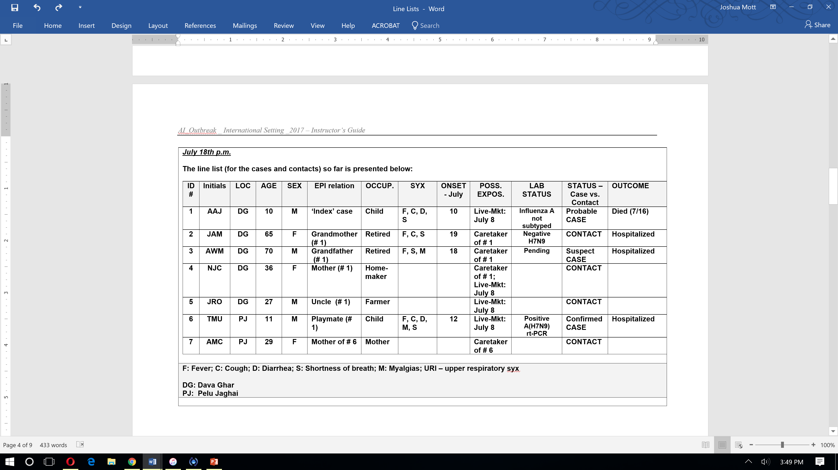
DBJ
SJO
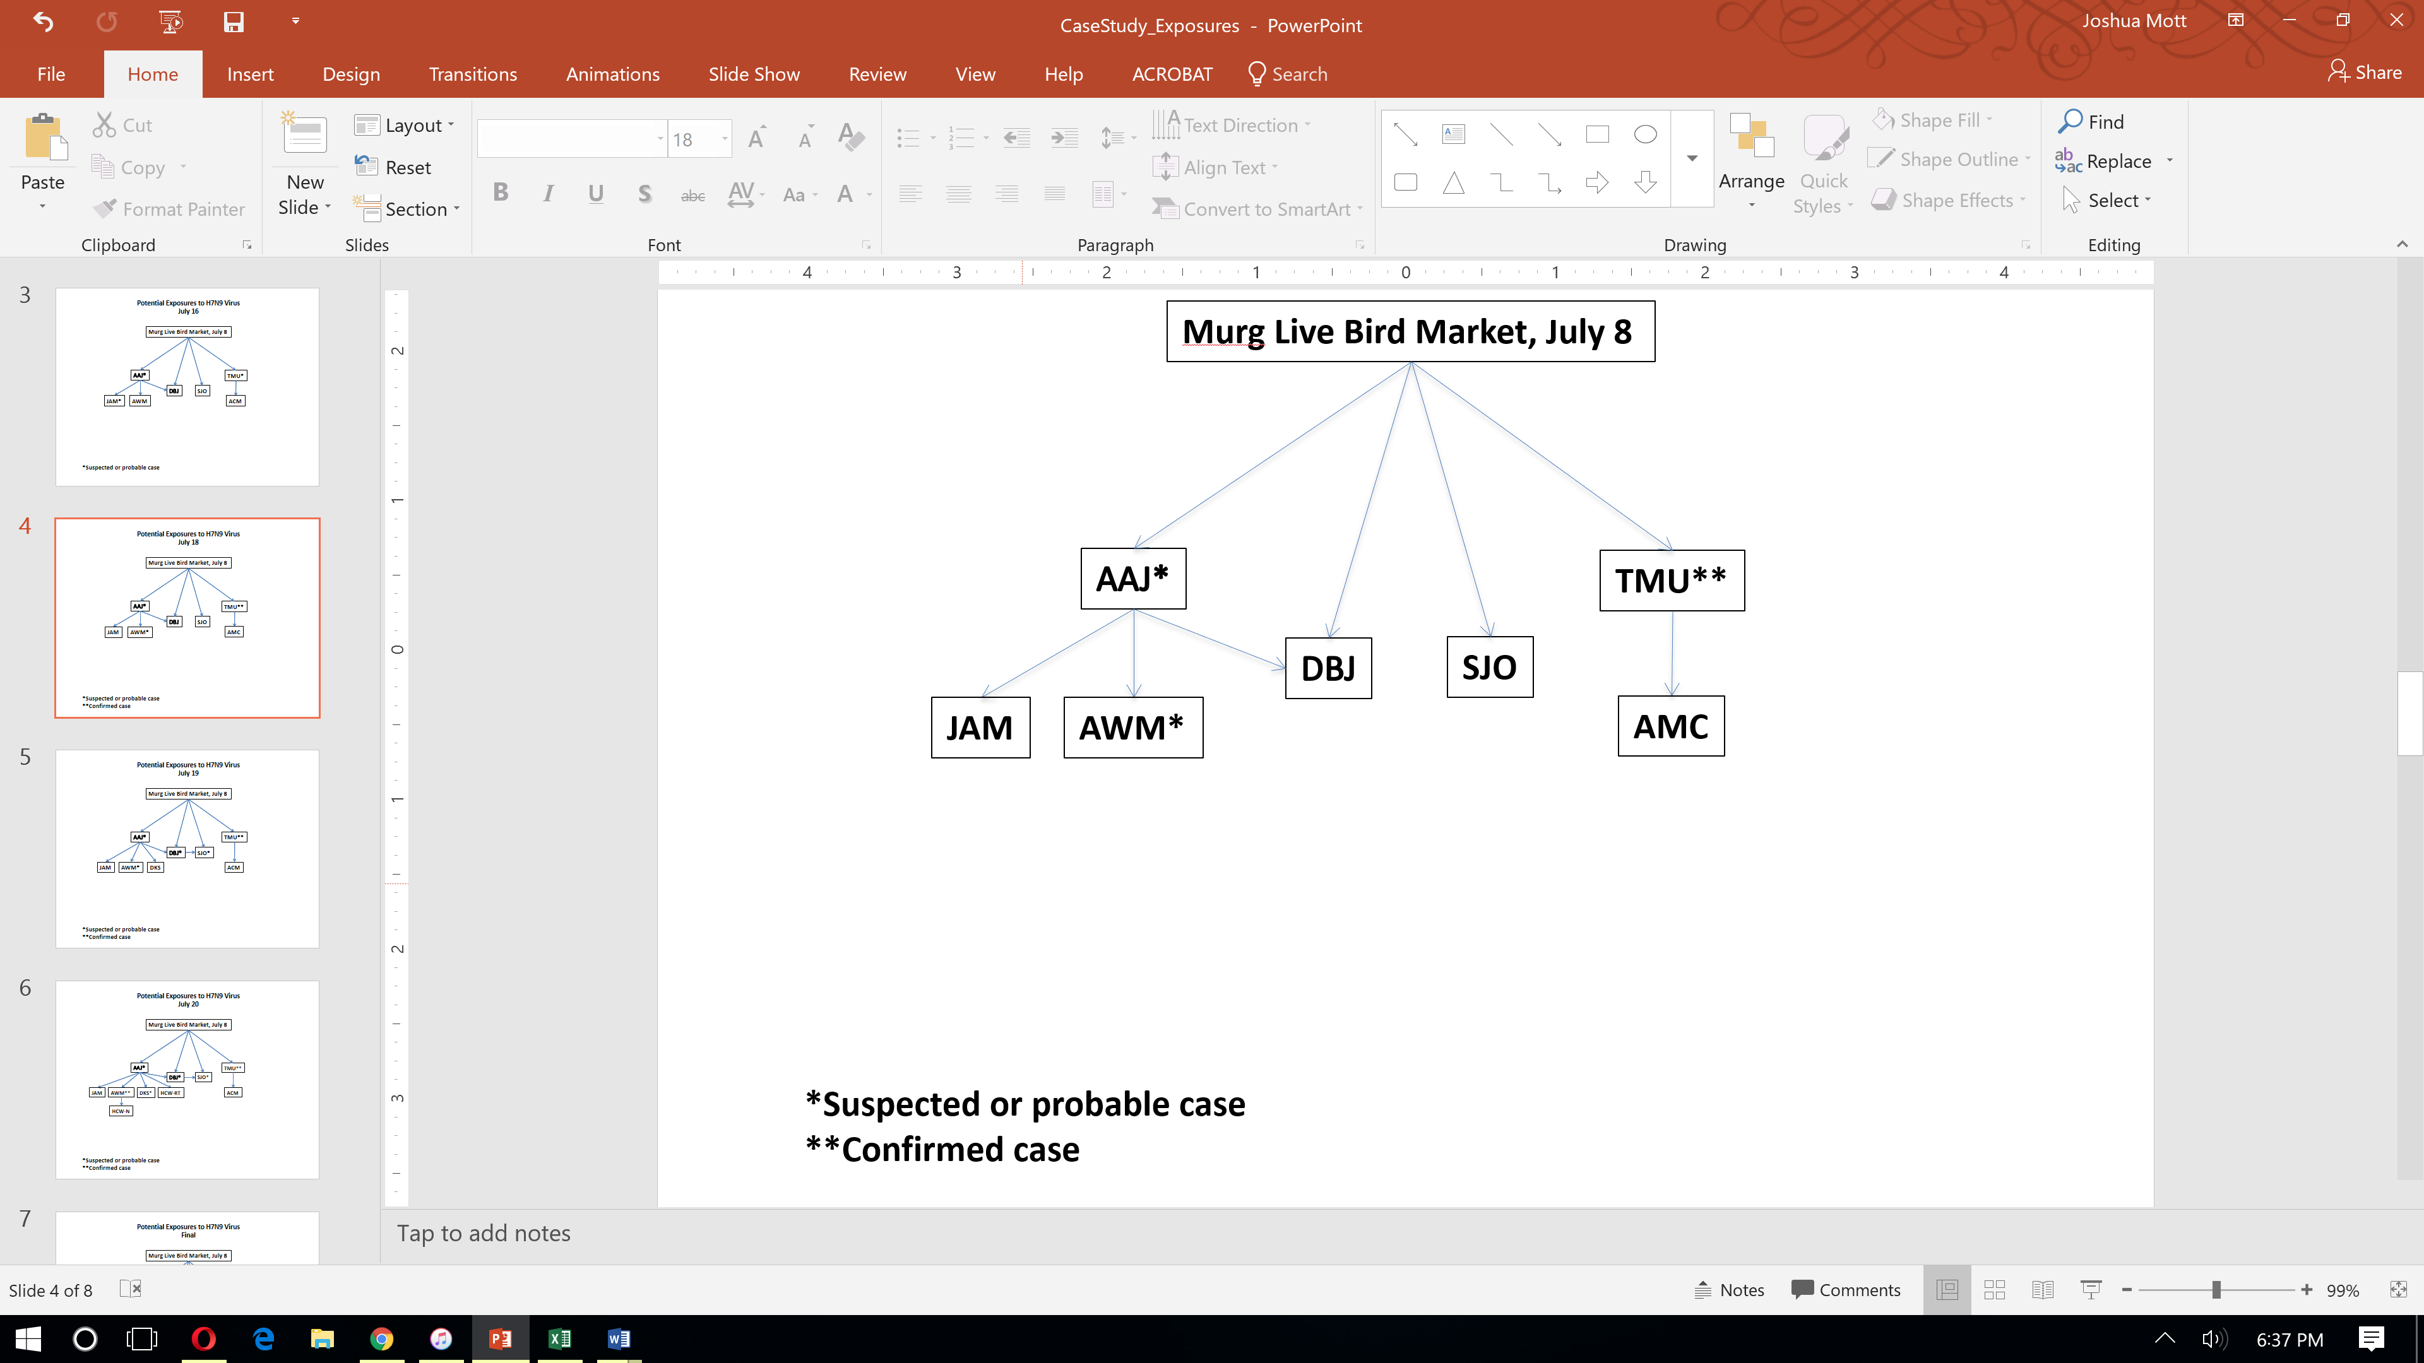

New information is available

As you take a short walk to collect your thoughts you receive an urgent message on your cell phone from the Director of Epidemiology. He has just been notified that a reporter from the regional newspaper is pursuing a story on the ill patients in the adjacent province. Somehow the reporter has learned of the ‘potential’ exposure at the July 8th live-market and wants to write an article notifying the public. The Director of Epidemiology repeatedly states that he wants to talk directly with the reporter and maybe even conduct a press event. He asks you for a list of ‘talking points’ to be created by your team and then shared with the Public Information Officer (PIO) who works with the MOH. He also wants you to help write a situation report for his Director General of Public Health.

Question 29:

What are the key principles and basic goals of emergency risk communication in this kind of situation?

Question 29 Suggested Answer and Facilitator Notes:

- Be first. Be clear. Be credible.

- Share frequently and foreshadow possible additional cases if need be.

- Follow appropriate procedures within your Ministries, yet ensure that joint multi-sectoral communications are created and published with partnering ministerial sectors.

- Speak to emotional needs.

Key Points: Messages could include

- An expression of empathy (“I understand that everyone is very concerned about this situation…)
- Clarification of facts (who, what, why, where, when, why, how)
- What is not known, and when future reports will occur
- The process for getting answers to what is not known
- Statement of commitment with multi-sectoral representation (to crisis response and recovery and to continue communications as more is known)
- Referrals for additional information.

Question 30:

What are three key communication messages that could be used to provide the public with an update of the current situation?

Question 30 Suggested Answer and Facilitator Notes:

Here is an example:
Concept: stay coordinated with partners but be the first to clearly and accurately describe the situation for the public.
- The Ministries of Agriculture and Health will together give you regular updates. Here are the facts we know to date:
  - One laboratory confirmed case of novel influenza A(H7N9) virus infection “bird flu” (in an 11-year old boy) has been identified in Pelu Jaghai.
  - Another 10-year old boy who died in Dava Ghar is considered a probable influenza A(H7N9) case, and his grandfather is ill and is a suspect case.
  - Both boys were playing with and around chickens at the Murg Market in Pelu Jaghai that has been confirmed to have chickens infected with avian influenza A (H7N9) virus “bird flu.”

Concept: acknowledge uncertainty and foreshadow to manage expectations
- An official investigation, involving collaboration between the Tropica MOH, Ministry of Agriculture, FAO, OIE and the World Health Organization is underway.
  - It’s early in our investigation and the complete scope of influenza A(H7N9) virus infection among potentially exposed humans is unknown at this time. There may be more cases.
  - There is currently no evidence of widespread influenza A(H7N9) virus infection or human-to-human transmission.
  - The Murg Market is closed until further notice and we continue to actively search for additional human cases. We are also testing many other animal markets and farms with connections to the Murg market.
  - Compensation of 1000 duckets per bird is being offered to farmers whose birds need to be taken as part of this response. Note:
    - Discussion Point: Note that the typical selling price of a chicken is about 1,000 duckets. If compensation is too low then farmers may hide or slaughter birds for quick sale or sell surreptitiously. If compensation is too high they may offer up well birds.

Concept: speak to people’s emotional needs
- The Government of Tropica understands the concern that the public must feel about this situation and we are committed to identifying the extent of this outbreak and rapidly controlling it.
  - Steps are being undertaken to ensure that all contacts of the ill child are being traced.
  - Steps are also being taken to ensure that A(H7N9) virus does not spread among poultry and poultry markets, which at present is the only known source of this infection to humans.

You can help us too. For more information about this investigation, or to report suspected cases of avian or novel influenza A(H7N9) virus infection in humans or animals, please do not hesitate to contact the Tropica Public Information Officer at +999-65-244-675.

Question 31:

What are the essential components of a situation report?

Question 31 Suggested Answer and Facilitator Notes:

Facilitator Notes: You will brainstorm and discuss these key categories with the participants. For the purposes of time do not have the participants fill out a situation report. However, it may be helpful to read through the report together to critique its content and to also get a sense of the broader response that would occur external to the activities in this case study.

Example Report:

Rapid Response Team Daily Situation Report

Date: July 18th, 5pm Location: Dava Ghar Province, Tropica

1. Rapid Response Team Composition

Name | Affiliation | Role

2. Surveillance/Epidemiology

2a. Update on human cases

There is 1 confirmed human case of novel influenza A(H7N9) virus infection:

As of July 18th there is one confirmed human case of Influenza A(H7N9). This is in an 11-year old boy from Pelu Jaghai. This boy had a symptom onset date of July 12th and had contact with chickens and chicken defeathering devices (which were also tested for influenza A(H7N9)) that tested positive for influenza A(H7N9) virus at the Murg Market on July 8th.

There are two possible cases of novel influenza A(H7N9) virus infection:

A 10-year old playmate of the confirmed case who lived in Dava Ghar also had contact with the same chicken at the live bird market on July 8th, died of respiratory illness on July 16th, and was buried by his family before specimens could be collected. This 10-year old decedent remains classified as a probable A(H7N9) case.

The grandfather of this 10-year old child is now currently hospitalized in Dava Ghar with fever, lower respiratory illness and myalgias and is classified as a suspected A(H7N9) case. Diagnostic specimens from the grandfather have been collected with results expected imminently.

2b. New cases and changes in classification since the last report

1) Since the last report at 5pm on July 16th, the 11 year old boy from Pelu Jaghai has received RT-PCR confirmation of influenza A(H7N9) virus infection in a respiratory specimen and his status has been changed from a “probable A(H7N9) case” to a “confirmed A(H7N9) case”.

2) On July 16th the grandmother of the 10-year old probable A(H7N9) case from Dava Ghar was classified as a “close contact”. Since that time her respiratory symptoms have been confirmed to be the result of active pulmonary tuberculosis but she remains a close contact and is still being followed for the possibility of A(H7N9) virus infection.

3) The grandfather of this 10-year old child is now currently hospitalized in Dava Ghar with fever, lower respiratory symptoms and myalgias and is classified as a suspected A(H7N9) case rather than as a contact. His laboratory results are pending.

2c. Contacts and exposed persons being monitored

Four contacts are currently being closely monitored for symptoms and are under voluntary quarantine. These contacts include:

1) The grandmother of the 10-year old decedent (probable case from Dava Ghar) who is known to also have active pulmonary tuberculosis.

2) The mother of the 10-year old decedent (probable case from Dava Ghar), who also attended the live bird market on July 8th

3) The uncle of the 10-year old decedent (probable case from Dava Ghar), who also attended the live bird market on July 8th.

4) The mother of the confirmed case from Pelu Jaghai, and his caretaker while ill.

Workers from the poultry farms and owners of backyard flocks that provided birds to the Murg Market are under surveillance for fever or respiratory symptoms. They are also under voluntary quarantine for 10 days. These flocks were identified through an ongoing joint MOH/MOA investigation.

2d. Update on human surveillance

Active surveillance for suspected human cases of influenza A(H7N9) virus infection is being undertaken in all health care facilities in Pelu Jaghai and Dava Ghar provinces. Active surveillance for fever and respiratory illness is also being undertaken among poultry workers and backyard flock owners that supplied birds to the Murg Market. They have been identified through traceback analyses. Door-to-door active surveillance for fever and respiratory illness is being undertaken every other day by local health workers in the villages of the confirmed, probable, and suspect cases. The community health workers and local health care providers are receiving refresher training in human case definitions and appropriate reporting channels.

2e. Update on poultry surveillance

The MOA is undertaking active surveillance of poultry at points of entry and at poultry distribution centers in Tropica. Enhanced surveillance is especially focused on distribution centers and farms with connections to the Murg market. To the extent that additional poultry need to be culled, compensation of 1000 duckets per chicken will be provided to the owners of the poultry. Enhanced biosecurity measures are also being put in place at all live bird markets.

2f. Evidence of human-to-human A(H7N9) virus transmission

To date there is currently no definitive evidence of person-to-person A(H7N9) virus transmission. However this remains a possibility in this outbreak and close contacts are being carefully followed and the possible sources of exposure are being identified for all cases to determine the transmission mechanisms of this virus.
3. Pending laboratory results
No additional clinical specimens could be obtained from the 10-year old probable case from Dava Ghar prior to his burial. RT-PCR analyses confirmed influenza A (H7N9) virus infection in the 11-year old child from Pelu Jaghai. Oropharyngeal and nasopharyngeal swabs collected from the grandfather of the probable case from Dava Ghar have been sent to the National Laboratory and are pending. All respiratory specimens have also been forwarded to the WHO reference laboratory for diagnosis of Influenza A(H7N9) virus infection.

4. Clinical management/Infection control

Non-hospitalized contacts have been advised by the MOH to remain at home for at least 7 days after their last contact with a probable or suspected case. The hospitalized contact is in isolation and has been started on antiviral treatment doses of a neuraminidase inhibitor (oseltamivir) given her underlying active tuberculosis. She is also being treated for her tuberculosis (NOTE: that this patient’s confidentiality must be maintained throughout the investigation). Non-hospitalized contacts have been educated about risk factors/risk behaviors of exposure, and the signs/symptoms of A(H7N9) virus infection. All contacts have received instructions on how to self-monitor for fever post-exposure. During this period, contacts have been instructed to stay at home voluntarily. If contacts have fever, they have been told to immediately report their symptoms to health authorities and/or the RRT and remain in voluntary home quarantine. All probable and confirmed cases are currently in isolation and are receiving treatment doses of neuraminidase inhibitors (oseltamivir).

Any contacts developing symptoms or reports of additional ill persons with exposures are being reported to the “119” hotline.

5. Planned activities

The team plans to visit (or telephone) each contact daily for at least 7 days following a known exposure to a suspected, probable or confirmed A(H7N9) case. Investigation and contact tracing will continue and all suspected cases will be reported to the appropriate authority.

Efforts to identify additional cases beyond close contacts will focus on:

• persons who may have been co-exposed to the same source as the case patients
• persons with bird and bird product exposures
• clusters of socially and geographically linked persons with respiratory illness
• persons with unexplained severe acute lower respiratory infection with fever
6. Requests for assistance and resources

We request policy clarification on the recommendation for prophylaxis of attendees at live bird markets with stated exposure to sick or dying birds. Notifications have been made to appropriate international IHR and OIE points of contact. Specimens have been shared with WHO Collaborating Centers for Reference and Research on Influenza, and with the OIE/FAO OFFLU laboratories.
7. Other
You may want to include your epidemiologic curve and line listing here but take care to maintain the confidentiality of the cases under investigation. In addition, issues you may want to discuss here are the recent press conference, security, and other concerns.

New information available

Now that you feel good about yourself for having handled these media coverage and reporting duties, you return to the team on the early evening of July 18th to summarize the investigation to date as you had originally planned. Instead your team says that there is a problem that has arisen with some of the family members of the little boy (AAJ). You are told that the mother (DBJ) and the uncle (SJO) called the MOH from their home telephone and indicated that they have runny noses and “feel a little weak.” DBJ first began to feel ill (on July 19th) and then about 10 hours later, SJO began to feel ill. Because they live 60 km from the hospital they are worried that if they fall ill they will not be able to obtain timely health care. They want to be hospitalized.

Question 32:

The mother (DBJ) and the uncle (SJO) ask you and the Director of Epidemiology if they can come to the hospital now but the hospital staff is worried that many more people will request the same treatment. How do you respond?

Question 32 Suggested Answer and Facilitator Notes:

The answer, which must come from local authorities, to this depends on many factors such as patient health, underlying conditions, stability of condition, distance from hospital, mobility, and available hospital beds, supplies, and infection control resources. For example, early in an outbreak when there are few known cases, a decision may be made to allow such cases to come to the hospital. In a situation with more widespread human illness, that policy might quickly become untenable. For example, during the 2009 H1N1 influenza pandemic, in certain situations some hospitals were overwhelmed by “worried sick” and were less able to effectively triage and provide early pneumonia care to those most in need of it. As a result, this decision must be taken very carefully.

Key Points:

1) This question illustrates that such staged contingency planning is very important for the MOH to consider in advance as part of their pandemic influenza preparedness efforts.
2) The MOH should call a rapid meeting to determine appropriate admission and triage plans for local hospitals.

Question 33:

If an asymptomatic person with known exposure to a confirmed human case of avian influenza A (H7N9) virus infection refused to accept voluntary quarantine, how would you respond?

Question 33 Suggested Answer and Facilitator Notes:

This is another decision that must ultimately be made by local authorities. The goal of quarantine is to protect the public by separating persons exposed to a communicable disease from the general population. It is based on utilitarian concepts of protecting the common good (the greatest possible good for the greatest number of individuals). Imposition of quarantine or other liberty limiting measures needs to be balanced with protection of individual rights, such as the protection of quarantined individuals’ privacy, protection against stigmatization, and avoidance of unequal burden being placed on specific individuals or groups. Whenever possible, voluntary measures should be used.

Key Points:

1) Remind the audience that quarantine is for asymptomatic exposed persons, whereas isolation is for symptomatic persons.
2) The following points might help you to provide advice in the current situation. Ethical justification of quarantine or isolation requires that:

- There must be a possibility of person-to person spread of disease and the necessity of quarantine as a containment measure.
- The least restrictive measures proportional to the goal of achieving disease control must be used. Voluntary quarantine should be used before more restrictive measures are enacted.
- Society must be able to provide necessary support services for those in quarantine (e.g., provide, food, water, household and medical supplies, etc.) and ensure the long-term psychological impact and stigmatization of persons quarantined or isolated is minimized.
- Public health officials must communicate clearly the justification for their actions and allow for a process of appeal (transparency principle).
- Quarantined individuals should be closely monitored to detect onset of symptoms. Those with symptoms should be moved to isolation or a cohort of symptomatic persons in order to ensure that other persons placed under quarantine are not put at increased risk.
- Efforts must be made to ensure that individuals are welcomed back to their communities following a period of quarantine. This was a critical concept during the West African Ebola virus disease epidemic.

New information available

A local temple has been offered as a potential site for quarantine and the mother and uncle agree to move there as it is only 5 kilometers from the hospital. DBJ and SJO will self-monitor for presence of fever and alert the local health committee with any change in their health status. When you again ask DBJ about any other family members who may have been around the 10-year-old (AAJ), she now tells you that there is one 19 year old brother (DKS), who is a university student in the city of Palmtown and came just to take care of his little brother during the family vigil on July 12-13th. He had gone back to the university on the 14th for exams.
JULY 19th:
The next day (July 19th) you learn that the 11-year old boy (TMU) is intubated and critically ill. Later that evening the Director of Epidemiology informs you that both the mother (DBJ) of the boy who died (AAJ) and AAJ’s uncle (SJO), have now been admitted to the hospital with cough, fever, shortness of breath, and pneumonia noted on chest x-ray. Additionally the mother also had severe myalgia, diarrhea and a mild sore throat. The mother provides more history that she in fact did care for her boy while he was sick at home; she recalls she and her parents (JAM and AWM) being close by the boy at home during the 48 hours prior to his admission to Dava Ghar Provincial Hospital.

JULY 20th:

You begin the day by getting updates from the MOH team. You are also told that the 19 year old student sibling (DKS) now has fallen sick (onset of symptoms – July 20th) – with fever, shortness of breath, and cough. He returned to his home province because he was not feeling well. He completely denied having attended any live-markets and any contact with dead or ill poultry as he was either at his brothers bed-side, or at school.

Later that morning you receive word that the grandfather (AWM) has died with multiple complications, including renal failure, encephalitis and ventricular arrhythmias. You are not surprised to learn that he died of influenza A(H7N9) virus infection – as confirmed by RT-PCR testing of respiratory specimens.

Question 34:

Update the line list - as of July 20th afternoon

Question 34 Suggested Answer and Facilitator Notes:

The updated line list as of July 20th afternoon is provided

Key Points:

1) As of July 20th, this line list shows that the grandfather (AWM) has died and was confirmed to be an influenza A(H7N9) case.
2) In the interim, the mother (DBJ) and the uncle (SJO) of the index case (AAJ) have been hospitalized as suspect influenza A(H7N9) cases, and a 19-year old sibling of AAJ who is a student from out-of-town (DKS) is also hospitalized as a suspect A(H7N9) case.

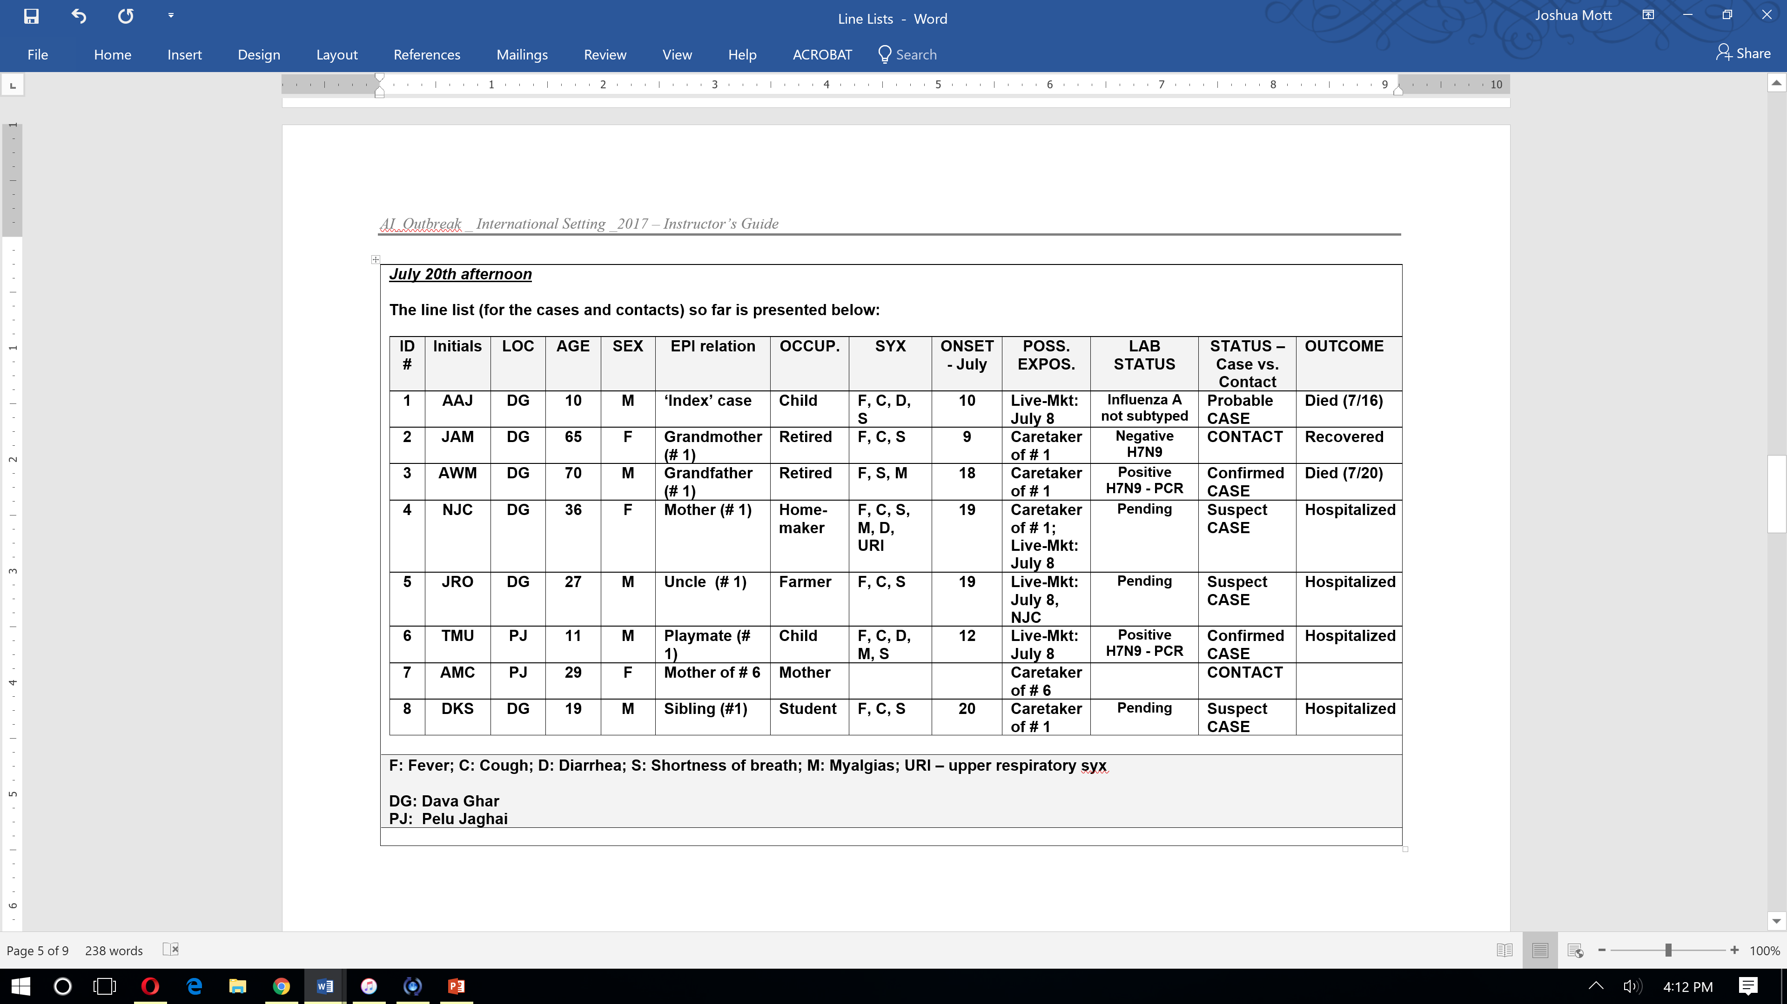
SJO
DBJ

New information available

You don’t have the appetite given all the tension but you manage to eat a bowl of vegetable and noodle soup. Before you finish you are approached by some scared health care workers (HCWs), including the respiratory technician (HCW-RT) on duty when the 10-year boy (AAJ) died. He reports having worn PPE but he thinks he “felt droplets touch his face” on July18. He is now running a fever and very worried. Additionally there are two other HCWs who are demanding something be done about their potential exposure to the deadly A(H7N9) virus.

There was a nurse (HCW-N2) who took care of the grandfather during the last hour of his life and helped in taking care of the body post-mortem. She is unsure if she wore all of the required PPE at all times. There was also a traveling nurse (HCW-N3) who recalls how scared she was even though she had adhered to contact and droplet precautions when briefly taking a meal tray into the grandfather’s hospital room. Neither have any signs or symptoms of respiratory illness.

Question 35: What are your antiviral use recommendations for these health care workers?

The respiratory therapist who took care of the 10-year old (AAJ), nurse #1 who treated the grandfather (AWM) and handled the body post-mortem, and nurse #2 who brought the grandfather a meal all request antiviral therapy. Assuming limited supplies of oseltamivir are available, who do you recommend should receive antiviral treatment, why, and at what doses?

Question 35 Suggested Answer and Facilitator Notes:

1) Respiratory Therapist: The respiratory therapist is a suspect case. There may have been a breach in his PPE based on his report that he felt droplets touch his face. However, he also has a fever. He should be promptly tested for influenza virus infection, including influenza A(H7N9) viruses, and simultaneously treated with a neuraminidase inhibitor (oseltamivir) as soon as possible.

The recommended dose of oseltamivir for the antiviral treatment of influenza, in adults and adolescents 13 years of age and older, is 150 mg per day, given as 75 mg twice a day for five days. Dosages are weight-adjusted for children ages 1-year and older:

• 30mg twice daily for ≤ 15 kg
• 45mg twice daily for >15 to 23 kg
• 60mg twice daily for >23 to 40kg
• 75mg twice daily for >40kg

2) Nurse # 1: The nurse who attended the grandfather and took care of the body may have had exposure to infectious aerosols and secretions and so she could also receive treatment doses as above.

3) Nurse # 2: The nurse who took the meal tray into the grandfather’s room likely had no significant exposure and cannot be considered a contact given the transient nature of the visit. She should not receive oseltamivir. In order to give her comfort she could also be asked to self-monitor temperature twice daily and report any fever.

Key Points:

1) It is important to point out that antivirals are most effective for treatment of influenza when antiviral treatment is started soon after illness onset.
2) Antiviral treatment does not always prevent severe illness or death.
3) Consistent and appropriate use of recommended PPE in the hospital is the first line of defense, and essential to help prevent spread to healthcare workers.

New information available
Later that evening (July 20th), your colleagues return from Pelu Jaghai having completed their case investigation and contact tracing. You also learn that DKS now has radiographically-confirmed pneumonia. The two teams find a room in the hospital to update their line lists and review all of the epidemiologic data.

Facilitator note: The complete line listing for these cases and contacts as of July 20th evening should now be provided to participants.

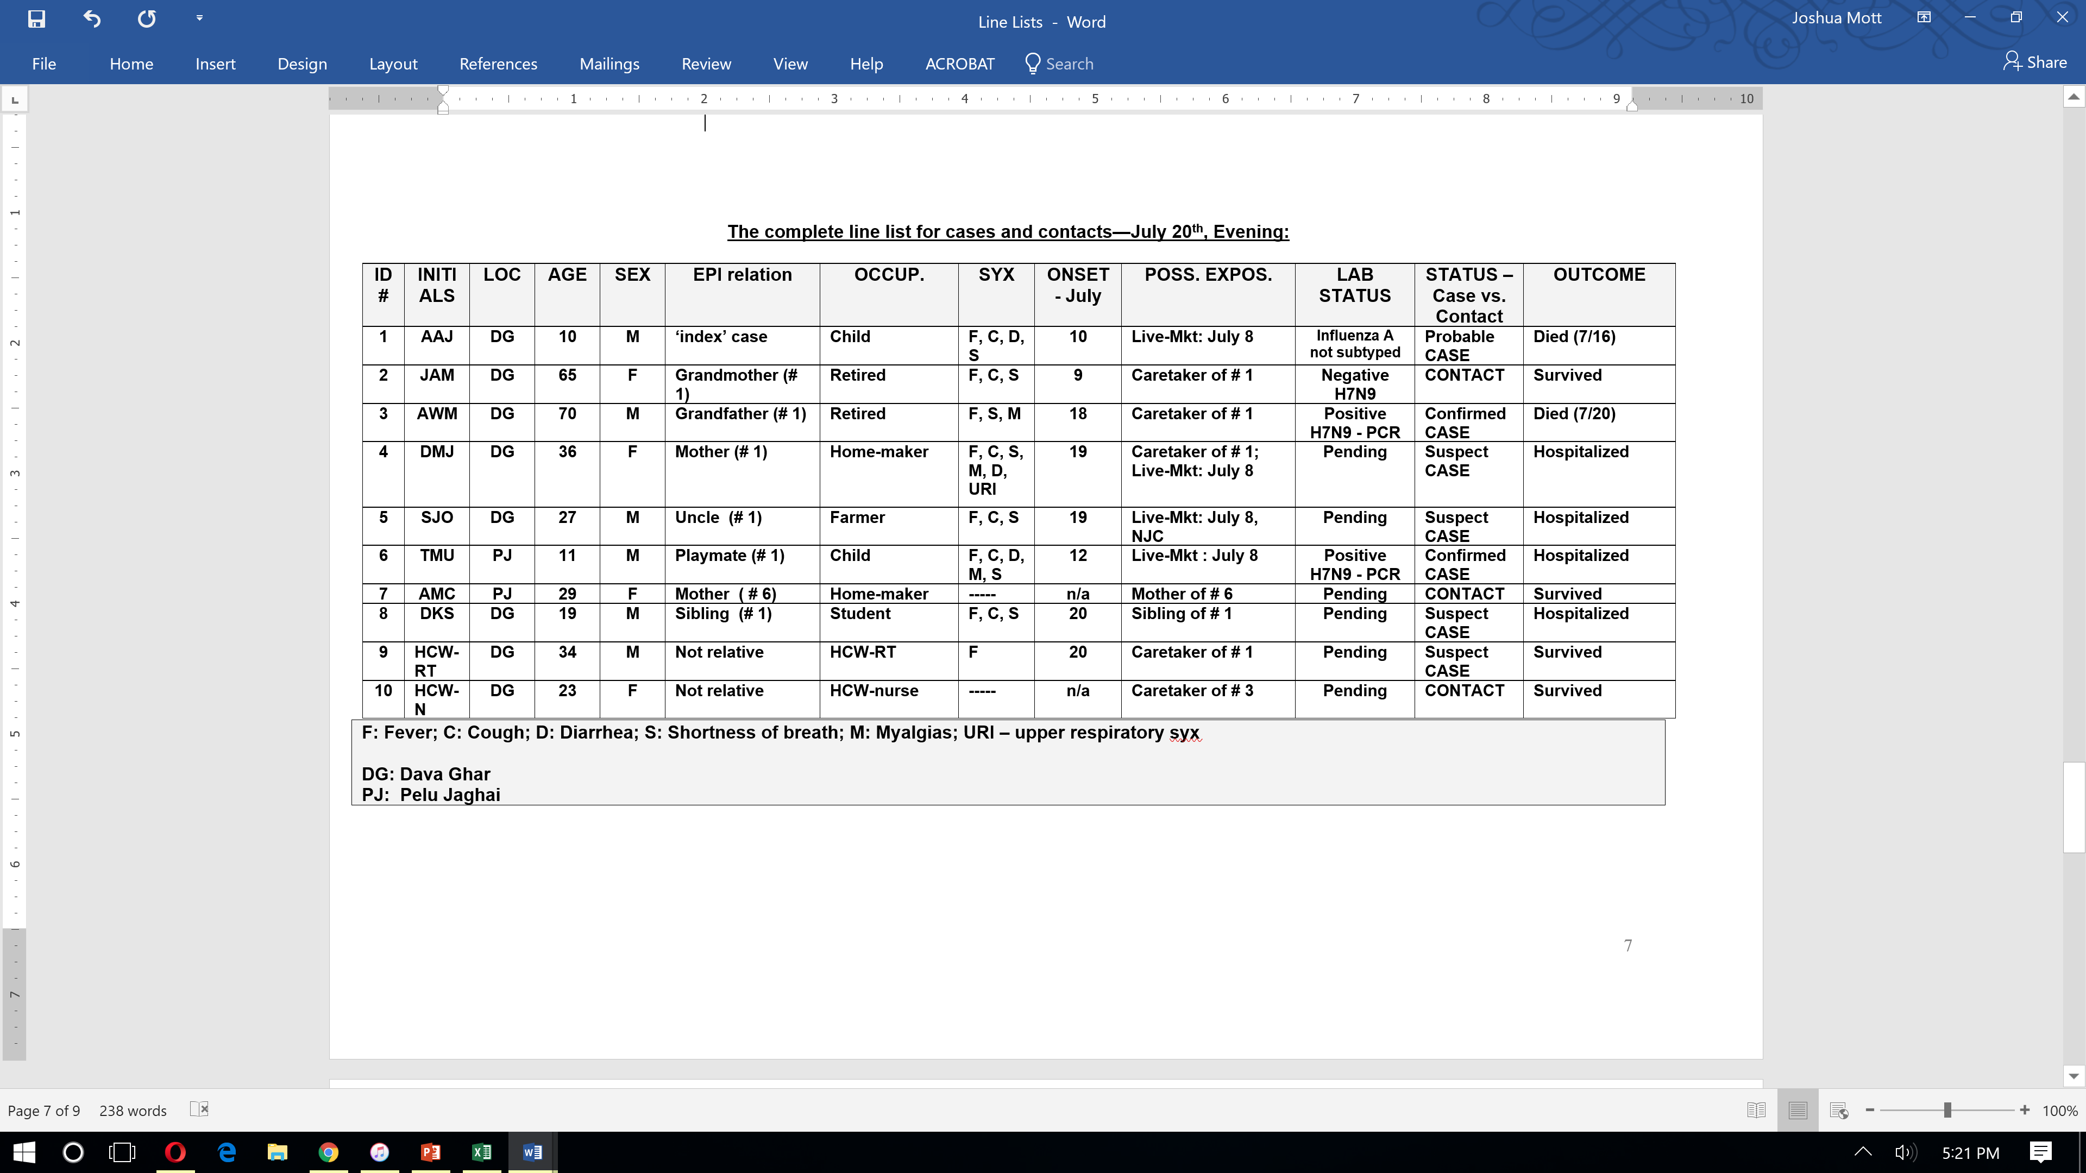
DBJ
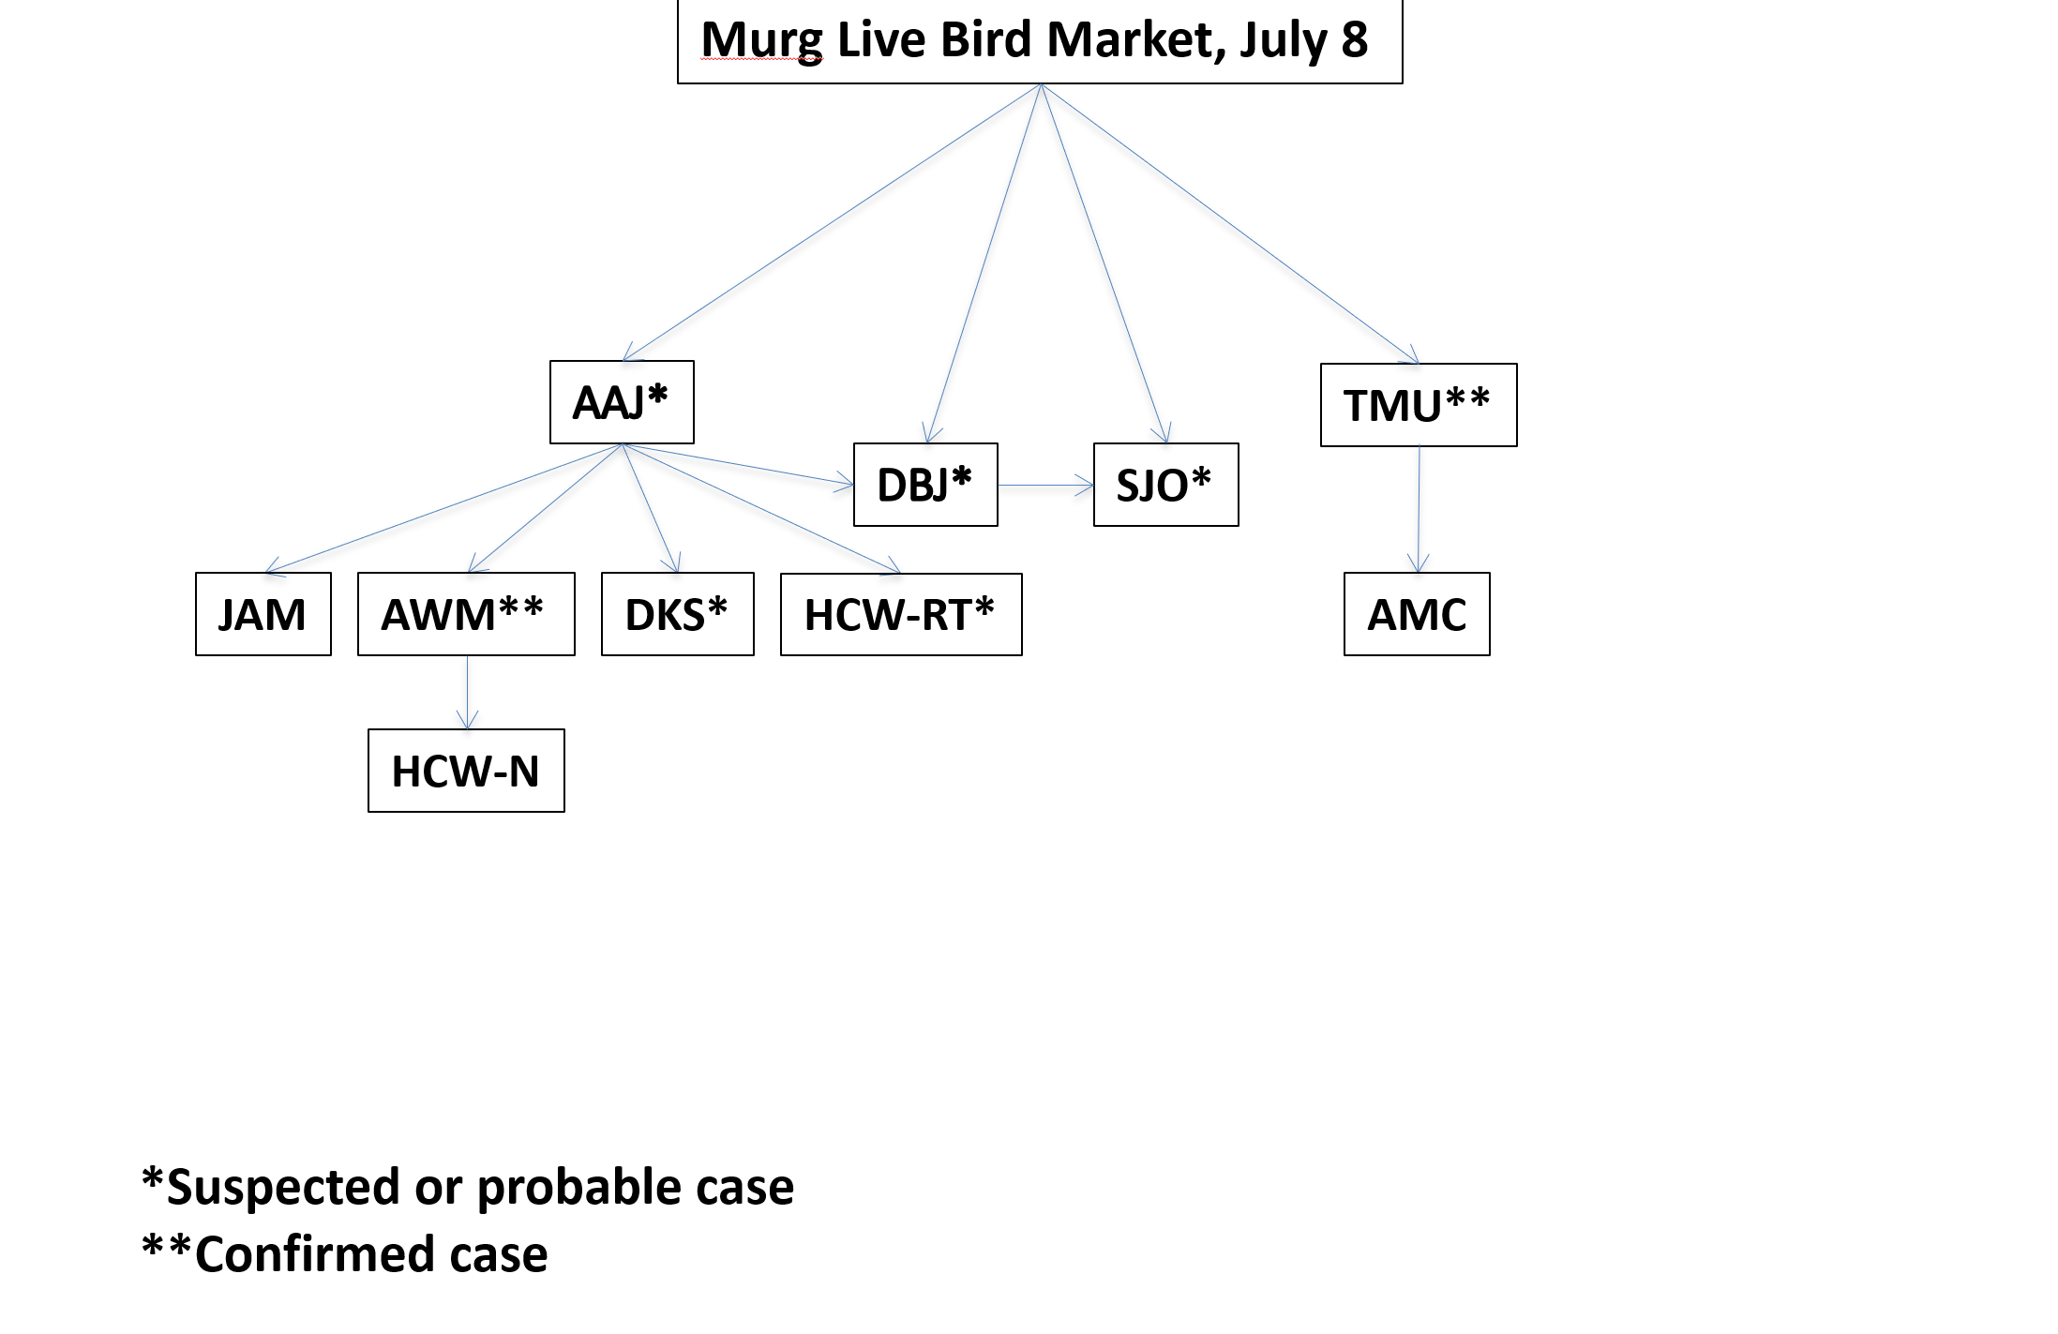

Question 36:

Make an epidemic curve of the cases as of July 20th evening. What can be learned from the epidemic curve?

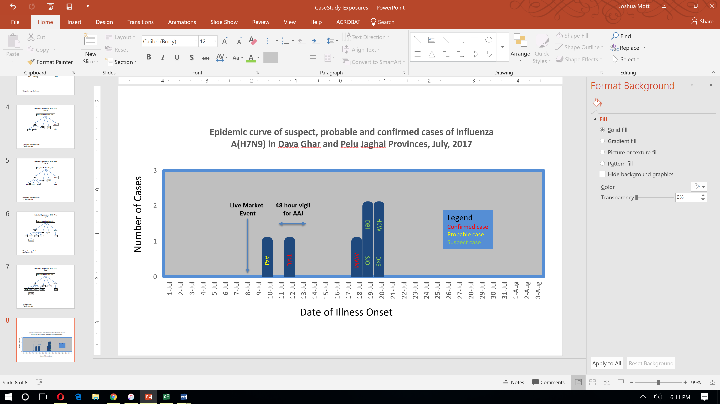

Question 36 Suggested Answer and Facilitator Notes:

- For those in the group who have never made an epidemic curve, ask a volunteer to draw the curve of suspect, probable and confirmed A(H7N9) cases and to then describe the X and Y axes. Coach this person to add arrows that indicate the two known exposure locations (the Murg Market, and the start and end of the 48 hour vigil) on the X-axis.

- Provide the completed epidemic curve to the participants after this is completed.

Key Points:
1) Participants should observe that besides showing the number of cases, the curve shows the two potentially different exposure sources, initially the live-market on July 8th and the 48 hour family vigil, lasting almost 48 hours from July 11-13th.
2) The former could represent a predominantly zoonotic exposure to avian influenza A(H7N9) virus; the latter could represent a predominantly human-to-human exposure to the virus.

Now discuss what the minimum and maximum incubation periods associated with each exposure could be by comparing the date of onset of each case with their dates of possible exposure.

- Live-Market: the minimum suggested incubation period is likely 2 days (AAJ), and the potential maximum is 11 days (if DBJ or SJO were exposed at the live-market). Recall the uncle (SJO) did not attend the vigil but had close contact with DBJ.

- Family-vigil: The minimum incubation period is 5 days (AWM), and the potential maximum is 9 days (DKS) - if source of exposure was AAJ.

Use this epidemic curve in conjunction with the line listing to systematically review with participants the possible sources of exposure and incubation periods for each case. Draw a schematic outlining each person’s potential exposures if it is helpful to the process.

Facilitator notes: Talk through the case by case findings:

- The 10-year old boy who died (AAJ) was likely infected with avian influenza A(H7N9) virus through poultry exposure at the live-market.
- The 11-year old boy (TMU) is within a plausible incubation period for exposure at the live-market and likely did not acquire A(H7N9) virus infection from the 10- year old playmate (AAJ).
- When considering the epidemic curve in the context of known exposure histories, then the following interpretations can be made regarding the mode of transmission for additional cases
  - The mother (DBJ) may have been exposed to avian influenza A(H7N9) virus at either the live-animal market OR as a result of close contact with her son (AAJ).
  - The grandfather (AWM) was likely exposed to avian influenza A(H7N9) virus as a close contact with his grandson (AAJ) as he had no reported poultry exposure.
  - The uncle (SJO) was likely exposed to avian influenza A(H7N9) virus at the live-animal market event but given the incubation periods he could possibly have been infected by exposure to DBJ. He was reportedly not around the boy (AAJ) after the onset of his symptoms.
  - The 19-year old (DKS) may have been infected with avian influenza A(H7N9) virus at the time of the family vigil. This person is of particular concern given the possibility of human-to-human transmission, and his subsequent travel and development of symptoms in Palmtown.
  - The HCW-RT was likely exposed during a breach in PPE while attending to AAJ.

- Much more urgent work remains to be done.

Facilitator note: This being a simulation, it should be noted that in a real-life situation, there may well be many more individuals who could have been exposed to avian influenza A(H7N9) virus (e.g., at the live market event, occupational exposures, etc.)

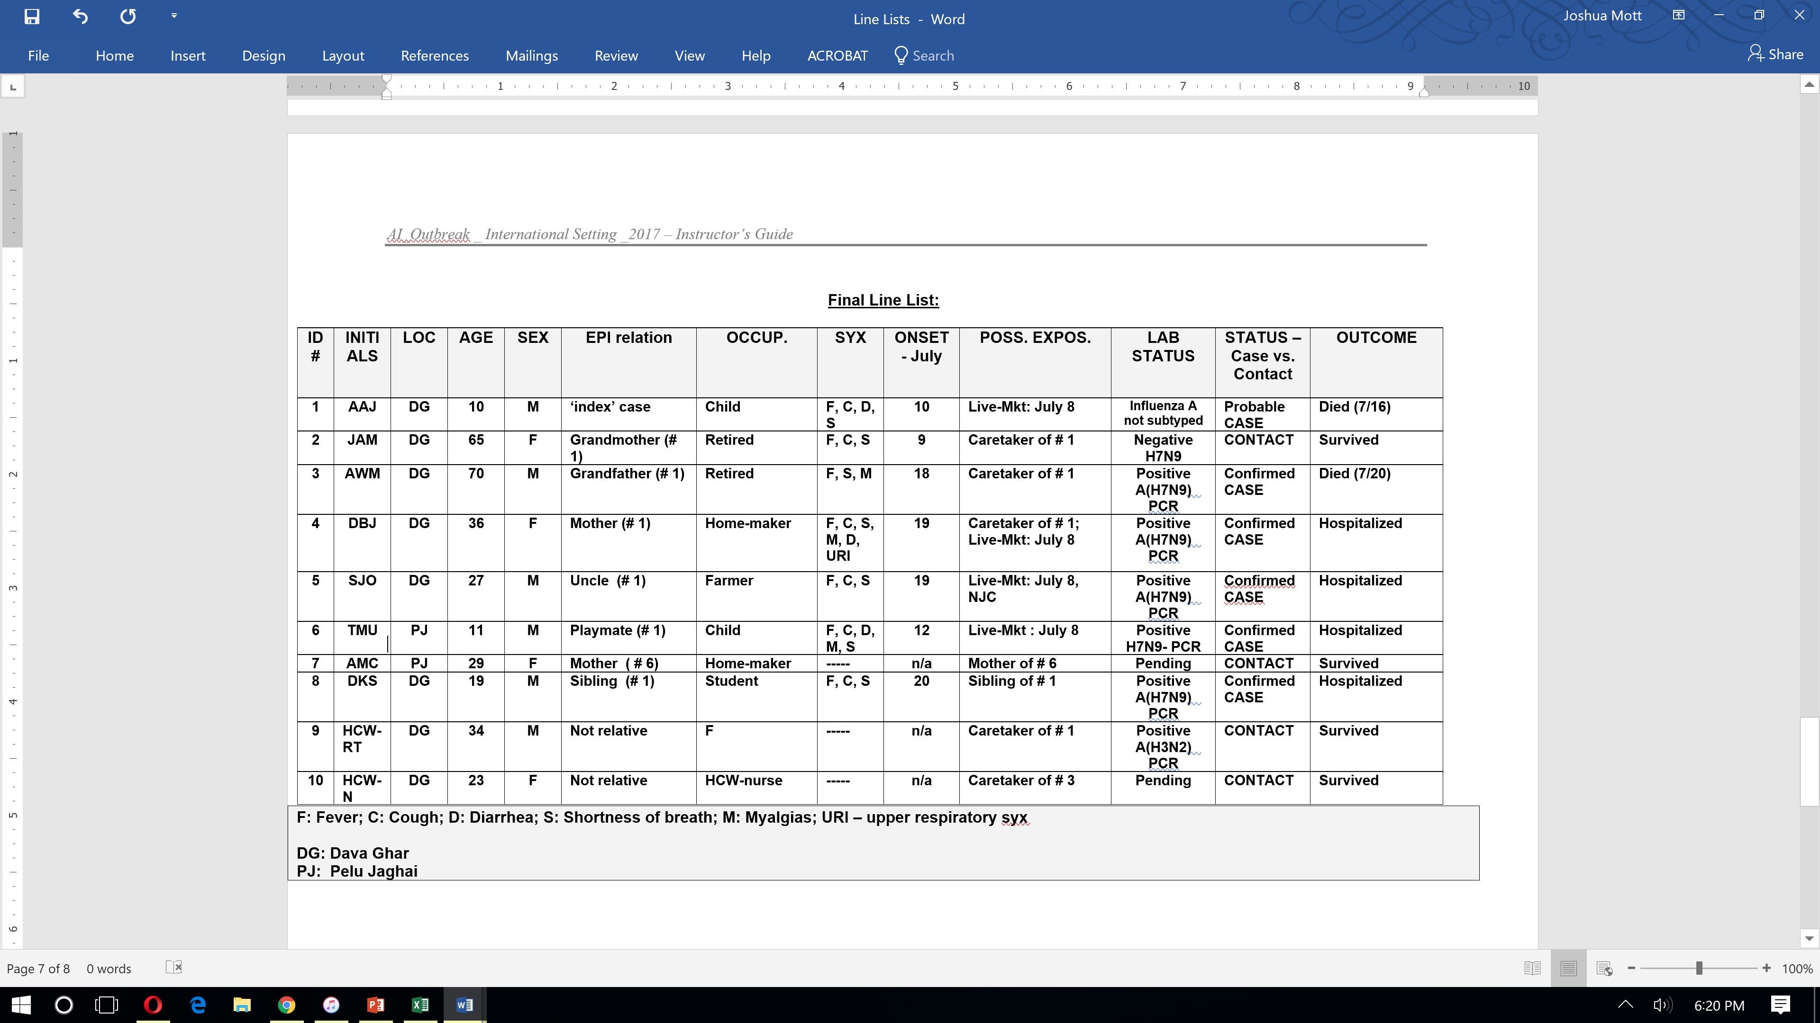

New information available
Update:

Over the next several days, the mother (DBJ), her brother (SJO), and the 19 y/o (DKS) are all confirmed positive for influenza A(H7N9) virus by RT-PCR and respiratory specimens are sent to the WHO reference laboratories. You also learn that all of the remaining individuals who were considered ‘contacts’ tested negative for influenza A(H7N9) virus. The respiratory therapist tested positive for influenza A(H3N2) virus.

Question 37:

Considering all of the information available what is the likelihood that each case was infected with influenza A (H7N9) virus via human-to-human transmission? Fill in the table below.

Question 37 Suggested Answer and Facilitator Notes:

Ask participants to create a column on the case line list called “human-human transmission”. Ask participants to label each case as “likely”, “not likely”, or “possible”. Before doing this discuss what the epidemiologic evidence for making a determination of human-to-human transmission needs to be.

To date there has been an apparently low risk of human-to-human spread of influenza A(H7N9) virus. However the virus can possibly acquire the ability to bind to upper respiratory receptors and spread among humans. Suspicion of human-to-human A(H7N9) virus transmission is increased when the time of onset between two cases falls within the incubation period (~2 to ~8 days), and when no alternative source of exposure is found. In practice it can be very difficult to differentiate between human-to-human transmission and a common source exposure. Human-to-human transmission may be indicated in the setting of:

- Well documented exposure to a confirmed, probable, or suspect human case of A(H7N9) virus infection;
and
- The time interval between contact with a human A(H7N9) case and illness onset is often 7 days or less;
and
Absence of an alternative source of exposures to avian influenza A(H7N9) virus such as through exposures to birds, animals, feathers, droppings, fertilizers made of fresh bird droppings, contaminated environments, or laboratory specimens
OR
- Several generations of transmission linked to a primary case

Thus a comprehensive epidemiologic case investigation is essential to make this determination. There is no laboratory test to prove human-to-human A(H7N9) virus transmission, but rather the epidemiological investigations are critical to determining whether human-to-human transmission of A(H7N9) virus is a possibility.

HUMAN-to-HUMAN transmission?

ID # | INITIALS | LOC | STATUS – Case vs. Contact | Human-to-human transmission? | Possible Sources of Exposure
1 | AAJ | DG | Probable CASE | Not likely | Live-Mkt: July 8
3 | AWM | DG | Confirmed CASE | Likely | Caretaker of # 1, no reported poultry exposure.
4 | DBJ | DG | Confirmed CASE | Possibly | Caretaker of # 1; Live-Mkt: July 8
5 | SJO | DG | Confirmed CASE | Possibly | Live-Mkt: July 8, DBJ
6 | TMU | PJ | Confirmed CASE | Not likely | Live-Mkt : July 8. Exposed to AAJ, prior to AAJ’s symptom onset.
8 | DKS | DG | Confirmed CASE | Likely | Caretaker of # 1. Exposed at vigil, denies poultry exposure.

Key Points:
1) Review criteria for establishing human-to-human A(H7N9) virus transmission above.

2) Clearly establishing human-to-human A(H7N9) virus transmission may be possible although difficult. There is no “test” to prove this. Rather the assessment is based upon findings of thorough epidemiological investigations.

3) There may be instances in which establishing human-to-human transmission is relatively clear but given the common sources of zoonotic exposure, or exposure to unknown fomites that may be present in the environment, it is nevertheless challenging to be certain of the mode of transmission that resulted in infection.

New information available
Over the next 10 days you, the Rapid Response Team, the Director of Epidemiology and the relatives of many of the patients are saddened to see the demise of the mother (DBJ) of the 10-year old boy (AAJ). The uncle (SJO) and the 19-year old (DKS) survive though they received the same early interventions and medical care as the mother. The 11-year old boy at Pelu Jaghai (TMU) also dies during this time period.

You reflect on the investigation findings and the ongoing passive and active surveillance activities in the region, now also including Palmtown. The local FETP and polio-eradication networks have mobilized to follow all contacts in Palmtown. You are emboldened to realize that no more acute unexplained respiratory infections with an underlying epidemiologic link to cases, contacts or sick poultry have arisen.

Question 38:

What would you do at this stage? How long must you wait before you and your colleagues consider this investigation closed and the outbreak(s) over?

Question 38 Suggested Answer and Facilitator Notes:

You need to wait for at least the passage of 2 incubation periods, i.e., approximately 2 weeks to allow for any signs or symptoms of illness, even very minor symptoms, to manifest among those exposed to avian influenza A(H7N9) virus either through direct contact with poultry and/or ill human cases. There will also have to be a risk assessment of poultry populations completed following 21 day stockout periods.

The most important measures at this point are:

    - To enhance ongoing active surveillance for avian influenza A(H7N9) virus infection in humans and animals (there is never a stronger indication for active surveillance than at this point in an investigation); this should include facility and community--based surveillance strategies.
    - To enhance biosecurity measures in farms, backyard flocks and markets;
    - To provide effective prevention and control measures for managing contacts and cases in both community and health care facilities;
    - To continue to offer strong, sustainable multi-sectoral public health risk communication messages, and;
    - To review and improve pandemic plans for interagency coordination and resource allocation.

New information available

By July 31st, you and your team receive information from the WHO Reference Laboratory that all of the A(H7N9) viral isolates that were obtained from infected patients were identical and were classified as Asian lineage LPAI A(H7N9) Yangtze River Delta virus strains. Sequence analysis also revealed that the influenza A(H7N9) viruses that were isolated were sensitive to the neuraminidase inhibitors oseltamivir and zanamivir, but resistant to the adamantane drugs amantadine and rimantadine. You finally pack your bags and return home to your family after a long and eventful stay in Tropica.

Facilitator note: Participants will receive question 39 as an additional copied handout so that they can fill in their answers and return this sheet to the facilitator.
Question 39: Please fill in your answers on the handout your facilitator gives you. We will be collecting these for discussion later.

What are 5 key actions that might be taken in your country to improve preparedness following reflection on this case study?

1)

2)

3)

4)

5)

What are 5 ways that this case study can be improved to be even more useful for your own local training needs?
1)

2)

3)

4)

5)
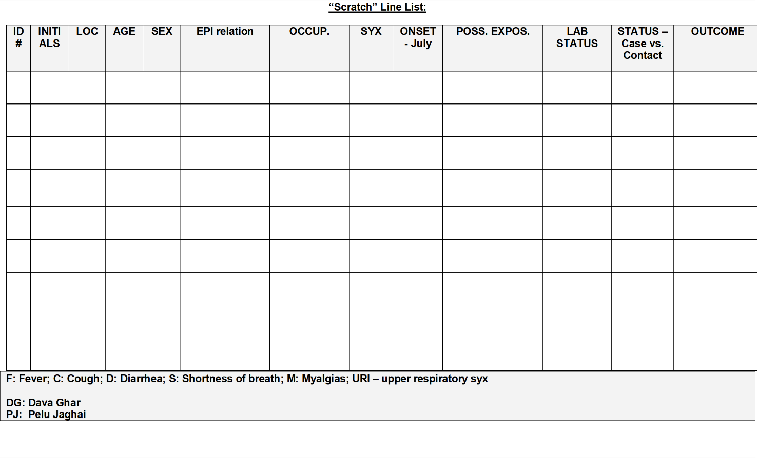

NOTE The blank line lists can be used by partners that want to change the names or other characteristics of persons in this scenario.

