Response to the spread of Asian lineage avian influenza A(H7N9) virus into a previously unaffected country

Participant's Guide

Learning Objectives

After completing this case study, the participants from the country teams should be able to:

- Demonstrate effective strategies to establish human and animal surveillance to detect novel influenza A viruses.

- Demonstrate awareness of the important on-the-ground complexities and management issues during poultry outbreaks of avian influenza and investigations of human infections with novel influenza A viruses.
- Understand influenza virus-specific concepts that include: appropriate surveillance strategies in humans and animals, specimen collection and transport in humans, laboratory testing, epidemiologic risk factors, transmission mechanisms and contact tracing, control and prevention, isolation/quarantine concerns, treatment in humans, control measures in humans and animals, risk communication principles, laboratory diagnostic methods, the pros and cons of poultry vaccination, and ethical considerations.
- Gain an appreciation for important novel influenza A virus coordination efforts involving the interface between animal and human health sectors, key stakeholders such as the WHO, FAO, OIE, Ministries of Health, Ministries of Agriculture and communication processes between field staff, headquarters and relevant subject matter experts.

Background

Tropica



Tropica is a lower-middle income country that contains 21 provinces and has a population of approximately 30 million people concentrated primarily in the central and southern coastal regions.

Geography: There is a tropical monsoon climate. Tropica is bordered by five other countries on the Western, Eastern and Northern borders, but faces the ocean on its southwestern border. Rural, transient migratory human populations regularly cross these borders and have prompted attempts at coordinated infectious disease surveillance activities between these countries. The 75% of the population that lives in rural areas does not have access to highways. Road conditions become very poor or impassible during the monsoon season, and in a recent health survey 30% of rural population respondents indicated that they would not bother taking sick family members to local hospitals but instead would go to their village healer.
Health problems: Malaria, cholera, plague, dengue, dysentery, watery diarrhea, and viral hepatitis are endemic with somewhat cyclic epidemic patterns. Tropica has had positive environmental samples for polio (though no human cases despite good surveillance) in the recent past so there are enhanced vaccination and surveillance efforts that will continue for at least three years. There is therefore a well-established grassroots polio eradication infrastructure. Village health volunteers are trained to report priority conditions (e.g. dengue and dengue hemorrhagic fever) to sub-district health officers and participate in mosquito larva control activities. Zika virus, and chikungunya have been also become increasing problems in the country.

Health care: The Tropica Ministry of Health is the focal point for planning, organization, financing, regulation and provision of health care for the population. Hospitals within the country include teaching hospitals, specialist hospitals, provincial hospitals, district hospitals, and local health stations/traditional clinics. Every district has a 16-50 bed hospital, with a district medical officer who has both public health (i.e., preventative) and curative responsibilities. Influenza antiviral medications not commonly used to treat influenza though the Ministry of Health maintains about 500 courses of oseltamivir for treatment in an emergency situation. There is some concern that they will expire soon.

There is an uneven geographical distribution of health care with poor quality of care and low service utilization in rural areas. However the leadership represented in the village health committees has connected those who traditionally lack adequate healthcare to health care providers, and has greatly facilitated public health campaigns associated with vaccine-preventable diseases, allowing them to be relatively successful both in terms of mass immunizations and disease surveillance.

Public Health laboratory testing capabilities for influenza viruses: Most district hospitals and traditional hospitals have very limited laboratory capacity. Some provincial and private hospitals have PCR capacity and receive external quality assurance checks from the central human (National) laboratory. Some of these hospitals can undertake rt-PCR analyses for seasonal influenza but do not have the materials to test for novel viruses. The national laboratory can perform real-time RT-PCR assays for seasonal influenza A/H1, A/H3 and B viruses as well as for avian influenza A/H5 and A/H7 viruses. They have passed recent external quality assessment tests using the WHO influenza reagent kits. The closest WHO regional reference laboratory for novel human influenza viruses is in the country to the Southeast of Tropica.

Animal Health laboratory testing capabilities for animal influenza viruses: The national/central veterinary laboratory has capabilities to detect low (LPAI) and high pathogenic avian influenza (HPAI) A viruses including A/H5 and A/H7. All samples must go to the national veterinary laboratory for real-time RT-PCR testing. Any additional testing is required to be submitted to the regional OIE Veterinary Reference Laboratory also in the country to the Southeast of Tropica.

Human surveillance and response infrastructure: There is a national notifiable disease surveillance system that requires a standard “minimum data set” from hospitals. The vital records system captures about 90% of urban and 50% of rural births. Acute flaccid paralysis (AFP) surveillance is conducted throughout the country although significant cold chain challenges remain in rural areas. There are six Influenza-Like-Illness (ILI) and Severe Acute Respiratory Illness (SARI) sentinel sites that collect specimens to be tested at the central human laboratory for influenza viruses. This influenza surveillance system is working well but is funded externally and a sustainability plan for this surveillance system is currently in preparation. Rapid response teams exist at the provincial and district levels are subject to staff turnover and there is variability in team quality and viability by district (some are outstanding and some quite unorganized).

Poultry surveillance and outbreaks: There is a network of local veterinary epidemiologists who have reported poultry die-offs to district, provincial, and national agricultural authorities in the past. This reporting remains in place but in the absence of poultry die-offs there is no active surveillance of healthy birds or environmental sampling currently in place. In the past there have been effective responses to highly pathogenic avian influenza A virus outbreaks in poultry, and there are sporadic outbreaks of HPAI A(H5N1) virus in domestic poultry. However no outbreaks have been reported during the current year. For smaller poultry die-offs there has been limited testing of birds, but during large outbreaks the central veterinary laboratory has received specimens and provided timely results. However, there have been sporadic local complaints in the media about low quality poultry with “poor egg production” in the southeastern region of Tropica. The farmers have been upset that they have been purchasing “lower quality imported chickens.” However on inspection many/most chickens appear healthy. Notwithstanding the Ministry of Agriculture has the desire to increase some surveillance for poultry die-offs, and even among healthy chickens when no die-offs are occurring, in this and other priority regions thought to be at risk along the value chain for avian influenza virus importation.

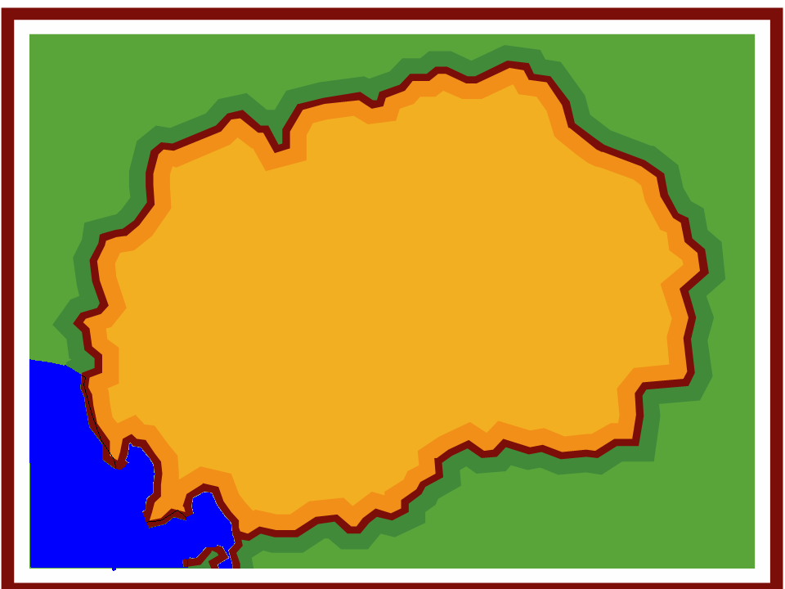
Tropica Provincial Hospitals
Palmtown
Pelu Jaghai
Dava Ghar

The month is June of the current year. You are an internationally renowned epidemiologist and you have been sent to Tropica with a similarly well-regarded veterinary colleague. The MOH and MOA have requested you to help them enhance human and poultry surveillance for novel influenza A viruses. Tropica already has six sentinel sites for influenza that systematically detect and collect specimens from outpatients and inpatients meeting the WHO ILI and SARI case definitions. However you have been asked to enhance broader surveillance in an attempt to improve the sensitivity and timeliness of detecting emerging respiratory pathogens, with a specific concern about influenza, in humans and animals. This is part of an effort to help Tropica meet its obligations under the International Health Regulations (2005) to meet needed core capacities for pandemic early warning surveillance.

An event-based reporting protocol exists linking the local village volunteers and health workers to District Health offices but this system is inconsistently used. There is an on-line application for smart phones and a hotline number used for reporting to local rapid response teams. With regard to poultry, a recent market (value) chain analysis (that identifies the main routes of poultry trade in Tropica) undertaken under the guidance of the UN Food and Agriculture Organization in Tropica suggested that there were five important regional distribution points for imported poultry. Some of these included the direct (and somewhat informal) transport of birds from a neighboring country known to have active circulation of several novel influenza A viruses [including avian influenza A(H7N9) virus] in local poultry populations. Some of these viruses are known to produce few or no signs and symptoms in infected poultry or wild birds (i.e., LPAI), yet they can cause severe disease in humans. This analysis also produced a set of live bird market network maps along poultry market chains with descriptions of how biosafety and security could be improved.

Question 1 (Write answers on a separate sheet of paper): The Ministry of Agriculture approaches your veterinary colleague and asks: “From the perspective of poultry surveillance, what types of activities might be recommended? What level of risk is Tropica at for a virus such as avian influenza A(H7N9) in poultry?”

New information available

The results of the market chain analysis suggest a specific importance of undertaking enhanced surveillance in Dava Ghar, Pelu Jaghai and several other local communities in the Southwestern part of Tropica. The Tropica Ministry of Agriculture has already been undertaking some focused testing of poultry for avian influenza A viruses in Dava Ghar and Pelu Jaghai. However you work with them during the next few days to thoughtfully expand surveillance into additional live poultry distribution areas thought to be at risk, such as main market chain distribution points or major live bird markets. Due to your combined efforts, active surveillance now, for the first time, includes healthy birds at locations when no poultry die-offs are occurring.

Question 2: From the perspective of human surveillance, what types of triggers for investigation (within the existing EBS protocol of Tropica) might you provide refresher training on? How might this differ for health care workers or community volunteers?

New information available

JULY 15:

It is now the morning of July 15, and you receive a call from a recently trained staff doctor at Dava Ghar hospital who notified the District Health Office that they have admitted two persons with “very severe” respiratory illness. The doctor is concerned that his patients may have “severe pneumonia, MERSCoV, or possibly a bird flu.”
Apparently, the two patients are related – a 65 year-old grandmother (JAM) and her ten-year old grandson (AAJ). The grandmother (JAM) resides in the same house as her husband (AWM), and both live in a house near the grandson’s house in a small mountain village in the province. This village is almost 60 km away from the hospital.
The child’s father was away in a nearby city during the week of illness onset and the grandmother (JAM), who is chronically in ill-health, became a caretaker of the child on July 11th along with the mother (DBJ) who lives with the child. The grandfather (AWM) also helped despite his elderly status and chronic heart illness. The child (AAJ) was brought to the hospital by his family two days ago and presented with fever, cough, diarrhea and shortness of breath.
The only pertinent history you are able to obtain regarding potential exposures is that the child visited a live bird market (called the “Murg Market”) with his mother (DBJ) and uncle (SJO) in Pelu Jaghai province (where his friends and relatives live) on July 8th.

The Director of Epidemiology of the MOH, following communication with the Ministry of Agriculture has determined that the Murg market was a central distribution node for poultry and determined to be at some risk for the spread of avian influenza. Poultry specimens were collected as part of the newly enhanced risk-based surveillance system about 20 days earlier and sent to the central agricultural laboratory for testing. You obtain the history that the boy played with chickens and a small dog, helped pour water into a chicken defeathering machine, and played with chickens at the live-animal market event with a friend. Shortly after hospital admission yesterday, the child’s condition rapidly declined because of worsening respiratory distress. He was started on ceftriaxone for treatment of suspected bacterial pneumonia. The mother (DBJ) is asymptomatic. The grandfather also denies any symptoms. The grandmother reports that her ongoing respiratory condition suddenly worsened on about July 9th. There are rumors that there are additional sick persons in a village in the adjacent nearby province, Pelu Jaghai.

Later on July 15th, after a call made by the MOH to the central animal laboratory, you learn that several specimens from the Murg market, including those from the group of chickens AAJ was playing with, had already tested positive for avian influenza A(H7N9) virus. Later a senior official abruptly added that “final confirmation has not occurred” and testing has been under way for the past 4 days.
Question 3:
Is it possible that opportunities have already been missed to prevent possible human exposures to avian influenza A(H7N9) virus? Why?

To be conservative and to protect the community the Director of Epidemiology decides to treat this as an investigation of a case of laboratory-confirmed avian influenza A(H7N9) virus infection in poultry.
Further clinical history, obtained over the phone, reveals that the child (AAJ) became ill on July 10th and was admitted to the hospital almost 4 days later. By the 2nd day of illness (July 11th) the child’s grandparents started assisting the mother with care of the child. The family was very distressed and kept close vigil taking care of the child for almost 48 hours in the village starting on July 11th. By the 3rd day, the child was deteriorating and also had a documented temperature of 38.7 °C (101.7° F). The family decided to bring him to the Dava Ghar hospital, despite the long distance. The child arrived in unstable condition late at night on the 13th (admitted in the early morning of the 14th). A nasal swab collected upon admission and tested for only seasonal influenza at the provincial laboratory tested positive for influenza A virus but negative for Influenza A(H1), A(H3) and influenza B. The chest X-ray on admission is shown.

Child (AAJ) CXR on Admission (10 year old boy)
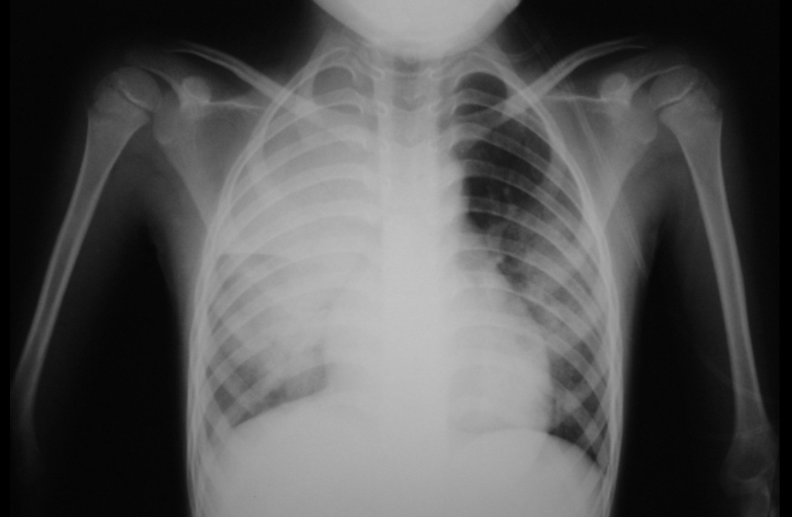

AAJ’s illness had rapidly progressed requiring respiratory support and he was placed on a mechanical ventilator. His status was deemed critical with this life-threatening pneumonia. You learn that the grandmother (JAM) has had long term chronic cough and dyspnea for the past 18 months. She also has had a temperature of 38 degrees Celsius since July 9th. Her condition was not improving but also had not worsened. She wanted to be near the child, and given her frail condition and ongoing respiratory symptoms a decision was taken to also admit her to the hospital for monitoring. The grandmother repeatedly denied any visits to the Murg market or contact with poultry.

On the phone the doctor said that no more clinical specimens were available for further testing as the provincial laboratory only had minimal nucleic acid available from the specimen for testing. The doctor said he would talk to the family about collecting more specimens from both patients for laboratory testing though he seemed very focused only on clinical management questions. It is the monsoon season and you then lost phone contact and could not continue that conversation despite your best efforts.

Question 4: You and your team realize the need to develop case definitions for this outbreak investigation. What are the critical components of a case definition?

Question 5: Have your team develop a suspect, probable and confirmed case definition for this outbreak. However after the discussion, for the sake of standardizations, please use the case definition below for further case characterizations. Note that case definitions may always be adapted to the local context to confirm any case of novel influenza A(H7N9) in humans.

Question 6: Using the case definition above how would you classify AAJ (the 10 year old boy) and JAM (the 65 year old grandmother)?

Question 7: What are appropriate laboratory tests for the confirmation of influenza A(H7N9) virus in humans and poultry in this setting? What minimum capacities are needed to establish RT-PCR testing in Dava Ghar?

Question 8: You realize that you will likely need to start creating a line list for your
investigation. What categories of variables might be included?

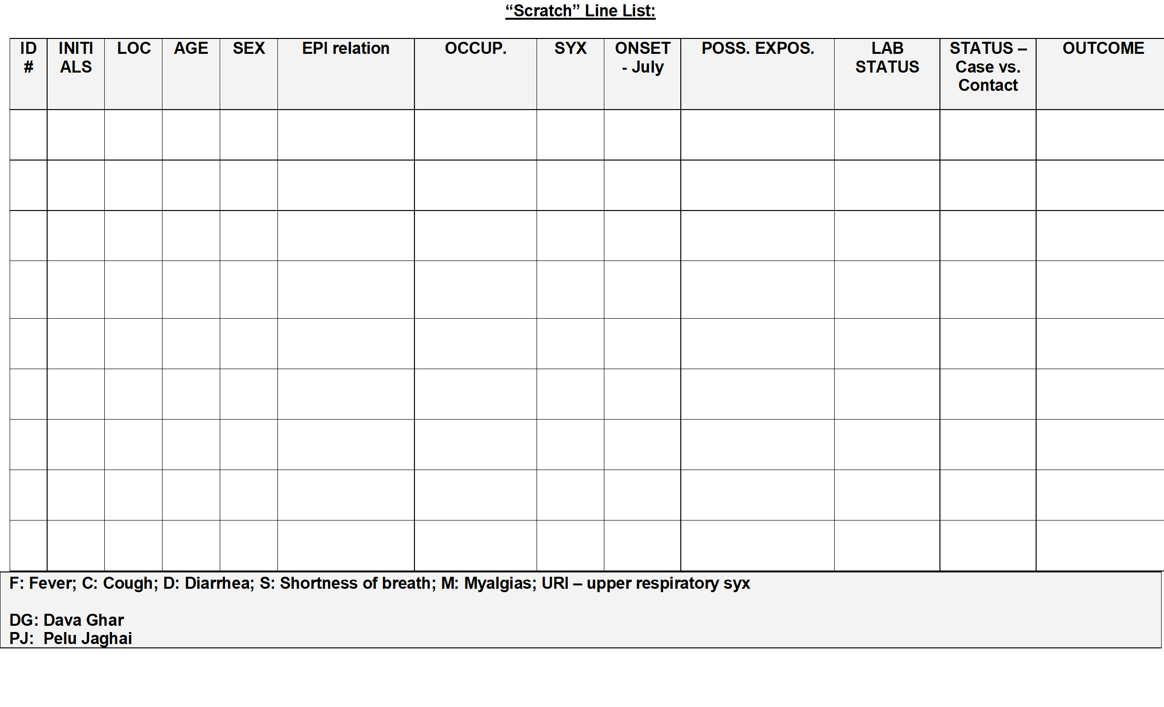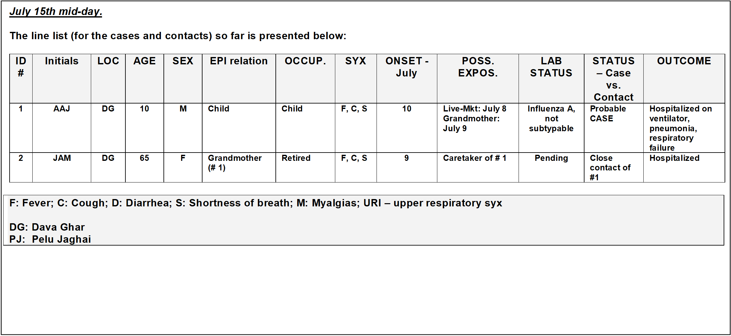

Question 9: What criteria should be used to define who is a close contact of this probable
case? Is JAM a close contact? What testing is needed for JAM?

Question 10: If limited quantities of neuraminidase inhibitor antiviral drugs are available, should AAJ and JAM be given antiviral prophylaxis or treatment? Should family members of AAJ be given antiviral chemoprophylaxis? How about health care workers who treated AAJ?

Question 11: If there are not enough antiviral resources to provide antiviral treatment to all close contacts, how should you prioritize resources?

New information available

JULY 16th:

The hospital is a 5 hour car ride away and your rapid response team doesn’t arrive at the Dava Ghar hospital until the next day (July 16th). You go directly to the hospital to begin the investigation. You are told the following:

The boy’s (AAJ) admission vital signs had been as follows: a temperature of 39○C, heart rate of 120, tachypnea at 30 breaths/minute with a blood pressure (BP) of 90/60. His oxygen saturation on room air was 88%; he was subsequently intubated on July 14th and placed on mechanical ventilation. He became hypotensive and went into renal failure. Despite aggressive measures, he died on the morning of the 16th, prior to your arrival.

You and your team are quite frustrated when you are told that the staff did not want to collect additional nasal or throat swab or endotracheal aspirate specimens because they felt the child’s condition was “too severe” and this would hurt him. The parents were frustrated and didn’t want more testing “just treatment”. Cultural practices and the family’s wishes precluded any further post-mortem evaluation. The child has been cremated quickly and the reasons for this are not clear though some mentioned fear in the community.

Question 12: Had your team arrived earlier, what might you have said to increase the chances that proper additional specimens had been collected from the boy (AAJ) for influenza A(H7N9) virus testing? What could you have done after the boy had already died in order to learn more about his infection?
New information available

The grandmother was verified to be a caretaker of the child (AAJ) and presented to the hospital in moderate respiratory distress. Her vital signs were as follows: temperature of 38.5○C, a respiratory rate of 28 breaths/minute, BP of 160/95 and an oxygen saturation on room air of 90%. The grandmother’s initial laboratory findings included high lymphocyte / leukocyte counts. She is not intubated. You and your team recognize that you will need to quickly determine whether you’re dealing with A(H7N9) virus infection or some other pathogen. You are justifiably concerned that this may in fact represent an outbreak related to a novel influenza A virus with pandemic potential. You decide to send biological samples from the grandmother to the national laboratory for testing.

Question 13: What specimens need to be collected from the grandmother?

Question 14: How and with what materials/procedures should the combined NP and OP specimens be collected from the grandmother?

Question 15: How should the swab specimens be stored, packaged, handled and
transported?

Question 16: What clinical data need to accompany the laboratory specimens?

As part of contact tracing, you want to identify all of the potentially exposed individuals who have had contact with the probable case (AAJ). In a team meeting, you review available information and determine that the mother (DBJ), uncle (SJO), and grandparents (JAM and AWM) qualify as contacts using the previously established criteria.

Question 17: Update the line list with the known contacts. : as of July 16th a.m

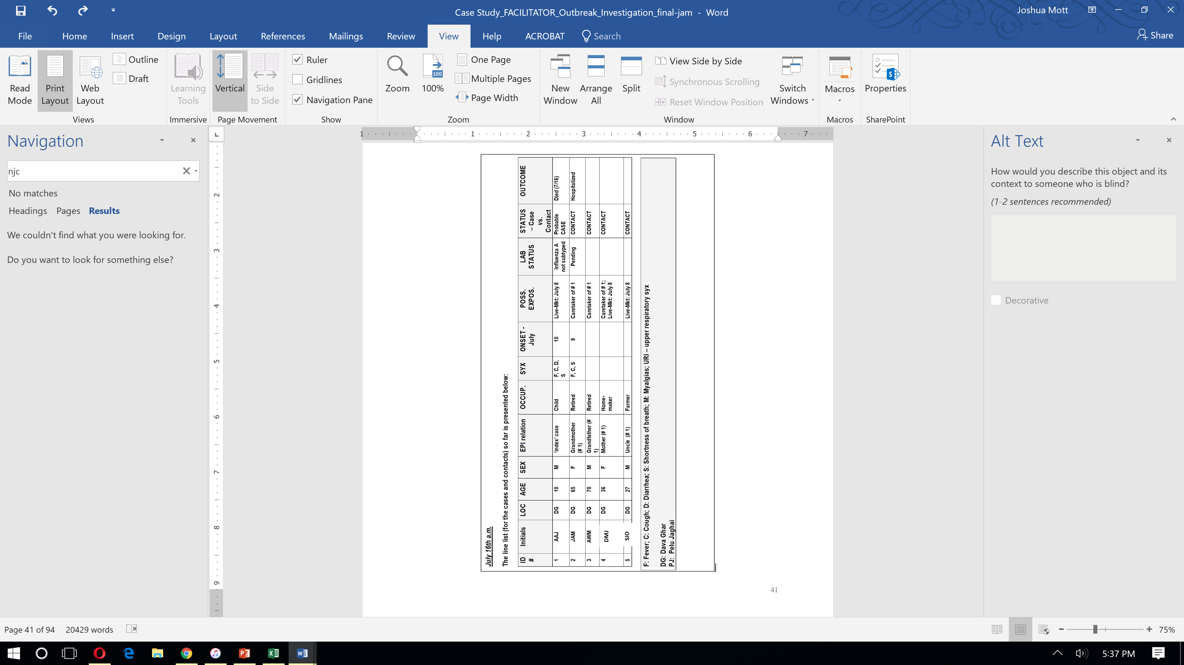
DBJ
Question 18: What specific places would you visit and who would you speak with to
Determine if there are additional cases and contacts to be concerned about?
What would your specific activities be at each of these places and with each person?

Question 19: Once you have identified contacts how long should you follow them?
What should be done if these contacts develop ARI, ILI or SARI symptoms?

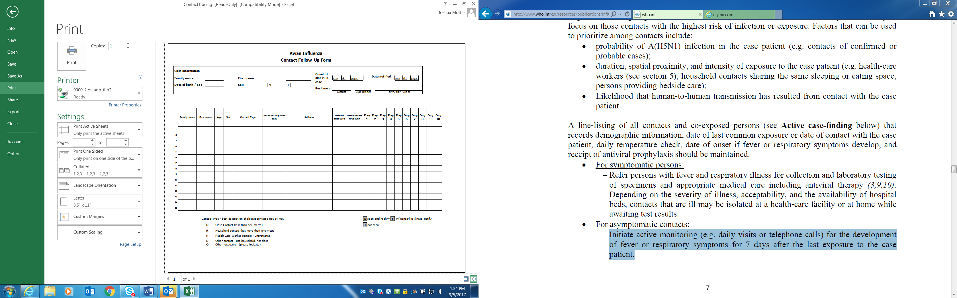

New information available

As a result of additional case finding and sensitization activities undertaken by your team, a village health committee leader in nearby Pelu Jaghai has reported that there is also a child with unexplained respiratory illness there. The Director of Epidemiology recommends that you and part of your team go out to meet the MOH field workers in Pelu Jaghai and make site visits to the local hospital and villages. The Director of Epidemiology states that he will stay and manage the situation in Dava Ghar. You visit the Pelu Jaghai hospital that day (July 16th). You are told by the staff doctor that yesterday they admitted a child of 11 years of age (TMU) for a severe respiratory illness characterized by fever, cough and shortness of breath that began on July 12th. He is critically ill but not intubated and is available for clinical evaluation. He has been kept in an improvised isolation room on one of the hospital wards. You and your team
members put on your PPE, evaluate the patient, review the medical charts and interview some available family members. The mother (AMC) of this boy (TMU) isn’t a very good informant and cannot provide details about her son’s recent history except that the boy was healthy up until July 12th when he developed illness. She recalls that the boy also visited the Murg market on July 8th as this was within walking distance of their house. No one else from her family visited the Murg market or touched chickens from the market. The boy is started on antiviral treatment and diagnostic specimens are collected.

Question 20: Update the line list: as of July 16th p.m.

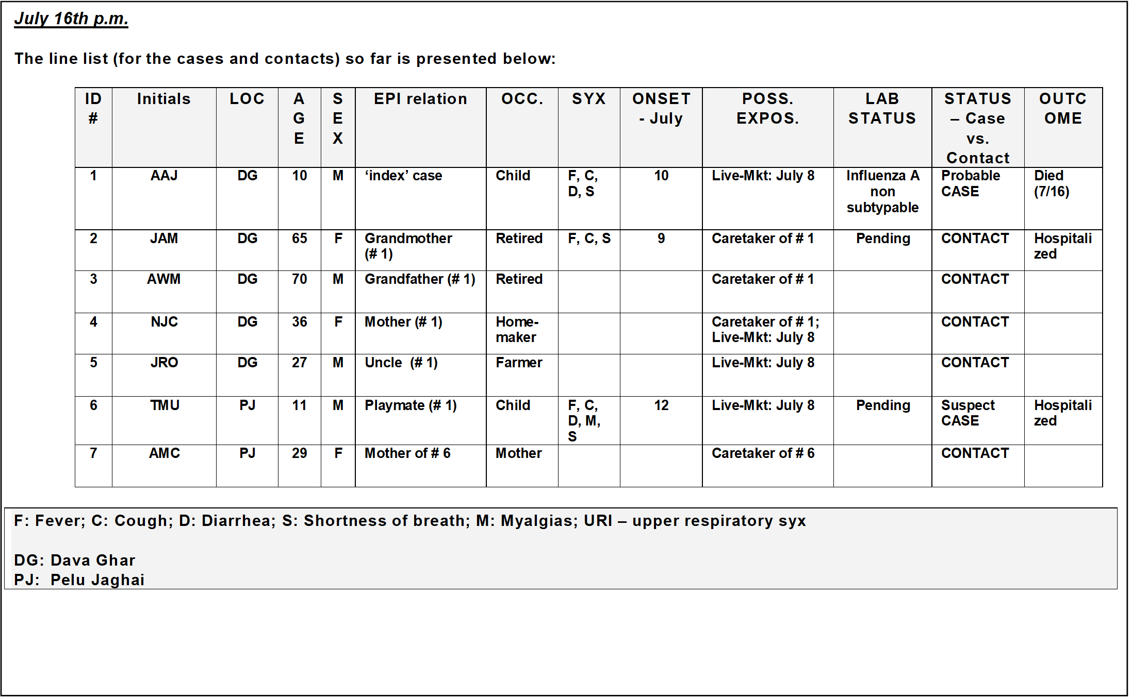
SJO
DBJ

Question 21: You and your medical colleagues realize the need to clinically evaluate TMU.
What clinical features might distinguish novel influenza A(H7N9) virus infection
in humans from seasonal influenza A or B virus infections?

Question 22: The Minister of Agriculture calls your veterinary colleague. She says that she
now has definitive confirmation of avian influenza A(H7N9) virus in chickens from the
Murg Market, as well as from environmental samples collected from the
defeathering machine. She would like to close, clean and disinfect the market, and
depopulate all of the poultry. She also asks for your team’s recommendations for other live
bird markets. What is your response?

Question 23: The office of a senior government official is also very concerned about the
economic impacts of this outbreak and wants to purchase a new A(H7N9) poultry vaccine
from a neighboring country and begin vaccinating all poultry in the country with emergency
funding. What is your response? What things would you consider if you pursue vaccination?
What problems could arise due to pursuing vaccination and how would you prevent or
address these possible problems?

New information available

JULY 17th:

The hospitals in Dava Ghar and Pelu Jaghai both have probable cases of human infection with novel influenza A(H7N9) virus in their wards. Understandably, the hospital physicians and nurses are concerned about health care worker safety. You must review infection prevention and control practices, respiratory hygiene and worker safety issues with the staff doctor.
Question 24: What are some specific questions about infection control that you will seek answers to at the hospitals?

Question 25: What are the five important times (moments) for Hand Hygiene:

Question 26: A triage nurse wearing an N-95 respirator raises a concern that N-95 respirators
are in short supply. She asks you who these should be prioritized for?

New information available (Participants should be taking notes)
You are intrigued by the possibility that there may be a possible epidemiologic connection between this 11-year old boy (TMU) in Pelu Jaghai and the 10-year old boy (AAJ) in Dava Ghar through a common potential Murg market exposure. Through additional interviewing you also learn that the two boys played a local children’s game ~ ‘hu-tu-tu’ called ‘chasing after the chicken’ at the live-market. During this game they enjoyed chasing what appeared to be one of the slower and unsteady chickens before it was placed in the defeathering machine. You oversee the appropriate collection and transport of respiratory specimens from this 11 year old (TMU). You get the history that it was the uncle (SJO) of the 10 year old (AAJ) who took him to the live-bird market. You return to Dava Ghar on the late afternoon of the 17th, tired and anxious that there are possibly other human cases of novel influenza A(H7N9) virus infection that you are missing.

JULY 18th:
On the morning of the 18th, you go with the staff doctor to make rounds on the ward to see the grandmother (JAM) and to conduct active case surveillance for any interim cases of respiratory illness. You find that the grandmother is coughing copious amounts of yellow sputum with occasional hemoptysis, and though she is laboring to breathe, she is not progressing to respiratory failure. She is still in isolation; you are given the real-time RT-PCR results of the laboratory testing of specimens. The results are negative for influenza A(H7N9) virus. One of her sputum specimens was positive for acid fast bacilli. Her chest x-ray, which you had not been able to see initially, now shows evidence of an upper lobe cavitary lesion, and a presumptive diagnosis of active pulmonary tuberculosis is made.

As part of the team’s daily updates, you are also told that the grandfather (AWM) now has been documented to have a new fever and complaints of myalgias and a worsening lower respiratory infection. Being frail and very anxious about JAM’s condition, he hadn’t really ventured out of her hospital room. He wore an N-95 respirator almost continuously and sat by her bedside in deep concern. He has congestive heart failure due to chronic hypertension. Though he had already been started on antiviral treatment doses of oseltamavir, his clinical status rapidly worsens.

Later on the 18th, you intend to get your team members together and create a more detailed summary of the ‘cases’ to date and to tally any data that they have acquired from their active case surveillance efforts. Your team also informs you that the combined OP/NP swab specimen from the 11-year old child (TMU) is positive for influenza A(H7N9) virus by real-time RT-PCR. Both the probable case (AAJ) and the confirmed case (TMU) have been reported to the WHO, which is mobilizing resources to assist in the investigation. This reporting is essential to obtain additional resources to support a more robust response in Tropica now.
Question 27: What are the international reporting requirements in the above circumstance?

Question 28: Update the line list - as of July 18th p.m.
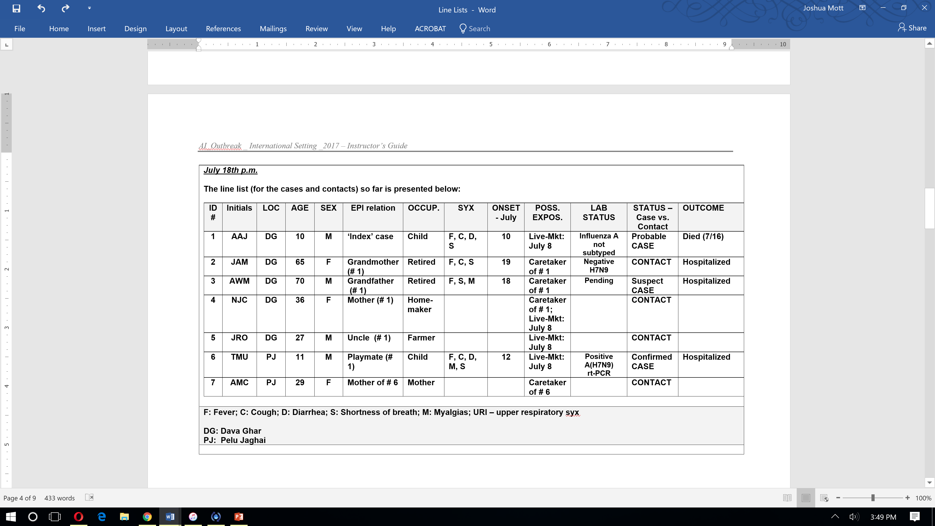
DBJ
SJO
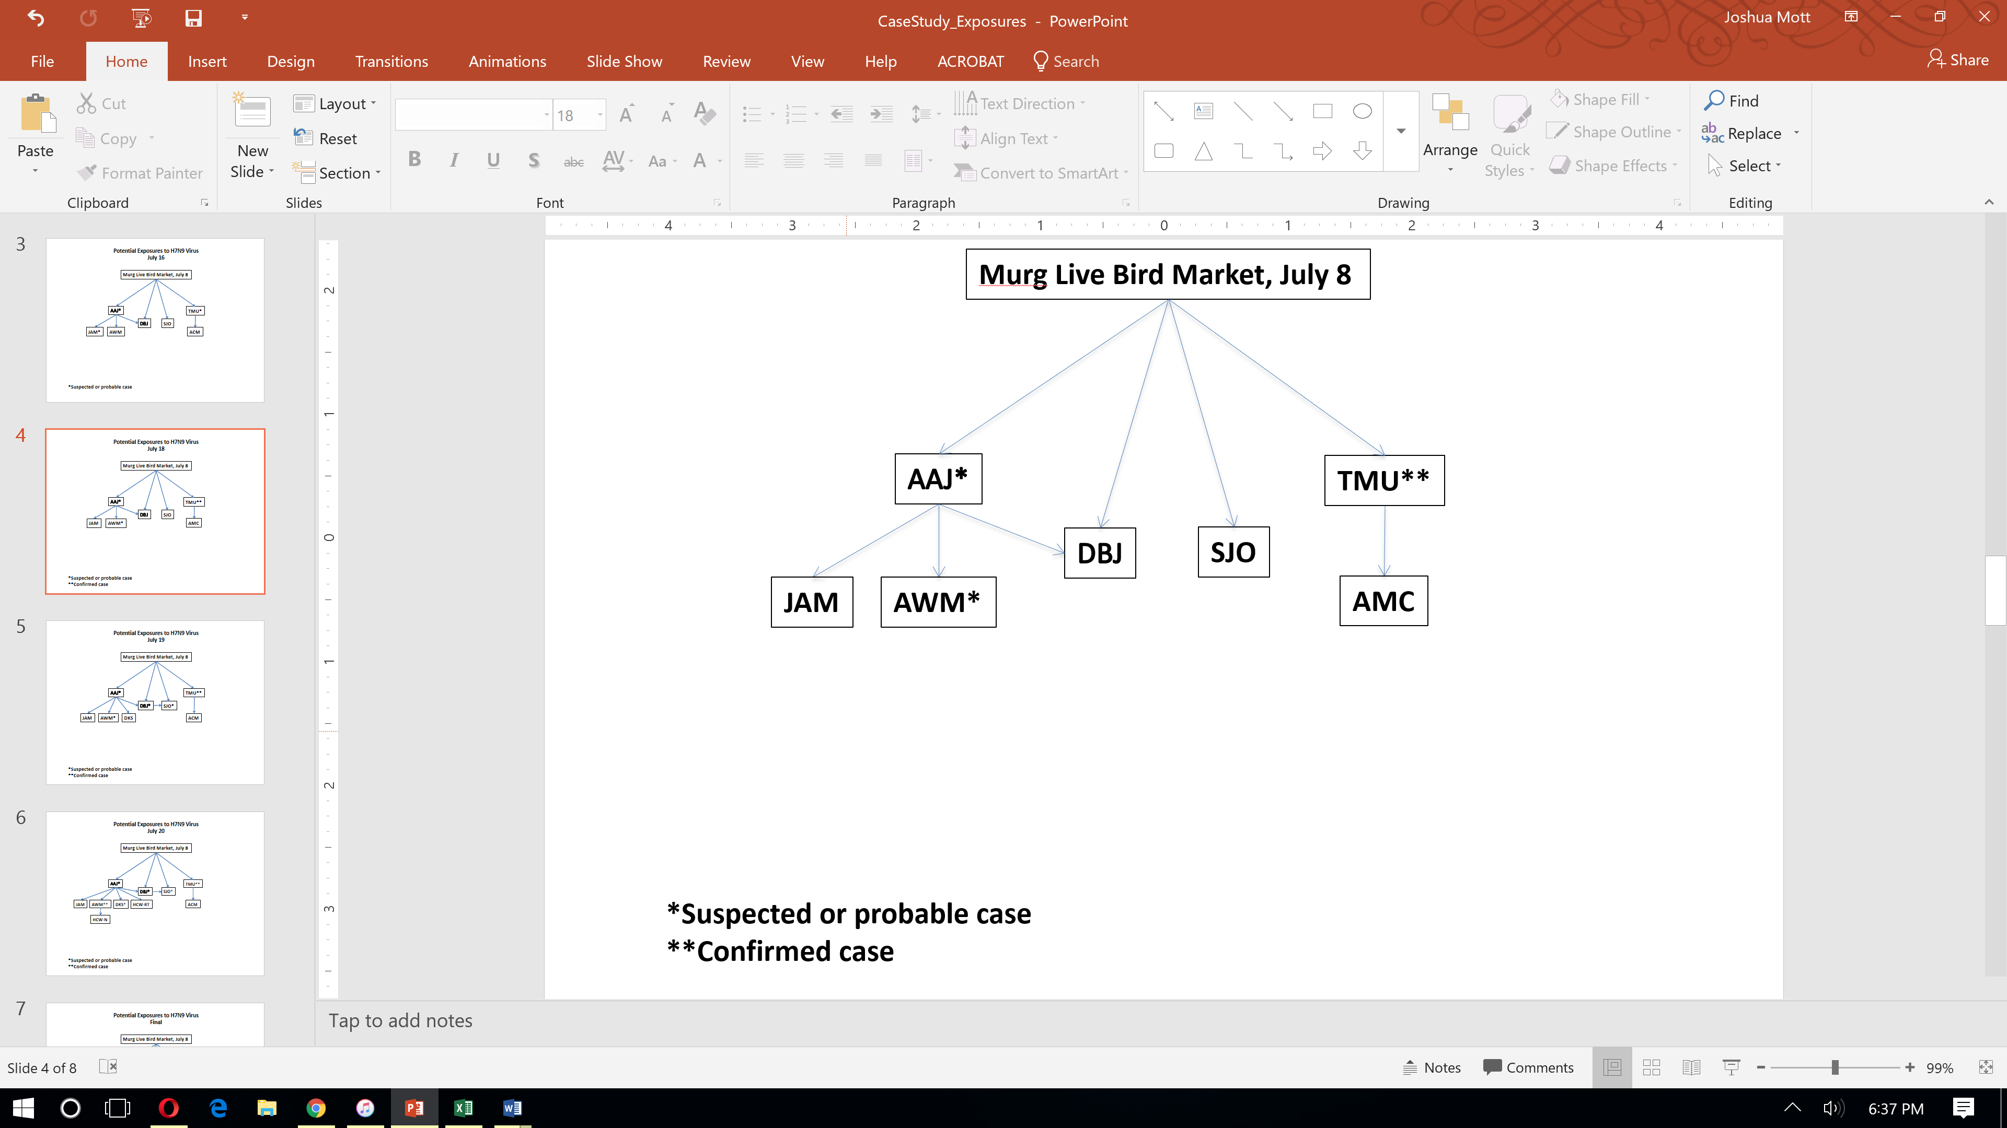

New information is available

As you take a short walk to collect your thoughts you receive an urgent message on your cell phone from the Director of Epidemiology. He has just been notified that a reporter from the regional newspaper is pursuing a story on the ill patients in the adjacent province. Somehow the reporter has learned of the ‘potential’ exposure at the July 8th live-market and wants to write an article notifying the public. The Director of Epidemiology repeatedly states that he wants to talk directly with the reporter and maybe even conduct a press event. He asks you for a list of ‘talking points’ to be created by your team and then shared with the Public Information Officer (PIO) who works with the MOH. He also wants you to help write a situation report for his Director General of Public Health.

Question 29: What are the key principles and basic goals of emergency risk communication in this kind of situation?

Question 30: What are three key communication messages that could be used to provide the public with an update of the current situation?

Question 31: What are the essential components of a situation report?

New information available

Now that you feel good about yourself for having handled these media coverage and reporting duties, you return to the team on the early evening of July 18th to summarize the investigation to date as you had originally planned. Instead your team says that there is a problem that has arisen with some of the family members of the little boy (AAJ). You are told that the mother (DBJ) and the uncle (SJO) called the MOH from their home telephone and indicated that they have runny noses and “feel a little weak.” DBJ first began to feel ill (on July 19th) and then about 10 hours later, SJO began to feel ill. Because they live 60 km from the hospital they are worried that if they fall ill they will not be able to obtain timely health care. They want to be hospitalized.

Question 32: The mother (DBJ) and the uncle (SJO) ask you and the Director of Epidemiology if they can come to the hospital now but the hospital staff is worried that many more people will request the same treatment. How do you respond?

Question 33: If an asymptomatic person with known exposure to a confirmed human case of avian influenza A (H7N9) virus infection refused to accept voluntary quarantine, how would you respond?

New information available

A local temple has been offered as a potential site for quarantine and the mother and uncle agree to move there as it is only 5 kilometers from the hospital. DBJ and SJO will self-monitor for presence of fever and alert the local health committee with any change in their health status. When you again ask DBJ about any other family members who may have been around the 10-year-old (AAJ), she now tells you that there is one 19 year old brother (DKS), who is a university student in the city of Palmtown and came just to take care of his little brother during the family vigil on July 12-13th. He had gone back to the university on the 14th for exams.
JULY 19th:
The next day (July 19th) you learn that the 11-year old boy (TMU) is intubated and critically ill. Later that evening the Director of Epidemiology informs you that both the mother (DBJ) of the boy who died (AAJ) and AAJ’s uncle (SJO), have now been admitted to the hospital with cough, fever, shortness of breath, and pneumonia noted on chest x-ray. Additionally the mother also had severe myalgia, diarrhea and a mild sore throat. The mother provides more history that she in fact did care for her boy while he was sick at home; she recalls she and her parents (JAM and AWM) being close by the boy at home during the 48 hours prior to his admission to Dava Ghar Provincial Hospital.

JULY 20th:

You begin the day by getting updates from the MOH team. You are also told that the 19 year old student sibling (DKS) now has fallen sick (onset of symptoms – July 20th) – with fever, shortness of breath, and cough. He returned to his home province because he was not feeling well. He completely denied having attended any live-markets and any contact with dead or ill poultry as he was either at his brothers bed-side, or at school.

Later that morning you receive word that the grandfather (AWM) has died with multiple complications, including renal failure, encephalitis and ventricular arrhythmias. You are not surprised to learn that he died of influenza A(H7N9) virus infection – as confirmed by RT-PCR testing of respiratory specimens.

Question 34:

Update the line list - as of July 20th afternoon

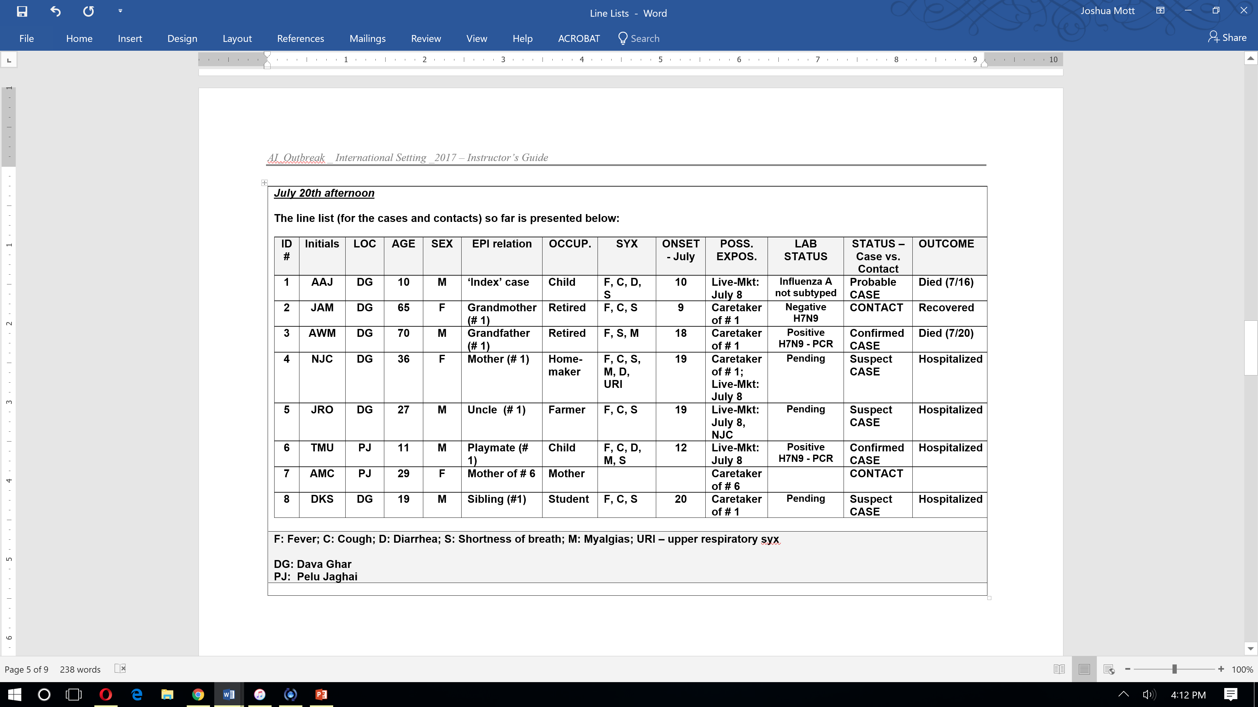
SJO
DBJ

New information available

You don’t have the appetite given all the tension but you manage to eat a bowl of vegetable and noodle soup. Before you finish you are approached by some scared health care workers (HCWs), including the respiratory technician (HCW-RT) on duty when the 10-year boy (AAJ) died. He reports having worn PPE but he thinks he “felt droplets touch his face” on July18. He is now running a fever and very worried. Additionally there are two other HCWs who are demanding something be done about their potential exposure to the deadly A(H7N9) virus.

There was a nurse (HCW-N2) who took care of the grandfather during the last hour of his life and helped in taking care of the body post-mortem. She is unsure if she wore all of the required PPE at all times. There was also a traveling nurse (HCW-N3) who recalls how scared she was even though she had adhered to contact and droplet precautions when briefly taking a meal tray into the grandfather’s hospital room. Neither have any signs or symptoms of respiratory illness.

Question 35: What are your antiviral use recommendations for these health care workers?

The respiratory therapist who took care of the 10-year old (AAJ), nurse #1 who treated the grandfather (AWM) and handled the body post-mortem, and nurse #2 who brought the grandfather a meal all request antiviral therapy. Assuming limited supplies of oseltamivir are available, who do you recommend should receive antiviral treatment, why, and at what doses?

New information available
Later that evening (July 20th), your colleagues return from Pelu Jaghai having completed their case investigation and contact tracing. You also learn that DKS now has radiographically-confirmed pneumonia. The two teams find a room in the hospital to update their line lists and review all of the epidemiologic data.

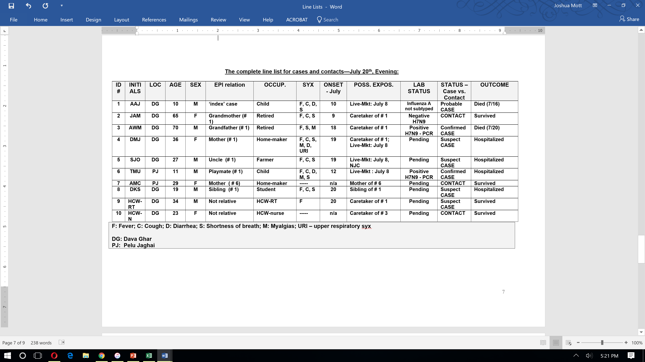
DBJ
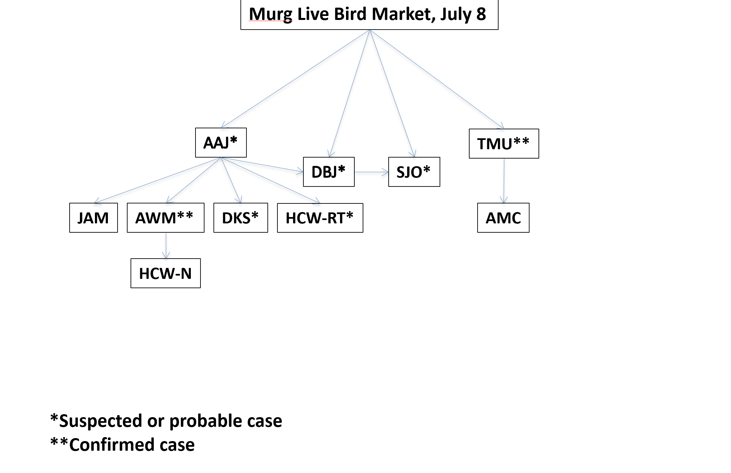

Question 36: Make an epidemic curve of the cases as of July 20th evening. What can be learned from the epidemic curve?

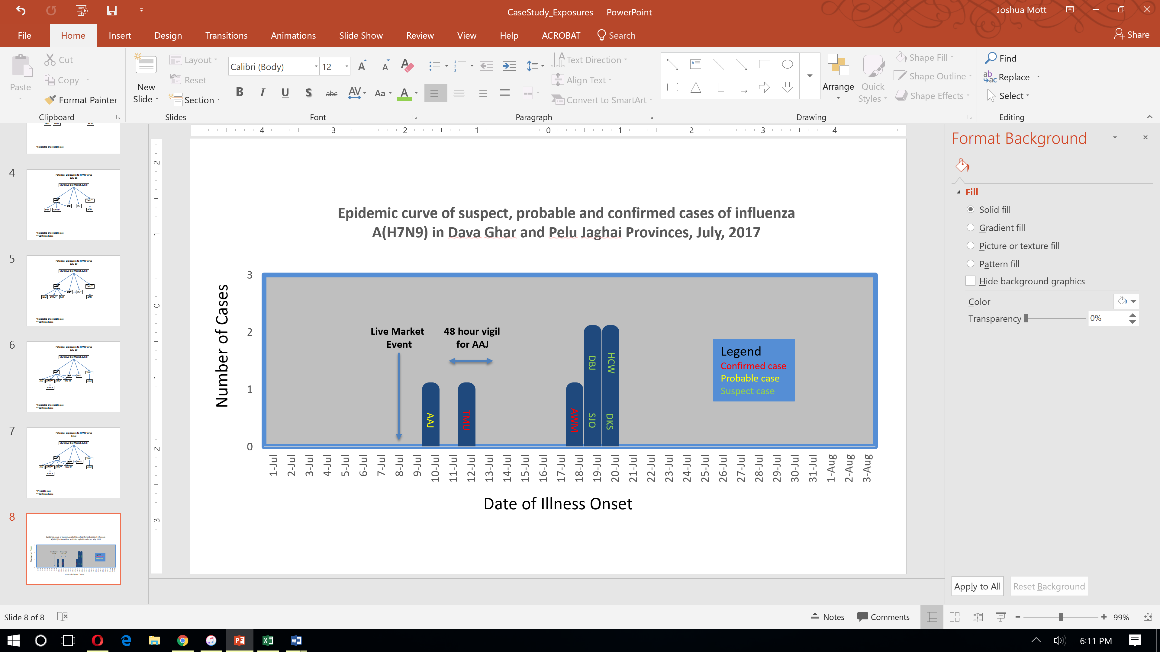

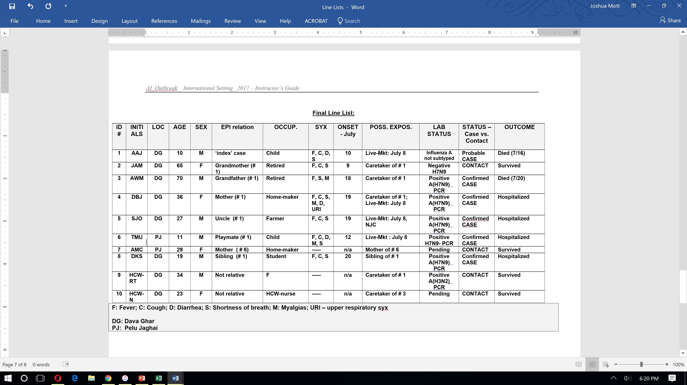

New information available
Update:

Over the next several days, the mother (DBJ), her brother (SJO), and the 19 y/o (DKS) are all confirmed positive for influenza A(H7N9) virus by RT-PCR and respiratory specimens are sent to the WHO reference laboratories. You also learn that all of the remaining individuals who were considered ‘contacts’ tested negative for influenza A(H7N9) virus. The respiratory therapist tested positive for influenza A(H3N2) virus.

Question 37: Considering all of the information available what is the likelihood that each case was infected with influenza A (H7N9) virus via human-to-human transmission? Fill in the table below and indicate is Not Likely, Possibly, or Likely for each person, based on their possible sources of exposure.

Question 37 Suggested Answer

HUMAN-to-HUMAN transmission?

ID # | INITIALS | LOC | STATUS – Case vs. Contact | Human-to-human transmission? | Possible Sources of Exposure
1 | AAJ | DG | Probable CASE
3 | AWM | DG | Confirmed CASE
4 | DBJ | DG | Confirmed CASE
5 | SJO | DG | Confirmed CASE
6 | TMU | PJ | Confirmed CASE
8 | DKS | DG | Confirmed CASE

New information available
Over the next 10 days you, the Rapid Response Team, the Director of Epidemiology and the relatives of many of the patients are saddened to see the demise of the mother (DBJ) of the 10-year old boy (AAJ). The uncle (SJO) and the 19-year old (DKS) survive though they received the same early interventions and medical care as the mother. The 11-year old boy at Pelu Jaghai (TMU) also dies during this time period.

You reflect on the investigation findings and the ongoing passive and active surveillance activities in the region, now also including Palmtown. The local FETP and polio-eradication networks have mobilized to follow all contacts in Palmtown. You are emboldened to realize that no more acute unexplained respiratory infections with an underlying epidemiologic link to cases, contacts or sick poultry have arisen.

Question 38: What would you do at this stage? How long must you wait before you and your colleagues consider this investigation closed and the outbreak(s) over?

New information available

By July 31st, you and your team receive information from the WHO Reference Laboratory that all of the A(H7N9) viral isolates that were obtained from infected patients were identical and were classified as Asian lineage LPAI A(H7N9) Yangtze River Delta virus strains. Sequence analysis also revealed that the influenza A(H7N9) viruses that were isolated were sensitive to the neuraminidase inhibitors oseltamivir and zanamivir, but resistant to the adamantane drugs amantadine and rimantadine. You finally pack your bags and return home to your family after a long and eventful stay in Tropica.

Question 39: Please fill in your answers on the handout your facilitator gives you. We will be collecting these for discussion later.

What are 5 key actions that might be taken in your country to improve preparedness following reflection on this case study?

1)

2)

3)

4)

5)

What are 5 ways that this case study can be improved to be even more useful for your own local training needs?
1)

2)

3)

4)

5)
