Class Exercise - Laboratory
Detection, reporting and characterization of novel influenza virus infections

Scenario 1 The following real-time RT-PCR pattern (using the CDC Influenza Virus Real-time RT-PCR Reagent Kit) is obtained from a sample collected one week ago from a SARI sentinel site hospital:

1. What is your interpretation of the rRT-PCR pattern?

Facilitator Answer: The specimen is positive for a Eurasian lineage H7Nx virus and negative for all other influenza A subtypes tested (H3, pdmH1). Because the CDC Eurasian lineage H7 test was used in this reaction, further characterization is needed to determine if the sample is positive for the H7N9 virus currently circulating in China or if it is a different lineage of H7.

2. What aspects of the laboratory assay would you want to verify?

Facilitator Answer: If a positive control was used in the rRT-PCR reaction, confirm that the influenza A positive control and H7 positive control were also positive. If other subtyping assays were tested, confirm that these were negative. Check that the No Template Control (NTC) was negative. If concerned about possibility of false positives, repeat the test to confirm the result.

3. What additional information would be important to obtain about this case from the national epidemiologist and the local-level surveillance officer?

Facilitator Answer: Based on detection of influenza A H7 positive sample, the clinical symptoms/outcome of the patient should be requested from the hospital. It would be important to know if the person was expose to birds, wildlife or other animals. It would also be important to know if the person had family members or close contacts that experience ILI. Make attempts to have epidemiologists contact patient’s family or contacts as follow-up. Collect additional samples from family members and close contacts if they experience ILI. It is also important to know if they received appropriate oseltamivir treatment. Otherwise, you might be compelled to start the patient on antivirals depending on date of symptom onset, status (alive/dead), etc.

4. What steps would you take to report this case, to whom, and with what time frame?

Facilitator Answer: Based on detection of a novel influenza subtype, the result should be immediately reported to national authorities. National authorities should report onward to Ministry of Health for further reporting to WHO. An IHR may be generated based on national policies. Consider contacting veterinary health authorities to follow-up on trace-back investigation if possible source of animal or environmental exposure can be identified.

5. In addition to information sharing as per question #4, what additional steps would you take to further analyze the sample?

Facilitator Answer: Because the CDC assay does not discriminate between the Chinese lineage of H7N9 and other Eurasian lineages of H7Nx viruses, it is critical that additional testing be performed to determine the specific HA and NA genetic lineages of the virus. It is therefore critical that specimens be rapidly transported to an appropriate WHO reference lab or Collaborating Center, particularly if this is not part of an ongoing outbreak. Sequencing and isolation can go on at the initially identifying laboratory in parallel but if done prior to shipment, could significantly delay getting the additional viral characterization. CDC’s assay also does not include a NA gene primer/probe. A first step would be to sequence the HA and NA gene (even partial sequence of each gene fragment could be used to identify the lineage). Sanger sequencing is ideal for this type of genetic characterization. Assuming there is sufficient sample volume remaining, it would be important to aliquot some sample (ideally 0.5ml to 1.0 ml) and send to a WHO reference laboratory and/or CC for further characterization. If virus isolation capacity exists within your lab, attempting virus isolation in appropriate biocontainment is recommended. Use of both eggs and cells for isolation is recommended to increase chances of virus isolation (assuming sample volume is sufficient). If an isolate is propagated, consider sending both clinical specimen and an aliquot of the isolate to a WHO reference laboratory and/or CC for further characterization. Continue with full genome sequencing if possible. Deposit sequence data in publicly available sequence database if possible.

Scenario 2 The following rRT-PCR pattern (using the CNIC H7N9 rRT-PCR assay) is obtained from a sample collected two days ago from a SARI sentinel site hospital.

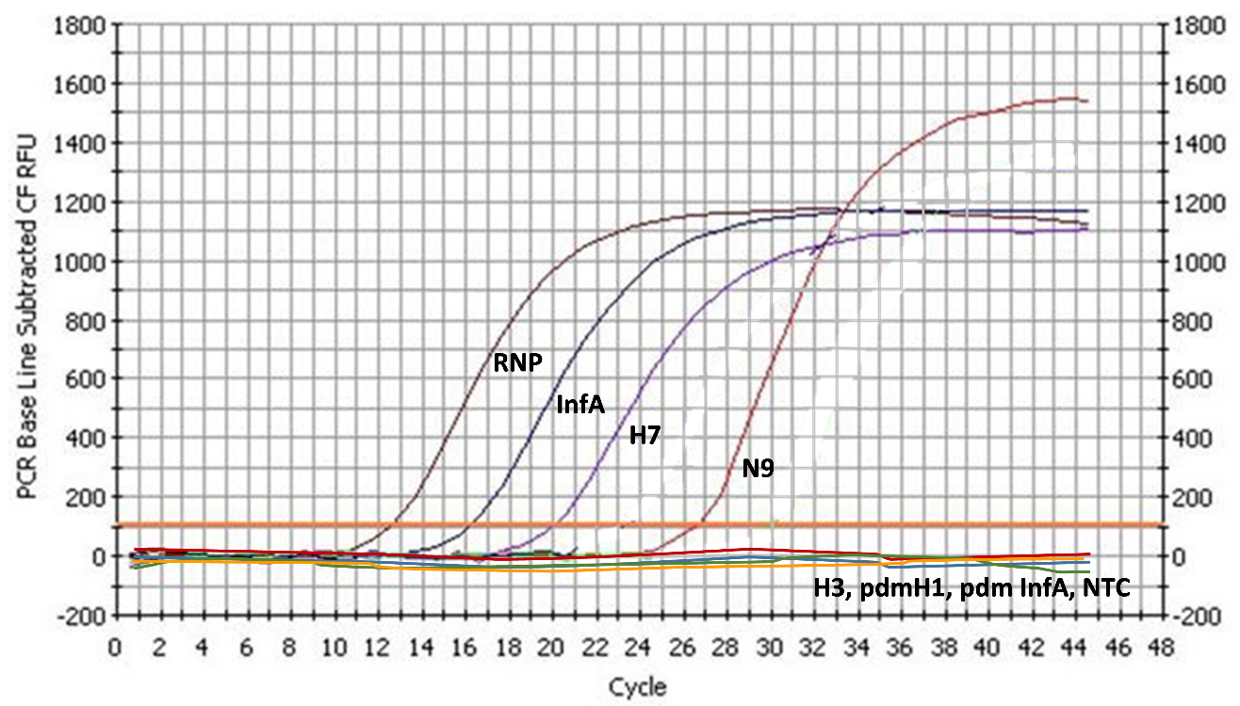

1. What is your interpretation of the rRT-PCR pattern?
The specimen is positive for the Chinese lineage of H7N9 virus and negative for all other influenza A subtypes tested (H3, pdmH1). Because the Chinese lineage H7N9 test was used in this reaction, this result is conclusive for positive identification of the H7N9 virus currently circulating in China.

2. What aspects of the laboratory assay would you want to verify?
Facilitator Answer: If a positive control was used in the rRT-PCR reaction, confirm that the influenza A positive control, H7, and N9 positive control were also positive. If other subtyping assays were tested, confirm that these were negative. Check that the No Template Control (NTC) was negative. If concerned about possibility of false positives, repeat the test to confirm the result.

3. What additional information would be important to obtain about this case from the national epidemiologist and the local-level surveillance officer?

Facilitator Answer: Based on detection of influenza A Chinese lineage H7N9 positive sample, the clinical symptoms/outcome of the patient should be requested from the hospital. It would be important to know if the person was expose to birds, wildlife or other animals. Did the person have any history of recent travel? It would also be important to know if the person had family members or close contacts that experience ILI. Make attempts to have epidemiologists contact patient’s family or contacts as follow-up. Collect additional samples from family members and close contacts if they experience ILI. Ask if antiviral treatment has been initiated if within the appropriate therapeutic window.

4. What steps would you take to report this case, to whom, and with what time frame?
Based on detection of a Chinese lineage H7N9 influenza subtype, the result should be immediately reported to national authorities. National authorities should report onward to Ministry of Health for further reporting to WHO. An IHR may be generated based on national policies. Consider contacting veterinary health authorities to follow-up on trace-back investigation if possible source of animal or environmental exposure can be identified.

5. In addition to information sharing as per question #4, what additional steps would you take to further analyze the sample?

Facilitator Answer: A first step would be to quickly send the specimen to WHO reference laboratory or collaborating center if it is not part of an ongoing, characterized outbreak. Following that the receiving laboratory could also sequence the HA and NA gene (even partial sequence of each gene fragment could be used to further characterize the H7N9 virus). Sanger sequencing is ideal for this type of genetic characterization. Assuming there is sufficient sample volume remaining, it would be important to aliquot some sample (ideally 0.5ml to 1.0 ml) and send to a WHO reference laboratory and/or CC for further characterization. If virus isolation capacity exists within your lab, attempting virus isolation in appropriate biocontainment is recommended. Use of both eggs and cells for isolation is recommended to increase chances of virus isolation (assuming sample volume is sufficient). If an isolate is propagated, consider sending both clinical specimen and an aliquot of the isolate to a WHO reference laboratory and/or CC for further characterization. Continue with full genome sequencing if possible. Deposit sequence data in publicly available sequence database if possible.

Scenario 3 There is suspicion that family members of the patient in scenario #2 were also exposed to infection due to their reporting of ILI. However, all family members were swabbed and samples were PCR negative. In this case, serology can be used to further identify infection. Answer the following question to address how to best determine if other family members were also infected with the virus using serology.

1. What is the best timing to collect sera if paired sera collection from the same family member is feasible? When should the first and second serum specimen be collected?

Paired sera collection is highly recommended whenever possible for serological identification of novel influenza virus infection. The first serum specimen should be collected immediately (before or within 7 days following symptom onset). The second serum specimen should be collected 2-3 weeks later.

2. In the event that it is only feasible to collect a single serum specimen, what would be the ideal timing of the serum collection?

If only single serum specimen can be collected, the single serum specimen from the suspected cases should be collected ≥ 14 days from the day of symptom onset. Studies have shown that higher sensitivity was achieved for antibody detection in H7N9 infected patients when sera were collected at around 3 weeks (21 days) or slightly later post symptom onset, but not too late as antibody waning will occur.

3. For sero-diagnosis, which assays should be used?

For H7N9 serodiagnosis, modified HI assays using horse red blood cells can be used as the primary assay. If the laboratory has the capacity to perform microneutralization assays, it is also recommended.
For identification of possible infection of novel influenza viruses using a single serum specimen, serological diagnosis should be determined by at least 2 assays: HI and/or MN or a secondary assay (for example western blot, ELISA).

4. What virus should be used to perform the testing of the sera? Which controls could be used?

Viruses/antigens that are antigenically same/closely related to the novel virus from the outbreak should be used in serological assays, including HI and MN. Appropriate positive and negative controls should be included in the assays. Ideally, the positive control should be sera collected from PCR confirmed infection cases that demonstrate positive antibodies to the novel virus.

5. What other information is needed from each family member to best assess sero-diagnosis.

Information collected from each family member should be as thorough as possible, information should be collected include, but not limited to:
- Whether the individual has acute respiratory illness based on case definition.
- The first day of symptom onset.
- All days of possible exposure (yes/no)to infected persons or poultry for the week prior to onset
- Levels of exposure
- Whether the individual had seasonal flu or received seasonal influenza vaccination recently.
- Age and other relevant demographic information
- Any antiviral treatment and its timing in relation to symptom onset
- Any antiviral prophylaxis (if undertaken)

NOTE: The data on antiviral use are more important for assessing resistance patterns than for serological diagnoses per se.

