Class Exercise - Laboratory
Detection, reporting and characterization of novel influenza virus infections

Scenario 1 The following real-time RT-PCR pattern (using the CDC Influenza Virus Real-time RT-PCR Reagent Kit) is obtained from a sample collected one week ago from a SARI sentinel site hospital:

1. What is your interpretation of the rRT-PCR pattern?

2. What aspects of the laboratory assay would you want to verify?

3. What additional information would be important to obtain about this case from the national epidemiologist and the local-level surveillance officer?

4. What steps would you take to report this case, to whom, and with what time frame?

5. In addition to information sharing as per question #4, what additional steps would you take to further analyze the sample?

Scenario 2 The following rRT-PCR pattern (using the CNIC H7N9 rRT-PCR assay) is obtained from a sample collected two days ago from a SARI sentinel site hospital.

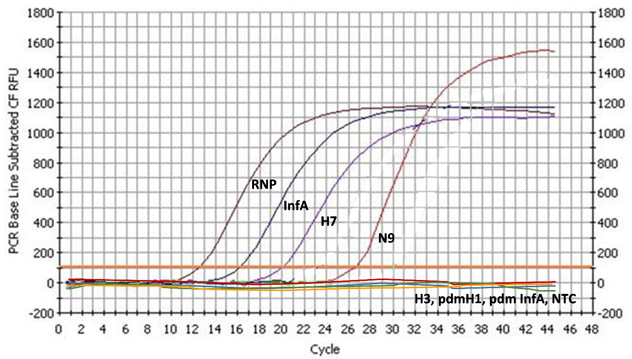

1. What is your interpretation of the rRT-PCR pattern?

2. What aspects of the laboratory assay would you want to verify?

3. What additional information would be important to obtain about this case from the national epidemiologist and the local-level surveillance officer?

4. What steps would you take to report this case, to whom, and with what time frame?

5. In addition to information sharing as per question #4, what additional steps would you take to further analyze the sample?

Scenario 3 There is suspicion that family members of the patient in scenario #2 were also exposed to infection due to their reporting of ILI. However, all family members were swabbed and samples were PCR negative. In this case, serology can be used to further identify infection. Answer the following question to address how to best determine if other family members were also infected with the virus using serology.

1. What is the best timing to collect sera if paired sera collection from the same family member is feasible? When should the first and second serum specimen be collected?

2. In the event that it is only feasible to collect a single serum specimen, what would be the ideal timing of the serum collection?

3. For sero-diagnosis, which assays should be used?

4. What virus should be used to perform the testing of the sera? Which controls could be used?

5. What other information is needed from each family member to best assess sero-diagnosis.

